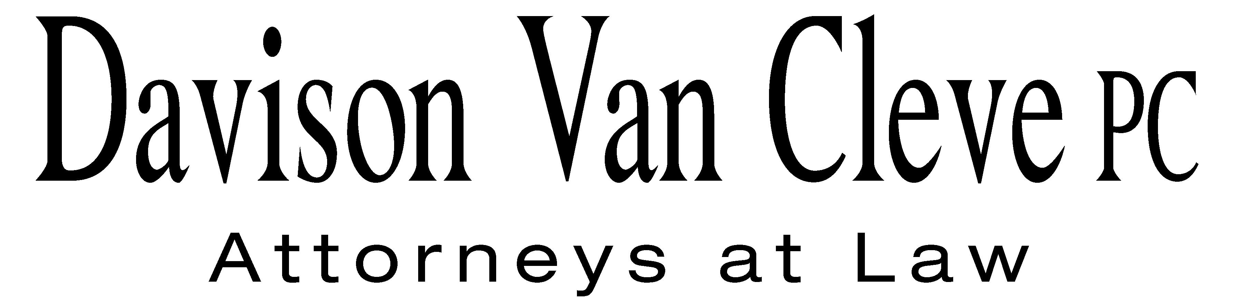
TEL (503) 241-7242 ● FAX (503) 241-8160 ● mail@dvclaw.com
Suite 400
333 SW Taylor
Portland, OR 97204

June 14, 2011

Via Federal Express and Electronic Mail

Mr. David E. Danner
Executive Director and Secretary
Washington Utilities & Transportation Commission
1300 S. Evergreen Park Drive S.W.
Olympia, WA 98504

Re: In the Matter of WUTC v. Puget Sound Energy, Inc

Docket Nos. UE-111048

Dear Mr. Danner:

Enclosed please find an original and twelve (12) copies of the Petition to Intervene on behalf of the Industrial Customers of Northwest Utilities in the above-referenced matter.

Thank you for your assistance. If you have any questions, please do not hesitate to give me a call.
Sincerely yours,

/s/ Sarah A. Kohler
Sarah A. Kohler

Enclosures
cc: Service List
CERTIFICATE OF SERVICE

I hereby certify that I have this day served a copy of the foregoing Petition to Intervene of the Industrial Customers of Northwest Utilities upon the parties, shown below, listed on the official service list in Docket No. UE-111048 by causing the same to be mailed, postage-prepaid, via U.S. Mail.
DATED at Portland, Oregon, this 14th day of June, 2011.
Davison Van Cleve, P.C.

/s/ Sarah A. Kohler
Sarah A. Kohler

Robert D Cedarbaum  Assistant Attorney General  WUTC  PO Box 40128  Olympia, WA 98504-0128  bcedarba@wutc.wa.gov | Donna Barnett  Perkins Coie, LLP  10885 N.E. Fourth Street STE 700  Bellevue, WA 98004-5579  dbarnett@perkinscoie.com
Simon ffitch  Office of the Attorney General  800 Fifth Avenue STE 2000  Seattle, WA 98104-3188  simonf@atg.wa.gov | Tom DeBoer  Director, Rates & Regulatory Affairs  Puget Sound Energy (E012)  PO BOX 97034, PSE-08N  Bellevue, WA 98009-9734  tom.deboer@pse.com
Jason Kuzma  Perkins Coie, LLP  10885 N.E. Fourth St. STE 700  Bellevue, WA 98004-5579  JKuzma@perkinscoie.com | Sheree Carson  Perkins Coie, LLP  10885 N.E. Fourth Street STE 700  Bellevue, WA 98004-5579  scarson@perkinscoie.com

