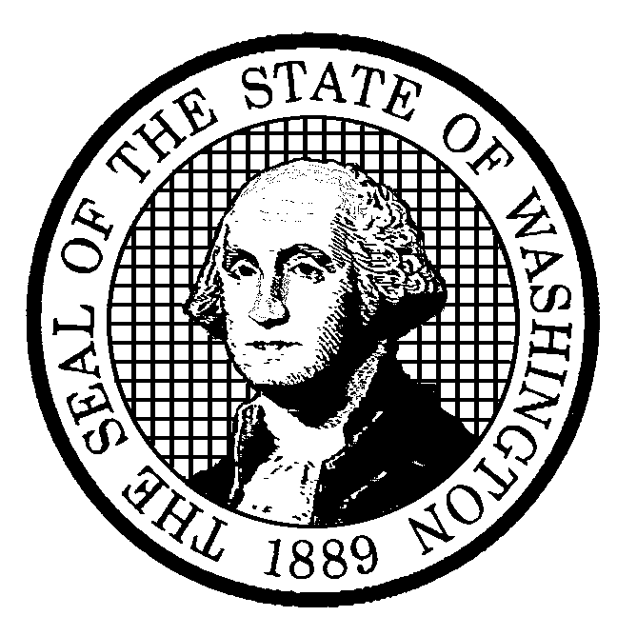

STATE OF WASHINGTON
Department of Community, Trade and Economic Development
Energy Policy Division

925 Plum Street SE, Bldg. 4 • PO Box 43173 • Olympia, WA 98504-3173 • (360) 956-2096 ph • (360) 956-2180 fx

May 16, 2003

Ms. Carole Washburn, Secretary
Washington Utilities and Transportation Commission
1300 S. Evergreen Park Drive SW
Post Office Box 47250
Olympia, Washington 98504-7250

RE: Docket No. UE-030311 and UF-030312 Least Cost Planning Rulemaking (WAC 480-100-238 Electric and WAC 480-90-238 Gas); Docket No. UE-030423 Purchases of Electricity (WAC 480-107)

Dear Ms. Washburn:

The Department of Community, Trade and Economic Development supports the Commission in its intent to conduct a review of the state’s least cost planning rules for investor-owned electric and natural gas utilities as well as the rules for purchasing electricity resources from bidders. The Energy Policy Division submits the following comments for consideration by the Commission during this initial review phase of the rulemaking process. As you are aware, the Energy Policy Division (EPD) has recently completed an update of the State Energy Strategy (SES). The first guiding principle, adopted by our advisory committee, focuses on the importance of least cost planning/integrated resource planning for the state’s utilities.

“Encourage all load-serving entities to adopt and implement integrated resource plans to ensure that they meet their obligation to serve their customers’ projected long term energy and capacity needs.”

These comments highlight areas of concern about implementation of least cost planning in Washington. Recent efforts by Washington’s electric investor-owned utilities have resulted in Least Cost Plans (LCPs) with rigorous resource analysis. However, that has not consistently been the case over the past decade. Addressing these issues would provide greater clarity to those participating in the development of LCP, would address societal and environmental costs and benefits more consistently, and could result in a stronger link between company LCPs and resource acquisition in the state by investor-owned utilities.

- Clarify that “Lowest Cost” includes environmental, societal, and health costs related to providing energy service.

Currently, during the development of each LCP stakeholders and representatives from the companies and the Commission are in the position of discussing what costs and benefits get included in the analysis to determine lowest cost. We recommend that the terminology in the WAC be expanded to read “lowest total cost” and that its definition specifically include societal, environmental, and health costs and, or benefits as well as the more traditionally analyzed costs of energy, fuel, capacity, storage, demand management, delivery and waste disposal.

- Quantify societal costs such as environmental and health costs as possible.

Legislation has been proposed at both the state and federal levels indicating that reducing emissions, such as CO2 and mercury, is a goal of many policy makers. ESHB 1002 Reducing the release of mercury into the environment was signed into law this spring. This bill does not address power plant emissions, though producing electricity at one coal plant is the third largest source of mercury emissions in Washington. Additionally, this winter, Washington State’s Attorney General, in conjunction with the Attorney Generals from several other states, announced plans to sue the U.S. Environmental Protection Agency for its failure to regulate power plant CO2 emissions under the provisions of the Clean Air Act. In light of the movement to regulate additional fossil fuel emissions in the future, the WAC needs to minimally address the following with regards to societal, health, and environmental costs.

  - Quantify all reasonably known health and environmental costs associated with a site specific or generic electricity power plant. This could occur either within a Commission forum with scheduled updates or could occur within the scope of each company’s LCP.
  - Direct the analysis comparing resources to include the cost of mitigating or preventing these environmental and societal costs. (Whether or not regulations at the time require mitigation.)
  - Direct the analysis comparing supply and demand resources to include, as possible, societal benefits.
  - Manage future risk to ratepayers for company resource acquisition decisions by specifying in Commission rules which future costs, such as the costs of mitigating fossil fuel emissions, shall not be paid by ratepayers.
  - Include language similar to WAC 480-107-001 in the LCP rules so that it applies to plant development by utility companies, “It is the Commission’s intent that bids under these rules shall include the costs of compliance by the project with environmental laws, rules, and regulations in effect at the time of the bid and those reasonably anticipated to be in effect during the term of the project.”

- Modify the rules (WAC 480-107-001) to give priority to the acquisition of cost-effective conservation.

Currently, the WAC indicates that the “rules are intended to provide an opportunity for conservation and generating resources to compete on a fair and reasonable basis to fulfill a utility’s new resource needs.” We recommend that preference be given first to acquire all cost-effective conservation prior to making any purchases of thermal generating plants. This would be consistent with the Northwest Electric Power Planning and Conservation Act - Public Law 96-501 Section 4(e)1 and the State Energy Strategy.

- Consider adopting language in rules that strongly links the LCP to actual resource acquisition.

We seek language or a mechanism in rules that would hold companies accountable for implementing their LCPs. For example, the LCPs could include specific performance benchmarks for implementation. The current process of the Commission writing a letter accepting or rejecting company LCPs is perhaps one cause of the wide variability in thoroughness and relevance of the LCPs over time and among companies. This question of relevance of the LCPs influences stakeholders’ willingness and ability to meaningfully provide comments on company resource acquisition plans in the State. The documents, on occasion, have become meaningless in less than six months due to the quality of the analysis in the document or lack of company commitment to the recommendations in the document.

We do not support one particular recommendation on how to strengthen the tie between the LCP recommendations and actual company resource acquisition. There could be benefits involved for investing in resources outlined in the LCP or penalties for investing in resources not identified in the LCP recommendations. We believe the issue of relevance is an important one and recommend that it be addressed during the review of the rules.

In the broader context, the timing of this review may be particularly useful in that the Northwest Power Planning Council is currently conducting a review of integrated resource planning efforts in the region as they relate to resource adequacy. The potential exists to highlight issues and opportunities for resolution at the local, state, or regional level, and to clarify terms and measurements.

Thank you for the opportunity to submit preliminary comments during this inquiry phase of revising the rules mentioned above. We look forward to participating in the Commission’s June 13th stakeholder workshop to discuss these and related issues.

Sincerely,

Tony Usibelli
Director, CTED Energy Policy Division

