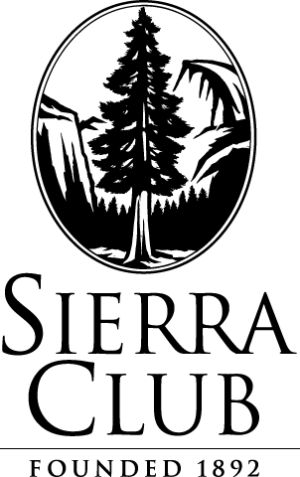
August 16, 2013

Via Electronic Filing

Steven King, Acting Executive Director and Secretary
Washington Utilities and Transportation Commission
P.O. Box 47250
1300 S. Evergreen Park Drive S.W.
Olympia, WA 98504-7250

Re: Docket UE-120767: Sierra Club Comments

Please find attached Sierra Club’s Comments in the above-referenced docket.

Please let me know if you have any questions. Thank you.

Respectfully submitted,

/s/ Derek Nelson
Derek Nelson
Legal Assistant
Sierra Club Environmental Law Program
85 Second St., 2nd Floor
San Francisco, CA 94105
(415) 977-5595
derek.nelson@sierraclub.org

85 Second Street, Second Floor San Francisco, CA 94105-3441 TEL: (415) 977-5772 FAX: (415) 977-5793 www.sierraclub.org

