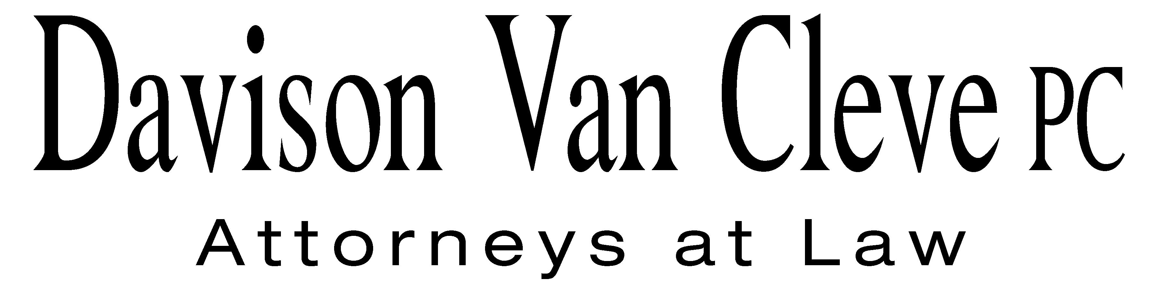
TEL (503) 241-7242 ● FAX (503) 241-8160 ● mail@dvclaw.com
Suite 400
333 SW Taylor
Portland, OR 97204

January 27, 2009

Via Email and Federal Express

Carole J. Washburn
Secretary
Washington Utilities and Transportation Commission
PO Box 47250
1300 S Evergreen Park Drive SW
Olympia, WA 98504-7250

Re: For a Determination of Emissions Compliance and Proposed Accounting Treatment For the Mint Farm Energy Center; or, Alternatively For an Accounting Order
Docket No. UE-082128

Dear Ms. Washburn:

Enclosed please find an original and twelve (12) copies each of the following documents for filing in the above-captioned matter:

- the Petition to Intervene of the Industrial Customers of Northwest Utilities; and

- the Notice of Appearance of S. Bradley Van Cleve and Irion A. Sanger on behalf of the Industrial Customers of Northwest Utilities.

Please return one file-stamped copy of each document in the postage prepaid envelope provided. Thank you for your assistance.

Sincerely yours,

/s/ Brendan E. Levenick
Brendan E. Levenick
Enclosures

cc: Service List

CERTIFICATE OF SERVICE

I hereby certify that I have this day served the foregoing documents upon all parties of record in this proceeding by mailing a copy thereof in a sealed, first-class postage prepaid envelope to each individual’s last-known address, as listed below.
DATED in Portland, Oregon this 27th day of January, 2009.
Davison Van Cleve, P.C.

/s/ Brendan E. Levenick
Brendan E. Levenick

PERKINS COIE  SHEREE CARSON  10885 N.E. FOURTH STREET STE 700 BELLEVUE WA 98004-5579  scarson@perkinscoie.com | PUGET SOUND ENERGY  KARL KARZMAR  REGULATORY RELATIONS  PO BOX 97034 PSE-08N  BELLEVUE WA 98009-9734  karl.karzmar@pse.com
PUGET SOUND ENERGY  DONNA BARNETT  10885 N.E. FOURTH STREET  STE 700  BELLEVUE WA 98004  dbarnett@perkinscoie.com | WUTC  SALLY BROWN  ASSISTANT ATTORNEY GENERAL  ATTORNEY GENERAL SECTION  STATE MAIL STOP 40128  sbrown@utc.wa.gov
DEPARTMENT OF ECOLOGY  ALAN R NEWMAN  SENIOR AIR QUALITY ENGINEER  PO BOX 47600  OLYMPIA WA 98504 | OFFICE OF THE ATTORNEY GENERAL  SIMON FFITCH  800 FIFTH AVENUE STE 2000  SEATTLE WA 98104-3188  simonf@atg.wa.gov
KAY SHIREY  ASSISTANT ATTORNEY GENERAL  OFFICE OF THE ATTORNEY GENERAL  2425 BRISTOL CT. SW FL 2ND  OLYMPIA WA 98504 | WUTC  ROBERT D CEDARBAUM  ASSISTANT ATTORNEY GENERAL  ATTORNEY GENERAL OFFICE STATE MAIL STOP 40128  bcedarba@wutc.wa.gov

