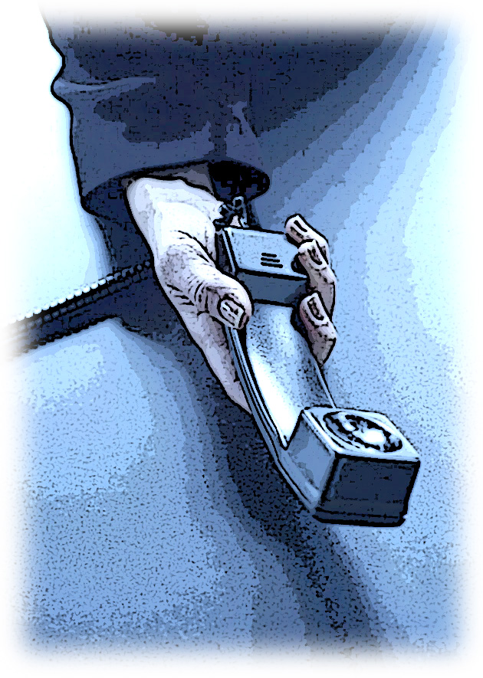
AGENDA

SERVICE EXTENSION RULEMAKING WORKSHOP
UT-073014

October 4, 2007 – 9:30 am to 12:30 pm
Commission Headquarters, Olympia, WA
Main Hearing Room 206

9:30 – 9:45 Registration, Handouts, and Coffee

9:45-10:00 Workshop Opening
- Welcome and Agenda Overview
- Introductions – All attendees
- Purpose of Meeting – Goals

10:00- 10:05 Commissioner Comments

10:05 – 11:00 Discussion of effectiveness of current rules and responses to stakeholder comments

11:00 – 11:10 Break

11:10 – 12:10 Continuation of discussion

12:10 – 12:30 Commissioner closing comments

12:30 Adjourn

WUTC Staff Team:
Fred Ottavelli, Facilitator
Wilford Saunders, Assistant Director, Telecommunications
Bob Shirley, Rulemaking Lead
Sharyn Bate, Regulatory Analyst
Jonathan Thompson, AAG Advisor
Patricia Clark, ALJ Advisor

