EXHIBIT NO. ___(MM-8T)
DOCKET NO. UE-130617
2013 PSE PCORC
WITNESS: MICHAEL MULLALLY

BEFORE THE
WASHINGTON UTILITIES AND TRANSPORTATION COMMISSION

WASHINGTON UTILITIES AND  TRANSPORTATION COMMISSION,  Complainant,  v.  PUGET SOUND ENERGY, INC.,  Respondent. |  | Docket No. UE-130617

PREFILED SUPPLEMENTAL DIRECT TESTIMONY
(NONCONFIDENTIAL) OF MICHAEL MULLALLY
ON BEHALF OF PUGET SOUND ENERGY, INC.

JULY 2, 2013
PUGET SOUND ENERGY, INC.
PREFILED SUPPLEMENTAL DIRECT TESTIMONY
(NONCONFIDENTIAL) OF MICHAEL MULLALLY
CONTENTS
I. INTRODUCTION 1
II. SALE OF PSE’S INTERESTS IN THE DEVELOPMENT ASSETS REQUIRED FOR THE CONSTRUCTION AND OPERATION OF LSR PHASE 2 TO PORTLAND GENERAL 2
A. PSE’s Interests in the Development Assets Required for the Construction and Operation of Various Phases of the Lower Snake River Wind Project 2
B. Sale of PSE’s Interests in the Development Assets Required for the Construction and Operation of LSR Phase 2 to Portland General 7
1. The Purchased Assets 11
2. The BPA Transferred Transmission Credits 12
3. Payments to PSE 13
4. Closing Date 14
III. UPDATE REGARDING NEGOTIATIONS BETWEEN PSE AND ELECTRON HYDRO FOR THE ELECTRON PPA 14
IV. CONCLUSION 15

PUGET SOUND ENERGY, INC.
PREFILED SUPPLEMENTAL DIRECT TESTIMONY
(NONCONFIDENTIAL) OF MICHAEL MULLALLY

I. INTRODUCTION
Q. Are you the same Michael Mullally who provided prefiled direct testimony in this docket on behalf of Puget Sound Energy, Inc. (“PSE”)?
A. Yes, I filed prefiled direct testimony, Exhibit No. ___(MM-1HCT), and six supporting exhibits, Exhibit No. ___(MM-2) through Exhibit No. ___(MM-7).
Q. What is the nature of your prefiled supplemental direct testimony in this proceeding?
A. This prefiled supplemental direct testimony
(i) presents
(a) new information related to the sale of PSE’s interests in the development assets required for the construction and operation of Phase II of the Lower Snake River Wind Project (“LSR Phase 2”) to Portland General Electric Company (“Portland General”) and
(b) details in support of PSE’s request for a change in the rate base and amortization treatment for the regulatory asset for the transfer of Bonneville Power Administration (“BPA”) Large Generator Interconnection Agreement (“LGIA”) credits to Portland General, which is addressed in the Prefiled Supplemental Direct Testimony of Ms. Katherine J. Barnard, Exhibit No. ___(KJB-8T); and
(ii) updates the Commission with respect to the negotiations between PSE and Electron Hydro LLC (“Electron Hydro”) for the proposed power purchase agreement for the entire output of the Electron Hydroelectric Project (the “Electron PPA”).

II. SALE OF PSE’S INTERESTS IN THE DEVELOPMENT ASSETS REQUIRED FOR THE CONSTRUCTION AND OPERATION OF LSR PHASE 2 TO PORTLAND GENERAL

A. PSE’s Interests in the Development Assets Required for the Construction and Operation of Various Phases of the Lower Snake River Wind Project
Q. Please describe the Lower Snake River Wind Project.
A. The Lower Snake River Wind Project is located in southeast Washington and encompasses over 124,000 acres of leased lands in Garfield and Columbia Counties. The Lower Snake River Wind Project comprises enough acreage and wind resources for at least a 1250 megawatt (MW) resource.
Q. Please describe the four wind resource areas located within the Lower Snake River Wind Project.
A. The four wind resource areas located within the Lower Snake River Wind Project are as follows:
1. Tucannon Wind Resource Area, which consists of approximately 41,500 acres in Columbia County;
2. Dutch Flats Wind Resource Area, which consists of approximately 10,000 acres in Garfield County;
3. Kuhl Ridge Wind Resource Area, which consists of approximately 39,900 acres in Garfield County; and
4. Oliphant Wind Resource Area, which consists of approximately 32,700 acres in Garfield and Columbia counties.
Q. Do these four wind resource areas delineate project areas or proposed construction phases associated with the Lower Snake River Wind Project?
A. No. The four wind resource areas neither delineate distinct project areas nor do they directly correlate with proposed construction phases. Rather, the four wind resource areas represent sections of the Lower Snake River Wind Project separated by natural and human-made features within which development activities such as wind resource evaluation, land lease negotiations, and environmental studies were initiated at different times.
Development and construction will occur in multiple phases with each phase encompassing areas in one or more of the wind resource areas. The phasing of the development and construction of the Lower Snake River Wind Project is not intended to coincide with the wind resource areas, and the size and geographic boundaries of each phase are being determined during the development process.
Q. How did PSE acquire interests in the development assets required for the construction and operation of the various phases of the Lower Snake River Wind Project?
A. PSE acquired interests in the development assets required for the construction and operation of the various phases of the Lower Snake River Wind Project via two separate transactions with RES America Developments, Inc. (“RES Developments”). On November 26, 2008 PSE entered into a Joint Development Agreement with RES Developments to acquire a half interest in development-stage wind projects in Columbia and Garfield Counties.
Q. What assets were acquired under the terms of the Joint Development Agreement?
A. The assets that were acquired included real property contracts (wind energy ground leases, anemometer agreements), meteorological towers and equipment, wind and climatic data and reports, environmental studies and reports, and interconnection studies and agreements.
Q. What happened after PSE entered into the Joint Development Agreement?
A. Initially, PSE and RES Developments worked to co-develop the site. The parties worked on continued wind evaluation, land leases, permitting, and wind turbine generator technology evaluation. During the months following the collapse of several large financial institutions, economic conditions deteriorated further and RES Developments re-evaluated its financial position. RES Developments’ management determined it was appropriate to attempt to sell its stake in the Lower Snake River Wind Project. On March 23, 2009, RES Developments issued marketing materials soliciting interest in the sale of its interests in the Lower Snake River Wind Project.
Q. What options did PSE face in light of RES Developments plan to sell its interests in the Lower Snake River Wind Project?
A. PSE was faced with three possible scenarios in the sale of the RES Developments’ interest in the Lower Snake River Wind Project:
1. 100% PSE ownership;
2. RES Developments sells its interest to a third party and PSE maintains 50% interest; and
3. RES Developments remains as a Joint Development Agreement co-owner and PSE maintains 50% interest.
PSE decided to purchase RES Developments’ interests in development rights for the Lower Snake River Wind Project. Shortly after RES Developments issued marketing materials, PSE initiated negotiations regarding the purchase of that interest which, due to further development work, was now considered to be “late stage pre-construction” development rights. The purchase of the RES Developments’ interest in the Lower Snake River Wind Project provided PSE with an option for the future ownership of up to approximately 1,250 MW of wind resources. Under the arrangement, RES Developments holds right to construct subsequent phases of Lower Snake River Wind Project through November 25, 2016.
Q. Has PSE developed any phase of the Lower Snake River Wind Project?
A. Yes. PSE developed Phase I of the Lower Snake River Wind Project (“LSR Phase 1”), which encompasses portions of the Kuhl Ridge and Oliphant Ridge Wind Resource Areas as depicted Figure 1 below.
Figure 1. LSR Phase 1
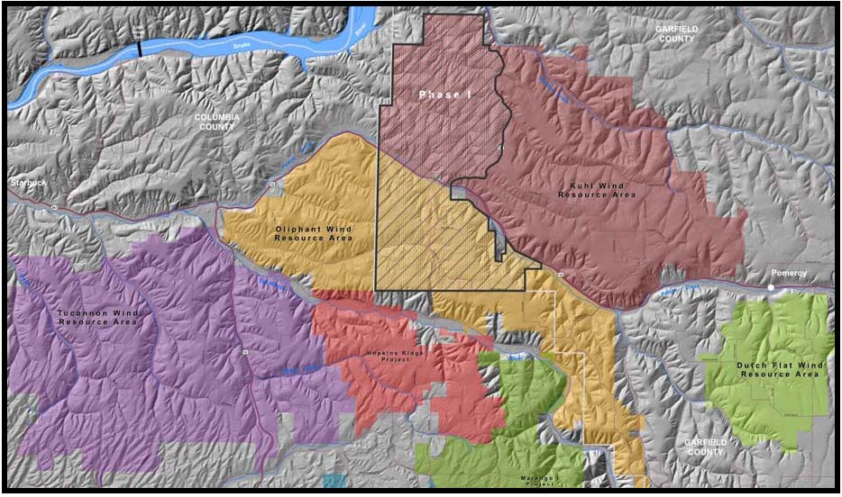
LSR Phase 1 is a 342.7 MW wind power generation facility located on an approximately 21,610 acre site in western Garfield County, Washington and bordering Columbia County. In Docket UE-111048, the Commission found that PSE’s investments in LSR Phase 1 were prudent and the costs of LSR Phase 1 to be reasonable for recovery in rates. PSE placed LSR Phase 1 into service on February 29, 2012.

B. Sale of PSE’s Interests in the Development Assets Required for the Construction and Operation of LSR Phase 2 to Portland General
Q. Please describe LSR Phase 2.
A. LSR Phase 2 is a fully permitted, shovel-ready utility-scale wind project located in Columbia County, Washington in the immediate vicinity of over 700 MW of operational wind projects separately owned by PSE and PacifiCorp. LSR Phase 2 encompasses the western and southern portions of the Tucannon Wind Resource Area as depicted in Figure 2 below.
Figure 2. LSR Phase 2
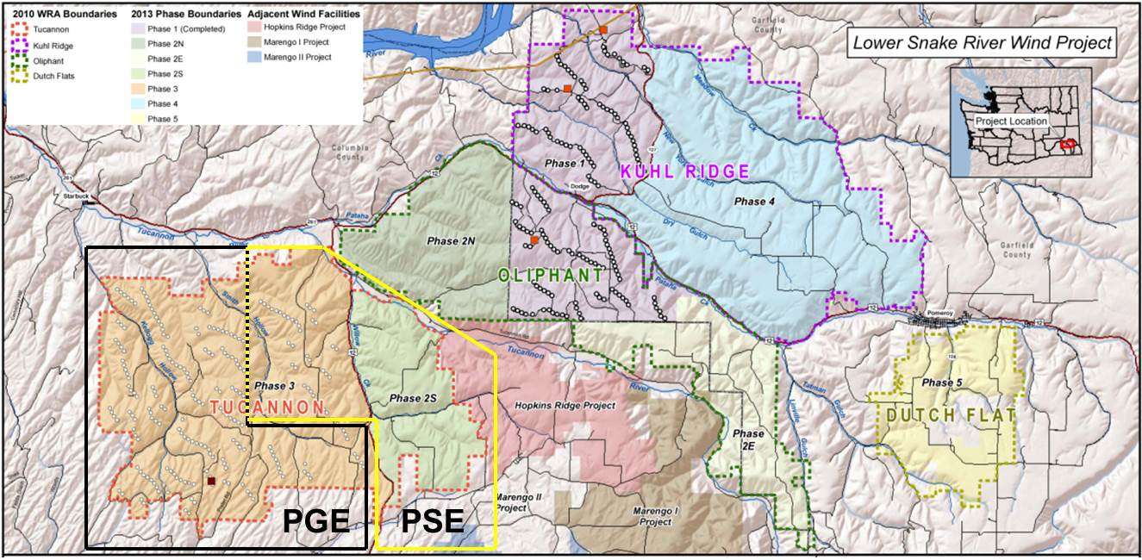
Please note that the black, “L”-shaped box in Figure 2 above depicts the area in which Portland General will construct LSR Phase 2.
Once constructed, LSR Phase 2 will have a nameplate capacity of 266.8 MW and an annual average capacity of 101 average megawatts (aMW). It is anticipated that LSR Phase 2 will consist of the following components:
(i) 116 Siemens SWT-2.3-108 turbines erected on 80 meter towers;
(ii) approximately 280 miles of 34.5 kilovolt (kV) conductor to deliver the output of the turbines to one 34.5/230 kV substations for LSR Phase 2;
(iii) approximately 18 miles of 230 kV overhead line to connect the LSR Phase 2 substation to LSR Phase 2’s point of interconnection at the Central Ferry substation, which includes an existing and operational 1250 megavolt amperes (MVA) 230/500 kV transformer;
(iv) approximately 28 miles of new roads; and
(v) other ancillary facilities including, for example, turbine foundations and other civil works, a supervisory control and data acquisition (SCADA) system and operations and maintenance facilities, communication facilities, permanent meteorological towers, and spare parts.
Q. Why did PSE decide to seek to sell its interests in the development assets required for the construction and operation of LSR Phase 2?
A. With LSR Phase 1 now in service, PSE projects that it has acquired enough eligible renewable resources and renewable energy credits (“RECs”) to meet the requirements of the state’s renewable energy targets for the foreseeable future. Indeed, PSE’s 2013 Integrated Resource Plan (the “2013 IRP”) does not project a need for PSE to acquire renewable resources until, at earliest, 2022. For example, the Base Scenario of the 2013 IRP projects a need for PSE of (i) 300 MW of renewable resources by 2022 and (ii) another 300 MW of renewable resources by 2033. Thus, PSE has rights in development assets for the Lower Snake River Wind Project that are surplus to what PSE needs to meet its renewable resource needs over the next two decades, and PSE sought opportunities to sell surplus rights.
Q. Please describe the process by which PSE submitted proposals for the sale of PSE’s interests in the development assets required for the construction and operation of LSR Phase 2.
A. On October 1, 2012, Portland General issued a request for proposals seeking power generating resources to help Portland General comply with Oregon’s renewable energy standard (the “Renewable RFP”). The Renewable RFP sought approximately 100 aMW of renewable power from renewable generation resources that met a minimum size of at least 10 MW from a variety of technologies, including wind, geothermal, biomass, biogas, solar, and hydroelectric power. Bids into the Renewable RFP were due November 13, 2012.
On October 24, 2012, PSE and RES Developments executed a Joint Marketing Agreement that outlines terms and conditions for co-submitting bids into the Renewable RFP. Pursuant to such arrangement, PSE would sell its interests in the development assets required for the construction and operation of LSR Phase 2, and RES Developments would construct LSR Phase 2 for Portland General. On November 13, 2012, PSE and RES Developments jointly submitted bids to the Renewable RFP.
Q. Did Portland General select a joint bid of PSE and RES Developments as a finalist in the Renewable RFP?
A. Yes. On January 22, 2013, Portland General selected the joint PSE and RES Developments proposals for the initial short list for the Renewable RFP. On February 19, 2013, Portland General further selected the joint PSE and RES Developments proposals for the final short list for the Renewable RFP. On March 11, 2013, Portland General commenced its due diligence process and entered into exclusive negotiations with PSE and RES Developments for (i) the purchase of PSE’s interests in the development assets required for the construction and operation of LSR Phase 2 and (ii) an agreement with RES Developments to construct LSR Phase 2.
Q. Were PSE and Portland General able to reach final agreement?
A. Yes. PSE and PGE entered into an Asset Purchase and Sale Agreement, dated as of June 3, 2013, pursuant to which PSE will sell its interests in the development assets required for the construction and operation of LSR Phase 2 (the “LSR Phase 2 Asset Purchase and Sale Agreement”). Please see Exhibit No. ___(MM-9CT), for a copy of the LSR Phase 2 Asset Purchase and Sale Agreement.

1. The Purchased Assets
Q. Please describe PSE’s interests in the development assets required for the construction and operation of LSR Phase 2 to be transferred to Portland General pursuant to the LSR Phase 2 Asset Purchase Agreement.
A. Subject to and upon the terms and conditions of the LSR Phase 2 Asset Purchase Agreement, PSE has agreed to sell, assign, transfer, convey, and deliver to Portland General the following interests:
(i) all of PSE’s right, title and interests in and to the Real Property, all as more particularly listed and described in Part II of Schedule 6.10.1 to the LSR Phase 2 Asset Purchase and Sale Agreement;
(ii) all of PSE’s right, title and interests in and to the Assumed Contracts, all as more particularly listed and described in Parts I, II and III of Schedule 6.10.1 to the LSR Phase 2 Asset Purchase and Sale Agreement;
(iii) the Conditional Use Permits, as partially assigned pursuant to the Assignment of Interest in CUP Agreement, for the development of not less than 266.8 MW of installed nameplate capacity and associated LSR Phase 2 and transmission, and all other Permits for development of LSR Phase 2 held by PSE at Closing, including those listed or described in Part I of Schedule 6.11 to the LSR Phase 2 Asset Purchase and Sale Agreement;
(iv) all applications for Permits listed or described in Part II of Schedule ‎6.11 of the LSR Phase 2 Asset Purchase and Sale Agreement;
(v) at least 267 MW of firm transmission rights, and related rights to interim conditional firm transmission service, to be exclusively owned by and in the name of Portland General for transmission of the electrical output generated by LSR Phase 2 via the Bonneville Power Administration BPA transmission system from the Point of Interconnection to the Point of Delivery, which Transmission Rights shall be transferred through a combination of partial and full assignments of the PSE Precedent Agreements, as further specified in Schedule 4.2.14 of the LSR Phase 2 Asset Purchase and Sale Agreement;
(vi) true and complete copies of all books, records, files, drawings, plans, specifications, consents, the Wind Data and any and all other wind analyses, solely for LSR Phase 2 and in the possession or under the control of PSE, including any of the foregoing that have not been finalized but are still in process, and other printed or written materials, in each case relating solely to LSR Phase 2;
(vii) the permanent and temporary meteorological towers and wind monitoring instrumentation located on the Real Property and set forth on Schedule 1.2 of the Asset Purchase and Sale Agreement; and
(viii) all warranties, guarantees, licenses and indemnification rights with respect to any of the Purchased Assets.
The LSR Phase 2 Asset Purchase Agreement refers to the interests described above as the “Purchased Assets.”

2. The BPA Transferred Transmission Credits
Q. Please describe PSE’s interests in the BPA transmission credits to be transferred to Portland General pursuant to the LSR Phase 2 Asset Purchase Agreement.
A. PSE has agreed to assign certain BPA Transferred Transmission Credits in an amount equal to $20,500,000 to Portland General. PSE has made prepayments of $102.2 million to BPA to construct the Central Ferry Substation and certain transmission Network Upgrades to interconnect the output of the various phases of the Lower Snake River Wind Project, including LSR Phase 1 and LSR Phase 2. PSE’s total prepayment of $102.2 million to BPA consisted of a $2.5 million prepayment for Interconnection Facilities and a $99.7 million prepayment for Network Upgrades. BPA will continue to refund to PSE the prepayment related to the Network Upgrade facilities, plus interest, through transmission credits to PSE’s point-to-point transmission tariff expenses in the future, but BPA’s refund obligation will be reduced by the $20.5 million of transmission credits transferred to Portland General. Please see the Prefiled Supplemental Direct Testimony of Ms. Katherine J. Barnard, Exhibit No. ___(KJB-8T), for a discussion of PSE’s requested ratemaking treatment with respect to the BPA Transferred Transmission Credits.

3. Payments to PSE
Q. Please describe the payments to be made by Portland General to PSE pursuant to the LSR Phase 2 Asset Purchase Agreement.
A. At the Closing, Portland General will pay a Closing Payment to PSE in an amount equal to $16,008,000, as such amount may be adjusted to reflect any prepayments or payments made in arrears by PSE under any of the Assumed Contracts and any payments made by PSE in respect of property taxes relating to the Real Property, in any case on a pro-rata basis up to and including the Closing Date.
In addition to this Closing Payment, Portland General will, after Closing and within two Business Days after BPA’s notice to Portland General that BPA has completed its processing of PSE’s assignment to Portland General of the BPA Transferred Transmission Credits, pay PSE an amount equal to $20,500,000 in consideration of such assignment.

4. Closing Date
Q. Please describe the proposed closing date for the LSR Phase 2 Asset Purchase Agreement.
A. The proposed closing date is at 10:00 a.m. local time on August 1, 2013 or on such other date to be agreed in writing by PSE and Portland General, which shall be no later than two business days after satisfaction (or waiver as provided herein) of the conditions set forth in Article 4 of the Asset Purchase Agreement, or at such other time or date as PSE and Portland General mutually agree upon in writing.

III. UPDATE REGARDING NEGOTIATIONS BETWEEN PSE AND ELECTRON HYDRO FOR THE ELECTRON PPA
Q. Have PSE and Electron Hydro finalized a proposed agreement for PSE’s purchase of the entire output of the Electron Project?
A. Yes. PSE and Electron Hydro finalized a form Electron PPA, which is Exhibit I to the Asset Purchase Agreement, dated as of May 30, 2013, for the sale of the Electron Project by PSE to Electron Hydro (the “Electron Asset Purchase Agreement”). Please see the First Exhibit to the Prefiled Supplemental Direct Testimony of Paul K. Wetherbee, Exhibit No. ___(PKW-15C), for a copy of the Electron Asset Purchase Agreement. Please see pages 83-118 of Exhibit No. ___(PKW-15C) for a copy of the form Electron PPA.
Q. Are the commercial terms of the Electron PPA consistent with the commercial terms discussed in your prefiled direct testimony, Exhibit No. ____(MM-1HCT)?
A. Yes. The commercial terms of the Electron PPA are consistent with the commercial terms discussed in my prefiled direct testimony, Exhibit No. ____(MM-1HCT).

IV. CONCLUSION
Q. Does this conclude your supplemental direct testimony?
A. Yes, it does.

WUTC v. Puget Sound Energy, Inc., Dockets UE-111048 and UG-111049, Order 08 at ¶ 515 (May 7, 2012).

