July 15, 2016

VIA ELECTRONIC FILING SYSTEM

Mr. Steven V. King
Washington Utilities & Transportation Commission
1300 S. Evergreen Park Drive SW
Olympia, WA 98504-7250

RE: Washington State USF Certification Report Pursuant to WAC 480-123-130
Docket No. UT-151559

Dear Mr. King
Pend Oreille Telephone Company respectfully submits to the Washington Utilities and Transportation Commission its annual report pursuant to WAC 480-123-130 State Universal Fund for the program year 2016. Please be advised that a native version of some of the files is not available.

Please feel free to contact me with any questions regarding this particular matter.

Sincerely,
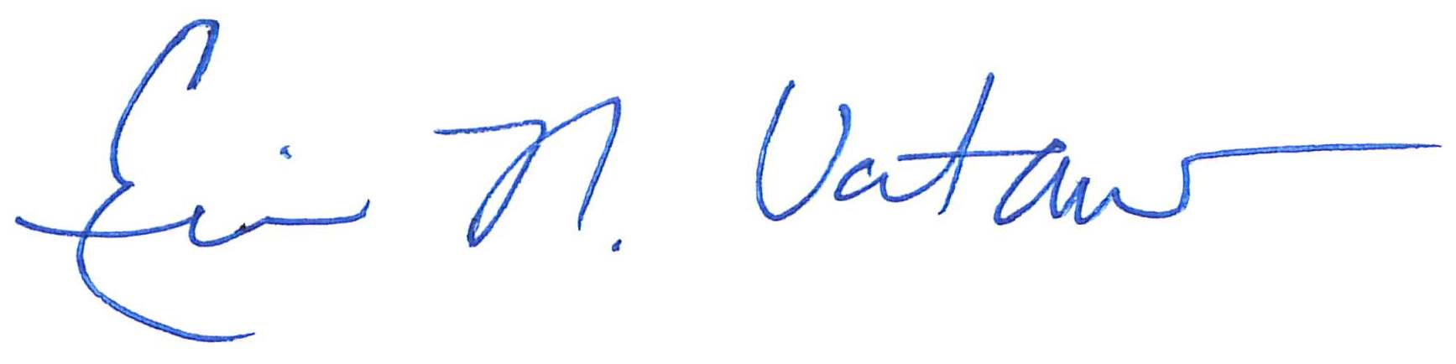
Eric N. Votaw, Senior Manager for
Moss Adams LLP
Enclosures

CC: Susan Case – Pend Oreille Telephone Company

