

August 7, 2012

Re: Withdrawal of Solid Waste Certificate application, docket # TG-120673

To Whom It May Concern:

After careful consideration, the partners of Prothrive Operations, LLC d/b/a Rubbish Works have decided to withdraw our application for a Solid Waste Certificate, docket # TG-120673.

Sincerely,

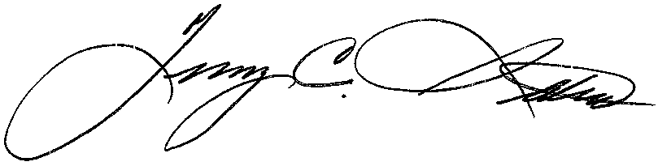

Terry C. Stokes – Manager
Rubbish Works Bellevue / Kirkland

