Current Unbundled Loop Basic Hot Cut Process Task List
1. CLEC performs pre-order loop functions. The results will assist the CLEC in determining the best loop to purchase that will meet their specific needs.
2. Local Service Request (LSR) form submitted to Qwest by means of IMA, EDI, or faxing.
3.,4. If faxed, Service Delivery Coordinator (SDC) reviews LSR and associated forms for completeness. Verification includes, checking: CLEC certification, Letter of Authorization (LOA), Summary Bill
Number, CLEC Termination Point, Network Channel (NC), Network Channel Interface (NCI) codes, CLEC Due Date Interval and facilities. If sent via IMA or EDI, the LSR is converted to one or more service orders and sent to the Service Order Processor (SOP).
5. The SDC issues the service order into the Qwest SOP. Then the service order is sent to the appropriate work groups including the Design Services Center.
6. The SDC issues the Firm Order Commitment (FOC) and sends it to the CLEC, if LSR was faxed.. IMA or EDI will send the FOC to the CLEC when the LSR is processed electronically.
7. CLEC receives FOC.
8. If facilities cannot be reused, the Loop Provisioning Center (LPC) must investigate alternate facilities.
9. On the Record Issue Date (RID), the circuit design is created based on the service request. The Word Document provides the central office and field technicians with the information necessary to wire the circuit.
10. Implementer verifies order and performs pre-tests (I.E. line verification).
10a. If circuit fails pre-tests, implementer issues hand off ticket for dispatch to resolve.
11. Provisioning work request received in Local Network Operations (LNO). Scheduler loads appropriate LNO personnel.
12. On the Design Verify and Assign (DV A) the central office technician (COT) wires the circuit according to the Word Document specifications, and performs Dial Tone (DT) check.
Current Unbundled Loop Basic Hot Cut Process Task List
13. If no DT, the implementer emails to the CLEC the no DT notifier.
14. On Due Date (DD) the COT contacts the implementer and performs 'lift and lay' and other work steps.
14a. If applicable, the field technician performs work steps associated with a dispatch out.
15. The implementer contacts the CLEC to advise conversion is complete.
16. The implementer calls RCMAC to complete voice disconnect order.
17. The implementer completes the order in WF A-C, billing information flows to the SOP.
18. The billing is completed in the SOP.
19. CLEC accepts the order.

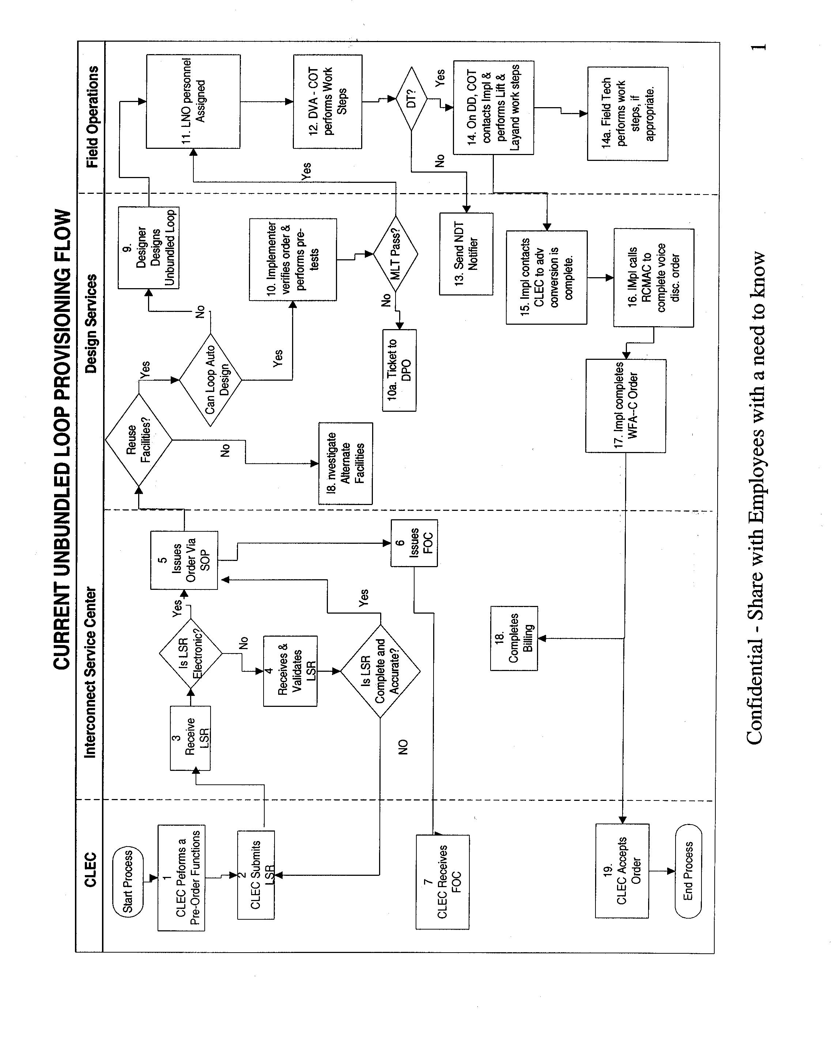

Coordinated Hot Cut Reuse Process Task List
Task
# Activity
1 At the requested appointment time the Qwest central office technician (COT) contacts the Qwest CLEC Coordination Center (QCCC) to indicate readiness to start the cut.
2 The QCCC contacts the CLEC to determine readiness.
3 QCCC advises the COT to start the cut and document the start time of the cut.
4 The COT performs the central office wiring and appropriate tests. The COT documents the start time of the "lift" and the end of the "lay" process
5 The COT notifies the QCCC that the work is complete and provides the QCCC with: the "lift" and "lay" time and the test results.
6 The QCCC documents the stop time of the cut and phones the CLEC that the work is complete providing test results. If the CLEC has purchased Cooperative or Performance Testing, the test results are also forwarded to the CLEC via email within two business days of order completion. .
7 Once CLEC accepts the loop, QCCC contacts RCMAC and documents the cut information manually on the form and electronically on the OSS-CN screen in WFA
8 RCMAC completes a':!Y necessary work.
9 CLEC does not accept the loop, the QCCC enters a jeopardy code on the order and notifies the Service Delivery Coordinator (SDC) and the RCMAC that the order will not be completed due to customer reasons.

Coordinated "Hot Cut" (reuse of facilities)

