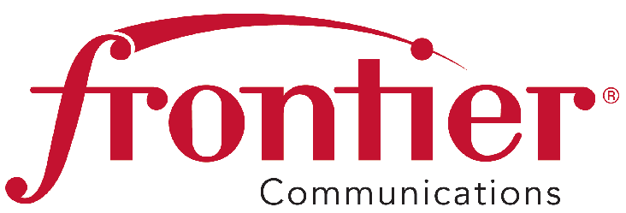
November 11, 2015 |  | 805 Central Expressway South  Suite 200  Allen, Texas 75013  Phone 972-908-4415  Fax 214-383-2737  Email: kimberly.a.douglass@ftr.com
Via electronic filing

Mr. Steven V. King
Executive Director and Secretary
Washington Utilities and Transportation Commission
1300 S. Evergreen Park Drive SW
P.O. Box 47250
Olympia, WA 98504-7250

Re: UT-150063 - Frontier Communications Northwest Inc. - Section 54.313 Updated Annual Reports

Dear Mr. King:

Frontier Communications Northwest Inc. (“FC Northwest”) hereby files an update to its FCC Form 481 Carrier Annual Report and certification that was filed with the Federal Communications Commission on November 10, 2015 in compliance with 47 C.F.R. § 54.313 of the Commission’s rules. As the Universal Service Administrative Company (“USAC”) has explained, the Office of Management and Budget (“OMB”) approved additional data requirements for the FCC Form 481 on September 2, 2015. These additional data requirements only affect price cap carriers receiving Connect America Fund Phase I Incremental support.

Sincerely,

Kim Douglass
Manager - Regulatory Affairs

Attachments

See, e.g., USAC, New Requirements: FCC Form 481 (last accessed Nov. 9, 2015), http://www.usac.org/hc/caf/tools/new-requirements-fcc-form-481.aspx.

