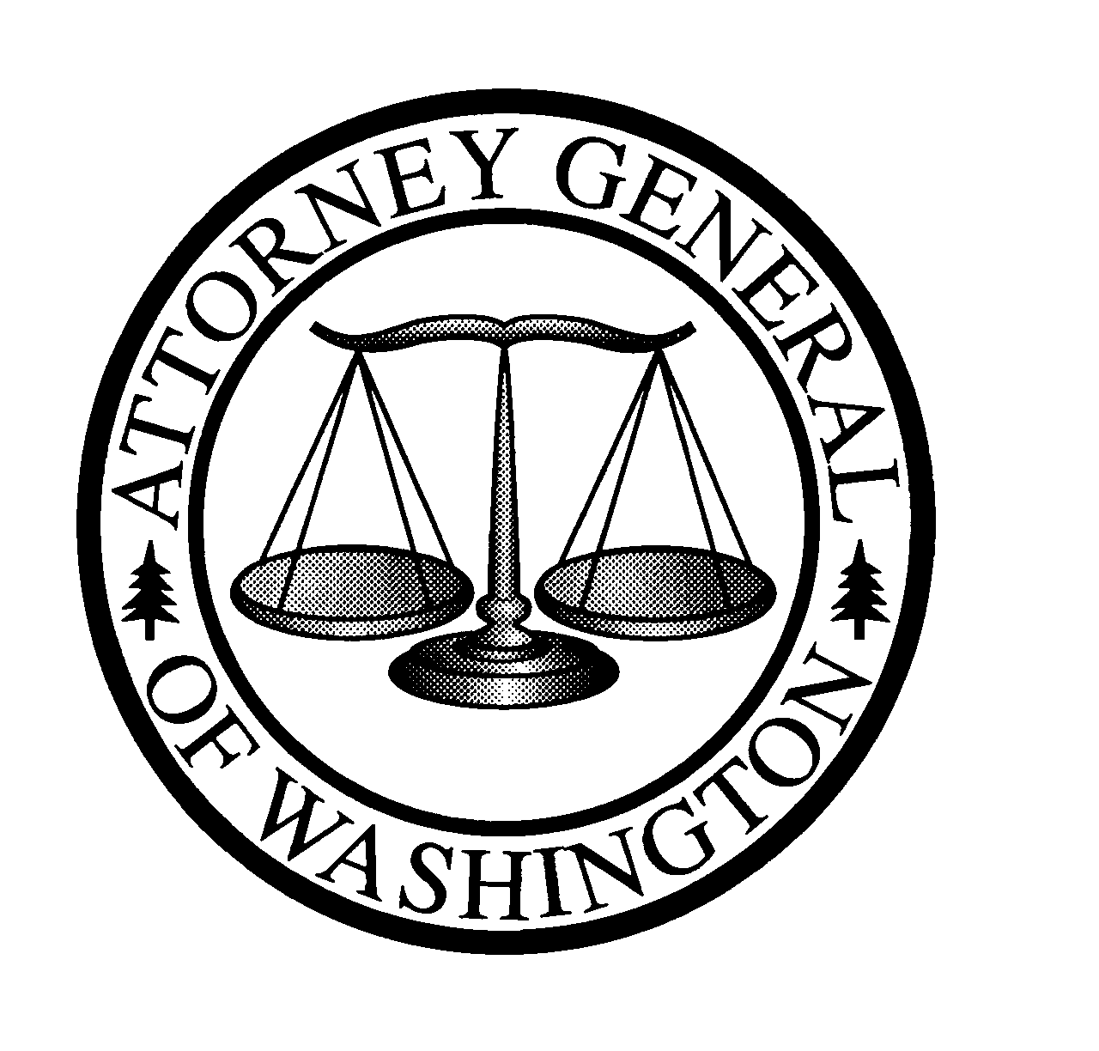
Christine O. Gregoire
ATTORNEY GENERAL OF WASHINGTON
900 Fourth Avenue, Suite 2000 • TB-14 • Seattle, Washington 98164-1012

March 12, 2001

Carole Washburn
Secretary
Washington Utilities and Transportation Commission
1300 S. Evergreen Pk. Dr. S.W.
PO Box 47250
Olympia, WA 98504-7250

Re: Telecommunications Rulemaking, Docket No. UT-990146

Dear Ms. Washburn:

It is Public Counsel’s understanding that at the March 14, 2001 Open Meeting, Commission Staff will ask the Commission to move four draft rules in the telecommunications rulemaking docket (UT-990146) to the CR-102 rulemaking stage. In this letter we provide comments on three of these draft rules, as they appeared on the UTC web site on March 9, 2001. We have no comments on WAC 480-120-131 at this time.

Service Installation Requirements
Two of these draft rules establish standards regarding the installation or activation of basic service (480-120-XXX) and non-basic services (480-120-XXY). Public Counsel supports the current draft of 480-120-XXX, which would establish a more stringent standard regarding completion of installation or activation of basic service than exists under the current rule (WAC 480-120-051). Specifically, we support Commission Staff’s proposal to modify the standard to require local exchange companies (LECs) to complete 95 percent of orders for basic service within five business days, and to complete 100 percent of such orders within 180 days. We also support the proposed draft rule 480-120-XXY, which requires LECs to complete all orders for non-basic services within 180 days of the order, unless the customer requests a later installation date.

We note that these draft rules include provisions that would exempt competitive local exchange carriers (CLECs) from complying with these rules, unless otherwise ordered by the Commission (subsection (3) of 480-120-XXX and 480-120-XXY). Since the vast majority of consumers, particularly residential and small business customers, have little or no choice in their local telephone service provider, Public Counsel believes that it is absolutely essential for the Commission to adopt and enforce standards of service quality for incumbent local exchange carriers (ILECs). In order to attract and keep customers, CLECs will have to provide a comparable level of service. Moreover, the proposed draft rules clearly contemplate that the Commission may order CLECs to comply with these rules. This may be appropriate as more competition develops.

Service Quality Credits (480-120-X08)
Throughout this rulemaking docket, Public Counsel has been supportive of Commission Staff’s proposed new rule, 480-120-X08, which would require LECs to provide customers with service quality guarantees and credits. While we prefer earlier, broader versions of the proposed new rule that included more remedies, Public Counsel continues to support this draft proposed rule, which has been modified since the February 22, 2001 rulemaking workshop. The current draft proposed rule still provides that LECs must issue customer credits when they do not meet the specified due date for installation or activation of services. Under subsection (1) of the current draft, ILECs are required to issue customer credits when orders for the first residential line or first two business lines are delayed beyond five business days from the receipt of the order (unless the customer requests a later due date). Subsection (2) provides that for all other services (orders not subject to the service credits in subsection (1))—the ILEC or CLEC must give the customer a due date, and if the LEC fails to meet that due date, customer credits would apply. Public Counsel strongly supports the language in subsections (1) and (2) of the draft rule that provides that the amount of the credit increases as the order is delayed for an additional week or partial week beyond the due date. We also support the $50 missed appointment credit, as outlined in subsection (3) of the draft proposed rule.

Thank you for your time and consideration of these comments. Matt Steuerwalt of Public Counsel is planning to attend the March 14 Open Meeting and will be available for questions.

Very truly yours,

Simon ffitch
Assistant Attorney General
Public Counsel Section Chief

cc: Glenn Blackmon
Bob Shirley
Tom Spinks
Mary Taylor

