BEFORE THE WASHINGTON
UTILITIES AND TRANSPORTATION COMMISSION

WASHINGTON UTILITIES AND TRANSPORTATION COMMISSION,  Complainant,  v.  3rd generation movers and hauling,  ____________________________________ | )  )  )  )  )  )  )  )  )  )  ) | DOCKET TV-121722  DECLARATION OF  MATHEW PERKINSON

Mathew Perkinson, under penalty of perjury under the laws of the State of Washington, declares as follows:

- I am employed by the Washington Utilities and Transportation Commission (Commission) as a Compliance Investigator in the Transportation Safety Enforcement Section. As a Compliance Investigator, my responsibilities include conducting investigations regarding the business practices of regulated utility or transportation companies. As part of those duties, I investigate regulated household goods companies that may be operating in violation of one or more statutes or rules enforced by the Commission.
- Regulated household goods companies must submit annual reports and file regulatory fees by May 1 of each year. Each year, the Commission distributes an annual report form and a regulatory fee form to facilitate these submissions.
- On February 29, 2012, the Commission mailed an annual report packet to 3rd Generation Movers and Hauling (3rd Generation) at the address on file with the Commission. The packet contained an “annual report form” and a letter from the Commission’s Executive Director and Secretary, David Danner. The annual report form includes a regulatory fee calculation schedule and requires a company to attach other documents as well. A completed annual report form, with the necessary attachments, constitutes a company’s annual report.
- The letter from David Danner explained the annual report and regulatory fee submission requirements. In the letter, Mr. Danner instructed 3rd Generation to return the completed form and pay any regulatory fees by May 1, 2012. The letter further stated that, if the company failed to file a completed annual report and pay regulatory fees by May 1, 2012, the Commission would assess a financial penalty of $100 for each business day after May 1 that the report was not filed and $100 for each business day after May 1 the regulatory fees remained unpaid. Those companies wishing to request an extension to file the annual report were instructed in the letter to do so before April 24, 2012, and to provide a reason for the extension. In addition, the letter advised that Commission Staff would seek revocation of the authority of companies that failed to file an annual report or pay regulatory fees by June 1, 2012. A copy of the letter is attached as Attachment A.
- On May 15, 2012, the Commission sent letters to those companies that had not yet filed their annual reports. 3rd Generation was one of these companies. The letter, signed by David Danner, informed 3rd Generation that, to date, it had incurred a penalty of $900. In the letter, Mr. Danner stated that companies who filed their annual reports no later than May 25, 2012, would receive mitigated penalties of $25 per day. Conversely, the Commission would impose an additional $25 per day for each instance in the previous five years that the company had received a penalty for filing a late report. A copy of the letter is attached as Attachment B.
- 3rd Generation did not file its annual report by May 31, 2012, which is 21 business days past the deadline of May 1. The Commission assessed penalties against the company in the amount of $2,100, in Docket UT-120900. 3rd Generation did not request an extension.
- On December 31, 2012, the Commission issued a complaint for cancellation of permit for failure to pay regulatory fees and failure to file an annual report; and a notice of hearing set for February 4, 2013. 3rd Generation did not appear at the hearing. Given that 3rd Generation failed to file the 2011 annual report or pay the 2012 regulatory fees, Commission Staff recommended that the Commission cancel the permit of 3rd Generation.
- On January 8, 2013, I spoke with Mr. Chris Watkins, the owner of 3rd Generation. He had received the Commission’s notice of hearing and wanted to know how to avoid cancellation of the company’s permit. I explained to Mr. Watkins that, to avoid cancellation of the company’s permit, he would need to file the 2011 annual report and pay the 2012 regulatory fees. I directed Mr. Watkins to the Commission’s website to retrieve the forms and provided contact information to the Commission’s Financial Services department to facilitate payment of the regulatory fees.
- On March 1, 2013, 3rd Generation filed its 2011 annual report and paid the required regulatory fees of $33.60. A copy of the 2011 annual report and a screen-print of the Annual Report Tracking System record showing receipt of the report and payment in full of the regulatory fee are attached as Attachment C.
- On March 1, 2013, in a letter to the Commission, 3rd Generation requested that the company’s permit not be cancelled. Mr. Watkins states,
My name is Chris Watkins. I am the owner of 3rd Generation Movers. I am writing in regards to issue # TV/121722. For the entire year of 2012 I moved my family and my business to Chino California. I did not work in the state of Washington at all in 2012. My address in Chino was 8241 Garden Gate St. Chino, Ca. 91708. (I faxed proof to Matt) I did not receive any mail from you all so I was not aware of the annual report that was required of me, although I put in a change of address. Because of this I also did not know of the hearing that I was supposed to attend this month. My understanding was that I had to send in the annual report no later than 2/28/2013. I am a first time business owner so I am learning and most of these requirements are new to me. I am asking that you all please do not cancel my license for it will require me to reapply all over again and pay the fee and I will be unable to work for a period of time. I no longer live at the Desmoines (sic) address so I do not receive mail there. My current address is 11216 s.e. 235th place. Kent, Wa. 98031. Please contact me with your decision and with any questions that you may have.

A copy of the letter is attached as Attachment D.

- On March 7, 2013, I spoke with Mr. Watkins regarding payment of the $2,100 penalty assessment in Docket TV-120900. Mr. Watkins said he can pay $200 a month, until the balance is paid off, however he is unable to pay the full amount at this time.
- As of April 1, 2013, 3rd Generation has not paid the $2,100 penalty assessment in Docket UT-120900. 3rd Generation was sent a Second Notice on August 29, 2012, and a Final Notice on October 3, 2012. The balance was sent to collections on January 8, 2013.
- Because 3rd Generation has filed its 2011 annual report and paid the required regulatory fees for 2012, Staff’s recommendation regarding this company has changed. Staff now recommends that 3rd Generation’s permit not be cancelled.
DATED this 1th day of April, 2013, at Olympia, Washington.

______________________________________
MATHEW PERKINSON
Attachment A

February 29, 2012

Dear Regulated Company:

Reference: Your 2011 Annual Report and 2012 Regulatory Fees are due May 1

State law requires you to file an annual report and pay regulatory fees to the Washington Utilities and Transportation Commission (UTC).

What is required of you?
By May 1, you must:
- Complete and file one paper copy or electronic version of the enclosed 2011 annual report form
- Pay your 2012 regulatory fees

What happens if you do not file a completed annual report and pay regulatory fees on time?
If you do not file your company’s completed annual report and pay the regulatory fees by May 1, the UTC will assess a financial penalty of $100 for each business day after May 1 that the report is not filed and $100 for each business day after May 1 the fees are unpaid. You may seek mitigation of the penalties in response to the assessment you receive, after you have filed a completed annual report and paid your regulatory fees. The amount of the penalties the UTC mitigates, if any, will depend on the reasons you were late and whether you have filed late in prior years. If you have not filed your completed annual report or paid your regulatory fees by June 1, 2012, Staff will initiate proceedings to have the UTC revoke your authority to operate in Washington.

What happens if you do not pay the regulatory fees by May 1?
If you do not pay your company’s regulatory fees by May 1, you will incur a 2 percent penalty on the amount due and a 1 percent monthly interest charge on the unpaid balance. These amounts apply in addition to the assessment of a penalty of $100 per business day after May 1 that the fees are unpaid.

May you request an extension of time if you are unable to file the annual report or pay your regulatory fees on time?
You may file a written request for an extension to file your completed annual report, but the UTC will not extend the deadline for paying regulatory fees. Any extension request must be filed with the UTC by April 24, 2012, and must state a valid reason for why you need an extension and identify a specific date by which you will file your completed annual report. The UTC will notify you by May 1 whether your request is approved or denied. Even if your request is approved, you will still be liable for penalties and interest payments if you fail to pay your regulatory fees by May 1.

What should you do if your company is no longer operating in Washington?
You may cancel your registration or permit by using the cancellation forms available on our website (see below), but if your company operated in Washington at any time during the 2011 calendar year, you must pay regulatory fees and file a closing annual report based on the months of operation during 2011 even if you cancel your registration or permit.

May you designate any information in your annual report as confidential?
Yes, but if you satisfy two conditions:

- You are eligible to request confidential treatment only if your company is regulated under Title 80 RCW, that is, if you operate an electric, natural gas, telecommunications or water company. Transportation companies, regulated under Title 81 RCW, may not request confidential treatment of documents because the authority for such treatment is found only in RCW 80.04.095. If a Title 81 company files its annual report or fee sheet as confidential, the UTC will not treat it as confidential.

- You must follow the steps for filing confidential documents in WAC 480-07-160. You may find this rule at the UTC website, www.utc.wa.gov/annual reports.

Please note: The regulatory fee sheet portion of your report is not a confidential document and will not be accorded confidential treatment under the rule. The UTC will not, however, disclose credit card information you list on the fee sheet.

May you perform some of these tasks online?
Yes. You may complete the following tasks from the annual reports page at the UTC website www.utc.wa.gov/annualreports:

- Obtain electronic versions of annual report forms
- Pay regulatory fees
- File your report electronically
- Cancel your registration (telecommunications companies) or permit (transportation companies) if your company ceased operations in 2011.

Where do you mail the completed annual report form and regulatory fee payment?
Washington Utilities and Transportation Commission
PO Box 47250
Olympia, WA 98504-7250

Is there any additional information you should file?
- If you are a gas distribution company, please also file both a paper and electronic copy of your Federal Energy Regulatory Commission Form 2.
- If you are an electric company, please also file both a paper and electronic copy of your Federal Energy Regulatory Commission Form 1.
- If you are a class 1 Railroad, please also file a copy of your Surface Transportation Board Form R-1 - including statistics specific to the state of Washington.

If you have questions about any aspect of your report or regulatory fee, please contact Rae Lynn Carnes at (360) 664-1152 or rcarnes@utc.wa.gov.

If you need this letter or an annual report form in an alternate format, please call 360-664-1243. The TTY Toll-Free phone number is 1-800-416-5289.

Sincerely,

David W. Danner
Executive Director and Secretary

Enclosures
Attachment B
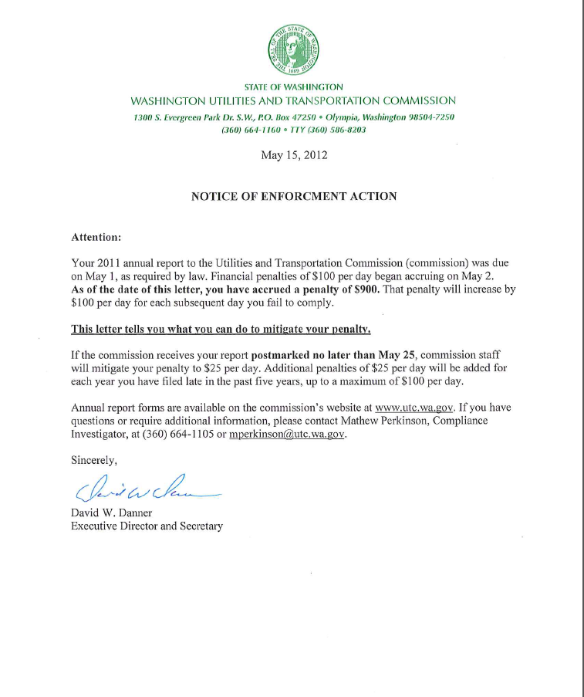

Attachment C
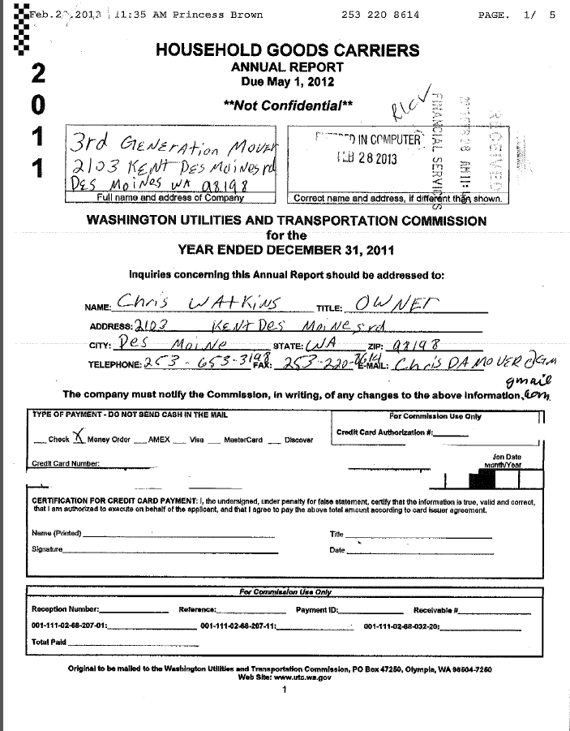
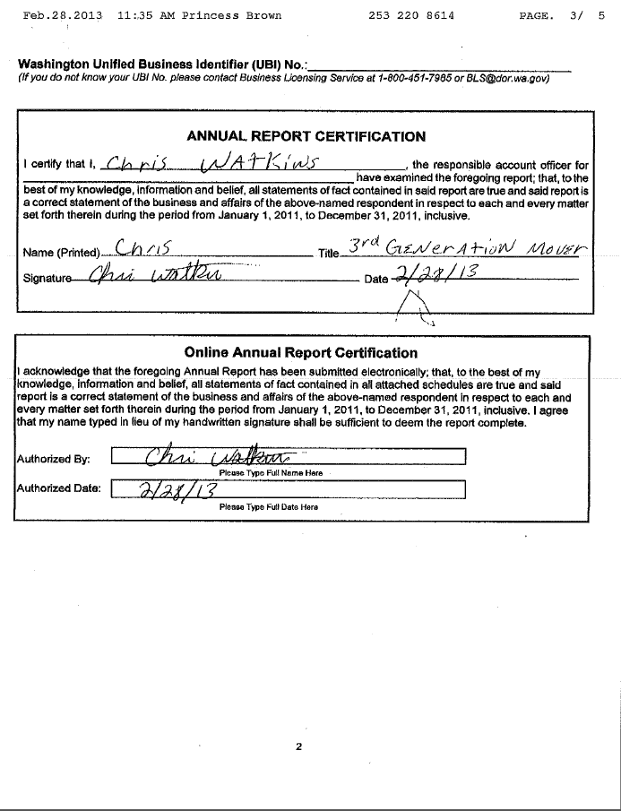
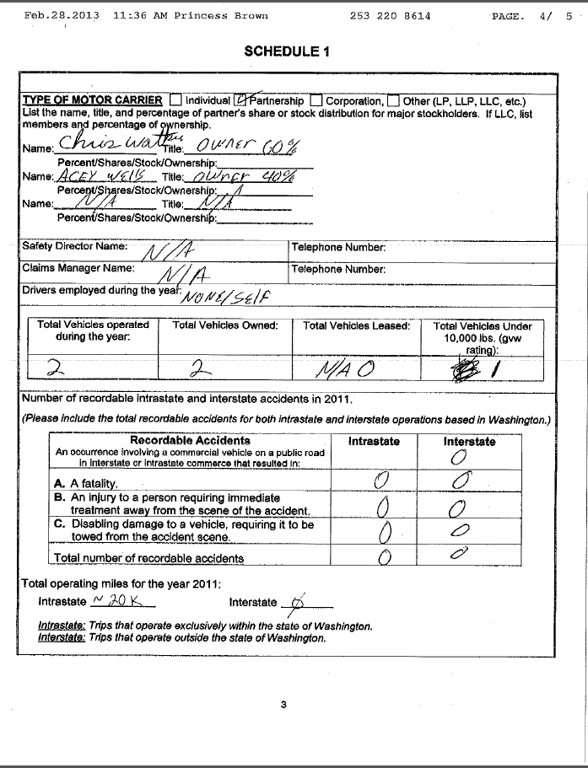
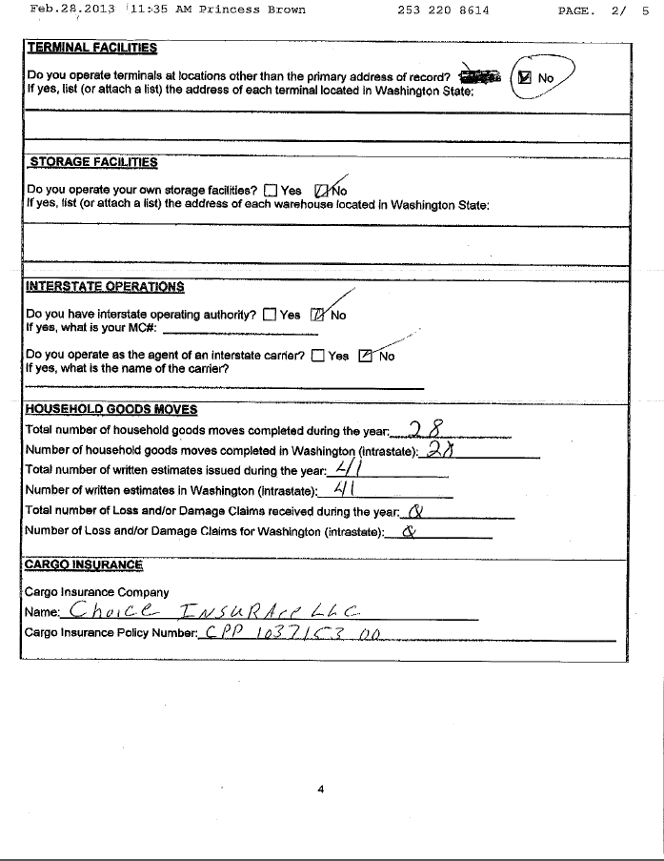
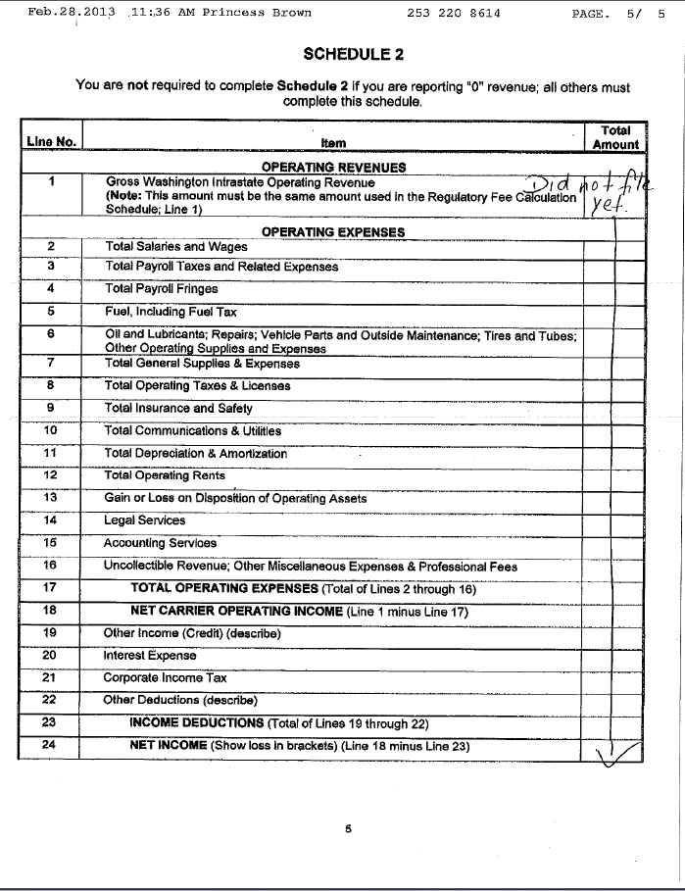
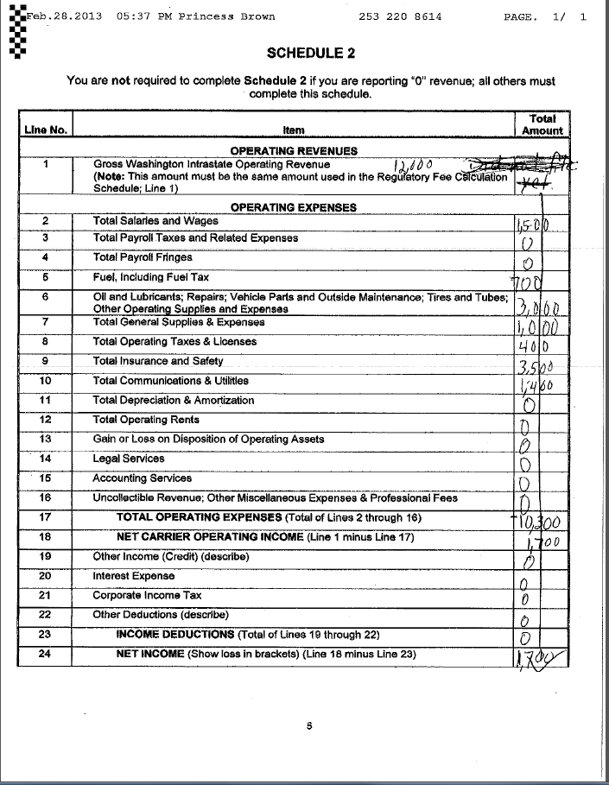
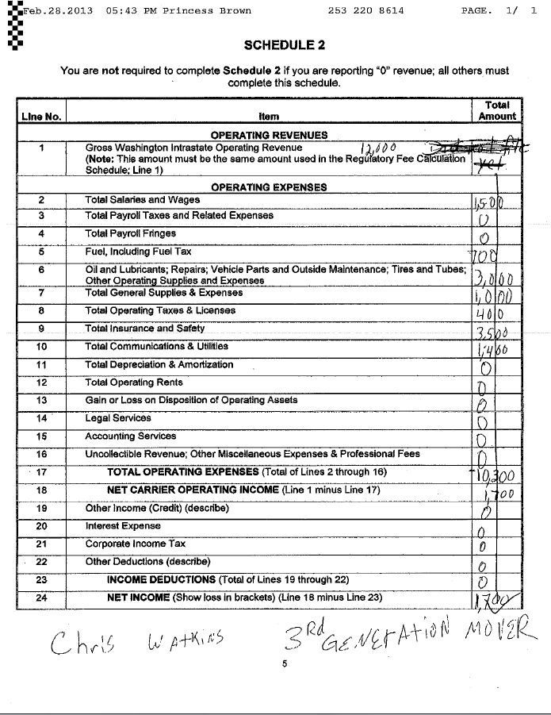
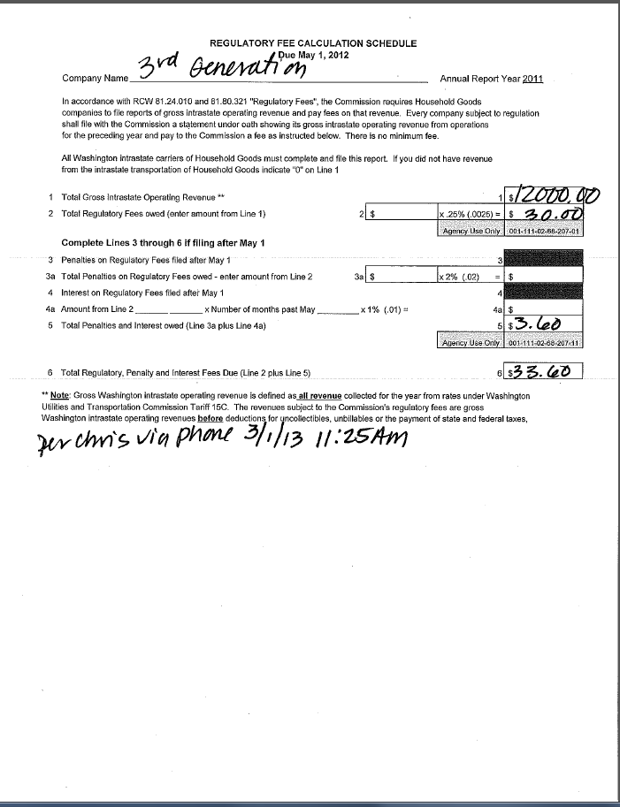
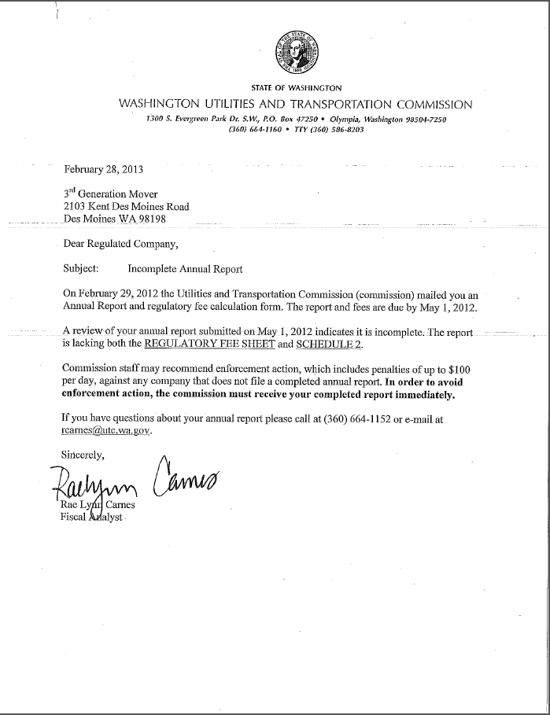
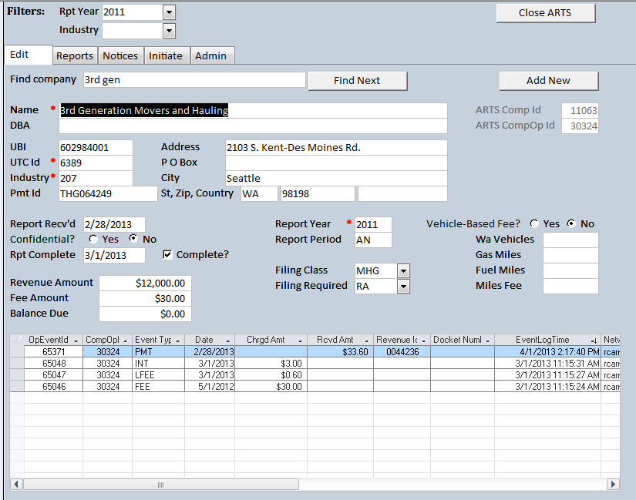
Attachment D
