Agenda Date: August 28, 2008
Item Number: A4

Docket: UW-081416
Company Name: Aquarius Utilities, LLC

Staff: Chris Mickelson, Regulatory Analyst
Dennis Shutler, Consumer Protection Staff

Recommendation

Issue an order granting Aquarius Utilities, LLC’s request for a surcharge to service $2,056,214 in Drinking Water State Revolving Fund loans approved by the Public Works Board, subject to conditions (a) through (h) set forth below.

Introduction

On July 29, 2008, Aquarius Utilities, LLC (Aquarius or company), filed with the Utilities and Transportation Commission (commission) a surcharge to service $2,056,214 in Drinking Water State Revolving Fund (DWSRF) loans approved by the Public Works Board (PWB). Proceeds from the loans will be used for capital improvement projects on each of the company’s four water systems. The company serves 880 customers located in Clallam, Kitsap and Mason counties.

Proposed Surcharge Rate Schedule

Time Period | Proposed Surcharge Rate

Monthly Surcharge
September 15, 2008 – December 31, 2008 | $4.00 per month
January 1, 2009 – December 31, 2028  * Or until the loans are paid in full, whichever occurs first. | $8.70 per month
One-time payment  (Within 30 days of filing approval.) | $1,639.14 one-time

The loan contracts are low interest (1.5 percent), 20-year loans approved by the PWB on condition that, prior to September 9, 2008, Aquarius obtains commission approval of rates to repay the loans. This surcharge filing, if approved, meets that condition.

Although the proposed surcharge is scheduled to become effective September 15, 2008, staff recommends the commission take action at this open meeting, to ensure the commission acts prior to the next PWB board meeting scheduled for September 9, 2008.

Background

The DWSRF loan program provides low-interest loans to water systems around the state for capital improvements that increase public health protection and compliance with drinking water regulations. The Department of Health (DOH) and the PWB jointly administer the DWSRF program. The DOH staff evaluates all loan applications and, using a scoring method designed to measure the health risk that each project will address, assigns points to each application. The applications are then ranked according to their scores.

The PWB staff determines the available funding for each annual loan cycle, and the ranked project list shows this funding cutoff. Projects below the funding cutoff line do not receive funding. The Public Works Board approves the final recommended funding list each spring. PWB staff also conducts an underwriting and readiness-to-proceed evaluation of each approved loan project.

DOH is responsible for evaluating and approving Water System Plans (WSP) or Small Water System Management Programs (SWSMP), which are a requirement for both the DOH and DWSRF loan projects. DWSRF loan projects must be included in a WSP or SWSMP. In addition, the DOH evaluates and approves the project reports and construction documents for all DWSRF-funded loan projects.

In May of 2007, Aquarius applied to DOH for five separate DWSRF loans. Four applications were to build new storage tanks at each of its four water systems, and to improve or upgrade existing storage tanks, including miscellaneous improvements such as booster pump stations, additional water supply, transfer switches and security system upgrades. We refer to these projects as the “storage tank” projects. The fifth application was to replace pipe on the Diamond Point water system. All five projects are included in the company’s WSP that the DOH approved.

Some Diamond Point (DP) customers disagree with the company’s WSP, believe that they did not have sufficient opportunity to participate in the planning process, and believe that the DOH improperly approved the WSP. The DOH has exclusive control over the WSP process. Staff has consistently advised customers that the commission has no role in the WSP planning process or the DOH approval process, and advised customers to work with the DOH on those issues.

The four storage tank projects ranked high enough to receive funding from the PWB. The PWB made the loan approvals subject to the condition that, prior to September 9, 2008, Aquarius obtains commission approval of rates to repay the loans.

The pipe replacement project qualified for funding, but did not rank high enough to receive funding. The scoring method includes five different health-risk categories. Pipe replacement projects fall in the lowest risk category. The PWB encouraged the company to refile its application next year, when that project might rank high enough to receive funding. The company could also seek a commercial loan that would carry a significantly higher interest rate (e.g., 8 percent instead of 1.5 percent) and likely have a shorter repayment term (e.g., 10 years instead of 20 years).

Some DP customers believe that the pipe replacement project is more important than the storage tanks and disagree with the scoring and ranking process. Again, as stated above, the DOH and the PWB have jurisdiction over those issues, not the commission. Staff has consistently advised customers to work with the DOH and the PWB on these issues.

On May 23, 2008, the company filed a general rate increase with the commission in Docket UW-080926 that would generate $106,055 (24.6 percent) in additional revenue per year. The company provided the PWB staff with the financial information that the company used to support its proposed general rate increase. The PWB staff concluded that, if the commission approved the proposed rates, the company would have sufficient revenue to repay the DWSRF loans.

Commission staff’s review of the company’s operations and financial records indicated that the company’s proposed rates were excessive. That financial data did not include any debt or expenses related to the DWSRF loans. Staff and the company agreed to a revised revenue requirement and a revised rate design. On July 1, 2008, the company filed revised rates at the staff recommended level that would generate $31,584 (7.3 percent) in additional revenue per year. At its July 10, 2008, open meeting, the commission approved the revised rates to become effective July 14, 2008, on a temporary basis, subject to refund.

After the commission’s open meeting, staff advised the PWB staff that the commission had approved lower rates on a temporary basis, subject to refund, and provided the PWB staff the revised financial information related to the 7.3 percent revenue increase. The PWB’s staff reviewed the revised financial information and concluded the rates would not generate sufficient funds to allow the company to repay the DWSRF loans.

Commission staff and the PWB staff worked with the company to file the proposed surcharge in this docket, which the company filed on July 29, 2008.

Customer Comments

On July 29, 2008, the company notified its customers of the surcharge by mail. The commission has received 51 customer comments (six in support, 45 opposed) on this filing as of August 27, 2008. Staff’s summary of the comments received and staff’s response are attached.

Some customers object to the Single Tariff Pricing method of setting uniform rates for all customers on all water systems. They correctly point out that method does not treat all customers equally in all circumstances. Single Tariff Pricing distributes costs incurred on one system to all customers on all systems. All systems will require additional investment. The only questions are: “How much?” and “When?” Staff remains convinced that Single Tariff Pricing results in fair, just, reasonable and sufficient rates over the long term. The following table illustrates the rates that customers would pay for the DWSRF loans on a stand-alone basis and under Single Tariff Pricing.

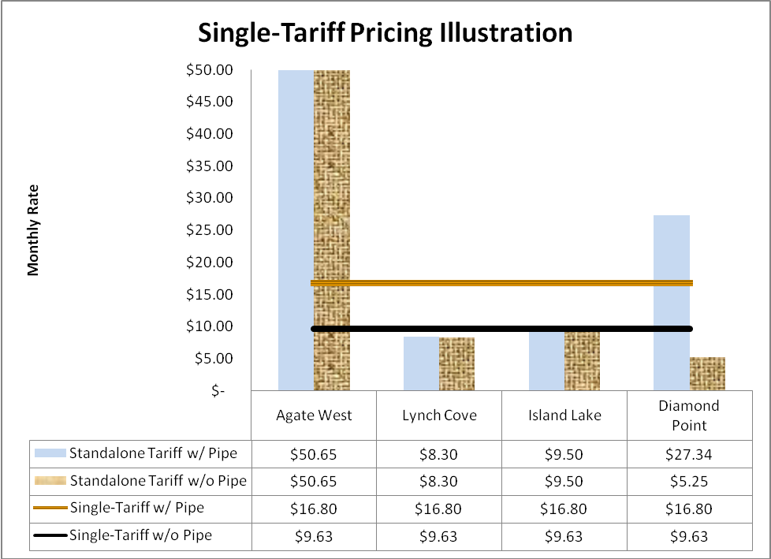

Note: This table shows calculations using the total amount of the DWSRF loan applications. The proposed surcharge to serve the four storage projects is $8.70, not $9.63, because a portion of the loan will be paid using facilities charges and owner equity.

Discussion

Some customers oppose or disagree with the DOH and the PWB processes and decisions that led to the PWB approving the loan applications for the four storage tank projects. As explained above, the commission does not have jurisdiction over those matters. Customers need to address their concerns to the DOH and the PWB.

The commission’s jurisdiction in this matter is limited to setting rates. Staff believes that the relevant questions before the commission are as follows:
- Are the proposed projects prudent investments?
- Is the proposed surcharge fair, just, reasonable and sufficient?

Staff believes all five projects that Aquarius filed for DWSRF loans are prudent investments. The DOH has primary jurisdiction regarding water quality and quantity issues, including water system design, construction and maintenance. All five projects are included in the company’s long-term WSP that the DOH has reviewed and approved. The DOH has reviewed, scored, and ranked all five DWSRF loan applications, including project reports and construction documents. The PWB staff reviewed all five applications to determine the company’s ability to repay the loans. All five projects qualify for DWSRF funding. The DOH concludes the proposed projects are necessary for the company to meet water quality and quantity standards. Staff finds no basis to conclude that the proposed projects are not prudent.

Staff believes that disagreement regarding project priorities is different from prudency of investment and is not relevant to the commission’s decision in this matter. Staff believes the DOH and the PWB concluded that all five projects are prudent investments. The DOH and the PWB review process resulted in different scores for those projects and different priorities for receiving funding. Disagreement over the project priorities does not change the prudency of the investments, especially in this case, where the PWB loans are tied directly to the storage tank projects and cannot be diverted to the pipe replacement project.

Staff has reviewed the company’s supporting financial documents, books and records, including the cost estimates for the proposed projects and the terms and conditions of the DWSRF loans. Staff believes the low-interest, long-term DWSRF loans are excellent funding options for both the customers and the company, and that the proposed surcharge is fair, just, reasonable and sufficient.

The company’s DWSRF loan repayment proposal relies on three revenue sources: monthly surcharges paid by current and future customers, facilities charges paid by future customers and future equity investment by the owner. To ensure that the company has sufficient revenue to service the four DWSRF loans, and because the revenue streams from the unknown future customers and future owner investment are not certain, Staff recommends that, if the commission approves the surcharge, its approval should be subject to the following conditions:

- This surcharge is to apply to all water customers served by the company. This surcharge will expire on December 31, 2028, or upon recovery of $2,056,214 in principal, whichever occurs first.

- Funds received from the surcharge, including interest earned on the funds while held in a reserve account, will be treated as contributions in aid of construction.

- All future funds received through the company’s facilities charge (current tariff and contracts), including any interest earned on the funds while held in a reserve account, will be used to pay the four DWSRF loans until this surcharge expires.

- Surcharge funds and facilities charge funds collected and interest earned upon such funds must be held in a separate DWSRF loan reserve bank account by the company for the benefit of customers. Such funds do not become the property of the company or company owners and may not be disbursed, alienated, attached, or otherwise encumbered by the company or its owners. In the event of a sale or transfer of the company, the trust obligations established in WAC 480-110 regarding any unspent surcharge or facilities charge funds will be transferred to the new owner of the company.

- The owner will invest a minimum of $10,000 annually by July 1 of each year, beginning in 2009, and every year thereafter, until this surcharge expires. These funds will be held in the same DWSRF loan reserve bank account specified in condition (d) above. Additional owner’s equity investment may be required to make the annual DWSRF loan payment, if revenue from the surcharge and the facilities charges is inadequate.

- The water company must report the following DWSRF loan reserve bank account information to the commission within 45 days of the end of the calendar quarter:

  - Beginning balance;
  - Amounts received, detailed by source;
  - Amounts spent, detailed by project or expense;
  - Ending balance;
  - Reconciliation of bank balance to general ledger.

- The company will immediately deposit one-time payments in the same DWSRF loan reserve bank account specified in condition (d) above.

- After 2014, excess funds held in the DWSRF loan reserve bank account will be remitted annually, at the time of the annual loan payment, to be applied to the principal of the DWSRF loans. “Excess funds” means money accumulated in the reserve account in excess of 10 percent of the DWSRF loan payment for the following year.

Conclusion

Staff concludes that the proposed projects are prudent investments to ensure the company can continue to provide safe and reliable drinking water that meets federal and state requirements. Staff has completed its review of the company’s supporting financial documents, books and records. Staff’s review shows that the expected expenses for the proposed projects are reasonable and required as part of the company’s operations. The company’s financial information supports the proposed surcharge request and the proposed surcharge is fair, just, reasonable, and sufficient.

Staff recommends the commission issue an order granting Aquarius Utilities, LLC’s request for a surcharge to service $2,056,214 in Drinking Water State Revolving Fund loans approved by the Public Works Board, subject to conditions (a) through (h) set forth above.

Attachment

