EXHIBIT NO. ___(SA-1CT)
DOCKET NO. UE-11___/UG-11___
2011 PSE GENERAL RATE CASE
WITNESS: SALMAN ALADIN

BEFORE THE
WASHINGTON UTILITIES AND TRANSPORTATION COMMISSION

WASHINGTON UTILITIES AND  TRANSPORTATION COMMISSION,  Complainant,  v.  PUGET SOUND ENERGY, INC.,  Respondent. |  | Docket No. UE-11____  Docket No. UG-11____

PREFILED DIRECT TESTIMONY (CONFIDENTIAL) OF
SALMAN ALADIN
ON BEHALF OF PUGET SOUND ENERGY, INC.

REDACTED
VERSION

JUNE 13, 2011
PUGET SOUND ENERGY, INC.
PREFILED DIRECT TESTIMONY (CONFIDENTIAL) OF
SALMAN ALADIN
CONTENTS
I. INTRODUCTION 1
II. VOLATILITY AND RISK IN PSE’S ELECTRIC AND NATURAL GAS RESOURCE PORTFOLIOS 3
III. MODELING THE POWER COST RISKS OF PSE’S ELECTRIC PORTFOLIO 7

PUGET SOUND ENERGY, INC.
PREFILED DIRECT TESTIMONY (CONFIDENTIAL) OF
SALMAN ALADIN

I. INTRODUCTION
Q. Please state your name, business address, and position with Puget Sound Energy, Inc.
A. My name is Salman Aladin. My business address is 10885 N.E. Fourth Street Bellevue, WA 98004. I am the Director of Structuring, Asset Optimization and Analytics for Puget Sound Energy, Inc. ("PSE" or "the Company").
Q. Have you prepared an exhibit describing your education, relevant employment experience, and other professional qualifications?
A. Yes, I have. It is Exhibit No. ___(SA-2).
Q. What are your duties as Director of Structuring, Asset Optimization and Analytics for PSE?
A. My responsibilities include oversight of the Structuring and Asset Optimization and Portfolio Analytics Departments. These departments engage in ongoing modeling and analyses that help the Company better optimize its electric and natural gas portfolios in the medium-term through wholesale power and natural gas market purchases and sales.
Q. What is the nature of your testimony in this proceeding?
A. This testimony is in response to the final order in PSE’s 2009 general rate case that requires the parties
to examine in PSE’s next general rate case, or in another suitable proceeding, the questions whether there are asymmetrical risks in the distribution of power costs that may affect the sharing of risks and benefits accomplished by the PCA sharing bands. It seems particularly appropriate that the Commission should hear more on this question in the future given the Company’s 2007 study concerning the balance between risk and benefits associated with deviations from baseline power costs and how it should properly be considered in the design of the PCA and its sharing bands.
Docket Nos. UE-090704 and UG-090705 (consolidated), Order No. 11, at ¶118.
The purpose of the testimony is to address whether there are asymmetrical risks in the distribution of power costs that may skew the sharing of risks and benefits accomplished by the PCA sharing bands.
To address this, my testimony first describes the challenges facing the Company in managing its electric and natural gas portfolios as well as the cost of the power and natural gas consumed by PSE’s customers. I focus in particular on the significant volatility and risk inherent in the Company’s electric portfolio due to factors such as streamflow variation affecting the supply of hydroelectric generation and weather uncertainty affecting load that make it very difficult to predict the amount of power PSE’s resources will produce or the amount of power PSE’s electric customers will use.
I describe modeling work the Company has performed in order to better understand the magnitude of potential variations in power costs above or below a baseline power cost rate that is projected at the time of a rate case and embedded in PSE’s electric rates. I describe the skewed nature of power costs and how that impacts the risk faced by customers and PSE.

II. VOLATILITY AND RISK IN PSE’S ELECTRIC AND NATURAL GAS RESOURCE PORTFOLIOS
Q. Is energy risk management a concern to the Company?
A. Yes, absolutely. PSE’s resource portfolio is subject to significant volatility and risk that can ultimately have a substantial impact on the Company’s energy costs. For this reason, PSE has an entire area of the Company devoted to energy risk management.
Q. What drives volatility and risk in the power portfolio?
A. PSE’s power supply portfolio contains a diverse mix of resources with widely differing operating and cost characteristics. Mr. David Mills describes PSE’s power supply portfolio in his prefiled direct testimony, Exhibit No. ___(DEM-01CT). Although there are many complex variables embedded in the portfolio, the major drivers of power cost volatility are: (1) streamflow variation affecting the supply of hydroelectric generation; (2) weather uncertainty affecting power usage and wind generation; (3) variations in market conditions such as wholesale gas and electric prices; (4) risk of forced outages; and (5) transmission and transportation constraints. All of these create load, resource and ultimately cost volatility. Mr. David Mills describes each of these areas in more detail in Exhibit No. ___(DEM-01CT).
Q. Are PSE’s power and gas costs subject to other risks?
A. Yes, examples of other risks include:
- counterparty risk, which is the risk of default by PSE’s counterparties on contractual obligations; and
- execution risk, which is the ability to execute wholesale market transactions. Market liquidity, counterparty credit requirements and contractual requirements are examples of execution risk.
Q. How has the Commission dealt with PSE's power cost volatility?
A. In response to significant price volatility, uncertainty in the wholesale energy markets and PSE’s need to add resources to meet its load obligations, the parties to PSE's 2001 general rate case who participated in the Power Cost Adjustment Collaborative agreed to a negotiated Power Cost Adjustment ("PCA") Mechanism. The PCA Mechanism set forth an annual accounting process for a sharing of costs and benefits between PSE and its customers over four graduated levels (so-called "bands") of power cost variances on the first $120 million of power cost variances. The Commission approved the PCA Mechanism in its Twelfth Supplemental Order, Docket Nos. UE-011570 and UG-011571 on June 20, 2002.
Q. Please describe the PCA bands.
A. The PCA Mechanism has a deadband of plus or minus $20 million, and annual sharing bands as shown below.

PCA Bands | Power Cost Imbalance ($ in millions) | % of Customer’s Share | % of Company's Share
Deadband | $0 - $20 +/- | 0% | 100%
Second Band | $20 - $40 +/- | 50% | 50%
Third Band | $40 - $120 +/- | 90% | 10%
Fourth Band | > $120 +/- | 95% | 5%

The PCA bands are symmetric, meaning that the PCA bands designated for allocation of costs resulting from under-recovery of power costs are identical to the bands designated for allocation of benefits resulting from over-recovery of power costs. As will be discussed below, in contrast to the symmetry of the PCA sharing bands, the power cost imbalance as a whole is asymmetric.
Q. What has been PSE’s experience with the PCA Mechanism since it was implemented?
A. PSE’s power costs exceeded the amounts recovered through the Power Cost Baseline Rate five out of the nine PCA periods as shown in the following chart:
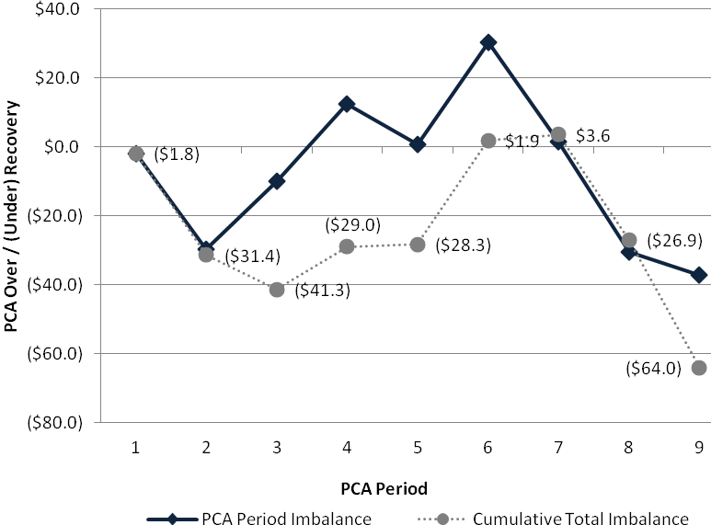
From the inception of the PCA to December 31, 2010, power costs have been under-recovered by $64.0 million in total. PSE’s share has been $50.5 million and the customers’ share has been $13.4 million. The primary drivers of this under-recovery were variations in hydro, wind, prices and load from the assumptions in the PCA Power Cost Baseline Rates.
Q. To what degree does hydro impact power cost volatility?
A. Because PSE's rates are set assuming that water conditions will be "normal" (based on the average of a 50-year or 70-year data set), when hydro conditions inevitably turn out to be higher or lower, it impacts PSE's actual power costs. In general, "dry" years increase power costs such that they are typically under-recovered, while "wet" years decrease power costs such that they are typically over-recovered.
As shown in the chart below, during PCA periods 1-9, the years with lower than "normal" hydro conditions primarily produced excess power costs. During the 2 ½ year period encompassing PCA periods 4, 5 and 6, higher than "normal" hydro conditions produced power cost savings. 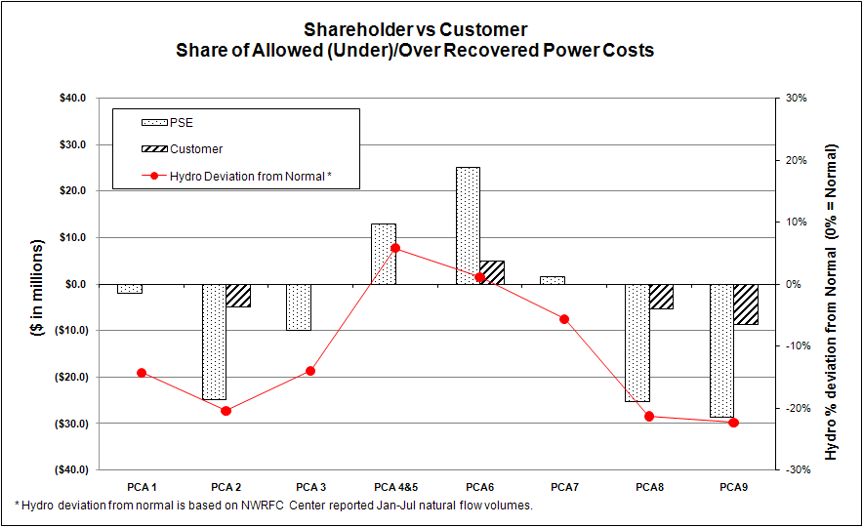

III. MODELING THE POWER COST RISKS OF
PSE’S ELECTRIC PORTFOLIO
Q. How did the Company approach the project of modeling the magnitude of power cost risks associated with PSE’s electric portfolio?
A. PSE sought to develop a methodology for modeling power cost risk associated with its electric portfolio that would be transparent to other parties and would incorporate to the extent possible techniques and methodologies that had been approved in prior Commission proceedings.
Q. How did the Company conduct the modeling?
A. PSE started with the AURORA model because it is familiar to the Commission and other parties. The AURORA model is a fundamentals-based hourly production cost model that relies on factors such as supply resources and regional demand for power and transmission to simulate competitive wholesale power markets. AURORA simulates, on an hourly basis, economic dispatch of the regional fleet of generating resources to meet regional electric loads, based on input fuel prices, other variable operating costs, inter-regional transmission limitations and other factors. AURORA thereby produces a forecast of the variable operating costs for the Company’s generating resources, as well as a forecast of wholesale power prices.
For its modeling project, PSE utilized the Monte Carlo feature of AURORA that permits AURORA to run many different simulations by adjusting the base case input data in AURORA databases for hydro availability, fuel prices and load.
Q. What assumptions did the Company input into AURORA as a starting point for its Monte Carlo simulation?
A. The Company used the AURORA databases from the 2009 general rate case filing as the basis for the analysis. The commission and other parties have reviewed and are familiar with the AURORA databases from PSE's 2009 general rate case filing. With respect to the hydro input, the Company used the average of the 50-year set of data from 1929 to 1978 that was used in the 2009 general rate case. For natural gas prices, the Company used actual spot natural gas prices from April 2010 to March 2011. All power cost and other results included in these analyses were for the 2009 general rate case rate year period of April 2010 through March 2011. It is important to note the purpose of this analysis is to look at the variability and asymmetry in the over or under-recovery of power costs due to load, weather, price, and hydro variability. In addition to the aforementioned factors, the actual over or under-recovery of power costs can vary due to other factors including, but not limited to changes in contract costs, true-ups, third party budgets, and load due to economic conditions.
Q. What did the Company do next?
A. A Monte Carlo risk file was developed to represent the variability and risks of the Company’s power supply portfolio. The input distribution and variability data included in this file are based on an historical assessment of the distributions, variability, and correlations of historic hydro availability, gas prices, and Company loads. The hydro risk data is based on the 50-year hydro data used in PSE's 2009 general rate case. The gas price risk inputs are based on actual gas prices over the August 2001 – March 2011 period.
To generate load scenarios, the Company used the 250 simulations generated by the Company’s energy risk management system, PowerSimm. PowerSimm incorporates temperature data from 1948 to 2010 and historical loads to derive these simulations. From these 250 scenarios, the standard deviation and correlation for each month was calculated and used as input parameters for the AURORA run.
Q. What were the results of the AURORA Monte Carlo modeling?
A. The AURORA Monte Carlo simulation feature produced 500 simulations. Following is a chart showing the distribution of PSE’s electric portfolio power cost over or under-recoveries (“imbalance”) before hedging derived from these 500 simulations using the 2009 general rate case final baseline rate of $64.387 where the expected power cost imbalance is set at $0.
REDACTED
VERSION
The chart above demonstrates that the potential outcomes of over or under-recovered power costs before hedging are not distributed symmetrically. Rather, the outcomes are skewed with a higher likelihood for the occurrence of over-recovery of power costs. While there are more scenarios where an over-recovery of power costs occurs, the magnitude of dollars in the under-recovered scenarios is greater than the over-recovered scenarios.
Q. How does PSE's experience with the PCA compare to the results discussed above?
A. Although the study shows a higher likelihood for the occurrence of over-recover of power costs, PSE's experience since 2002 has been just the opposite.
Q. Has the Company approached modeling power cost risks in other ways?
A. Yes. The Company studied the extent to which hydro variability drives the skewed power cost imbalance. A key question in regards to hydro was: If hydro variability could be perfectly forecasted, to what extent would that eliminate the skew in the distribution of the power cost imbalance?
Q. Was the Company able to answer that question?
A. Yes. To run the initial 500 simulations in AURORA, a risk file was set up that contained specific parameters for hydro. To run the 500 simulations without hydro risk, these inputs were simply set to zero, thereby defaulting to the use of average hydro conditions in each simulation.
Q. What were the results of the hydro modeling?
A. The Company found that neither the skewed nature of the distribution nor the fat tails of the imbalance were significantly affected when hydro variability was removed. A side by side comparison is illustrated below:
Q. Are these results expected?
REDACTED
VERSION
A. It may seem surprising that elimination of hydro risk does not more significantly reduce the potential volatility or skewed distribution in the over or under-recovery of power costs. Much of the skew and volatility is explained by factors other than hydro, such as changes in load, weather, and fluctuations in natural gas and power market prices. For this reason, hydro filtering mechanisms, which have been proposed in the past, are not an effective means for addressing the skewed power cost imbalance.
Q. To what degree does the Company’s hedging program impact power cost volatility?
A. Layering in the gas and power hedges approved in the 2009 general rate case narrows the distribution of the power costs thus reducing the magnitude of potential over or under-recoveries and decreases the skew in the distribution of power cost imbalances. The likelihood of either an under-recovery or an over-recovery within the +/- $20,000,000 band increases so there are more scenarios that have imbalances which are entirely borne by the Company. The chart below depicts the narrower, and less skewed distribution.
REDACTED
VERSION
Q. To what extent can the Company address the skew that exists within the power cost imbalance?
A. The Company’s hedging program, which reduces price volatility for customers and the Company, also reduces the skew in the distribution of the over or under-recovery of power costs. Before hedges, this analysis shows a higher likelihood for the occurrence of over-recovery of power costs for the power cost imbalance as a whole and within the deadband. After hedging, the distribution is narrowed and the skew is reduced. In fact, the analysis with hedges included shows an almost even number of occurrences between under-recovery and over-recovery throughout the entire power cost imbalance distribution. However, within the deadband there are more occurrences of under-recovery than over-recovery with the hedges.
Q. Can you elaborate on how the Company's hedging program affects the skew of the power cost imbalance within the PCA bands?
A. The table below shows the likelihood of the power cost imbalance ending up in the different PCA sharing bands, both before and after hedging.
REDACTED
VERSION

As previously discussed, the hedging program narrows the distribution of power costs and reduces the skew so that it exists primarily within the deadband. The likelihood for under-recovery in the deadband is ██ percent while the likelihood of over-recovery in the deadband is only ██ percent. It is the Company, not the customer that bears the higher risk of under-recovery within the deadband.
The deadband is an important area of focus because there is no sharing of risks or benefits by the customer within this $40 million band around the power cost baseline, as there is in the outer bands. Thus, any asymmetry within the deadband has more impact than the asymmetry outside the deadband. In contrast to the deadband, in the Second sharing band, any power cost imbalance is shared 50/50 between the Company and Customer so any skew is shared evenly and interests are aligned. The number of occurrences in the Third and Fourth sharing bands, where the Customer’s share is 90-95%, is significantly reduced once hedges are included.
Q. Can the skew in the deadband change over time?
A. Yes. The skew can change from an under-recovery to an over-recovery and vice versa based on factors that impact the overall portfolio. The direction of the skew towards either under-recovery or over-recovery, and the magnitude of the skew depends upon underlying variables that change frequently, including but not limited to market prices, market conditions, asset mix, load and hydro. If the deadband skew inverts, which could occur with new time periods and assumptions, then the Company would have a greater likelihood for occurrences of over-recovery of power costs within the deadband.
Q. Should the deadband be adjusted to address the asymmetry of the power cost imbalance?
A. While adjusting the PCA sharing bands could address the asymmetry seen in PSE’s portfolio at this point in time, the Company does not recommend this approach given that the asymmetry can and will change as the portfolio changes. If the deadband was adjusted it would be necessary to run the analysis during each rate proceeding as the skew can change frequently. If the deadband was set based on an under-recovery and the skew changed to an over-recovery over time without being reset, the sharing of risk would be even more skewed than if the current PCA mechanism was retained. The same would be true if the deadband was set based on an over-recovery and over time the skew changed to an under-recovery without the deadband being reset. Forcing the PCA bands to incorporate the current asymmetry would require constant updates to the sharing bands.
Q. Is the Company proposing to change the PCA Mechanism?
A. No, the Company is not proposing a change to the PCA Mechanism. There are times when the under-recovery and over-recovery of power costs occur; however, there has been no need to adjust rates based on the over or under recovery of costs. The bands as implemented provide a benefit to both the customer and the Company.
Q. Does this conclude your testimony?
A. Yes, it does.

There are several flaws with hydro filtering, which make it inappropriate to use with the PCA Mechanism. Because hydro filtering is outside the scope of this testimony, the flaws are not discussed further in this testimony.

