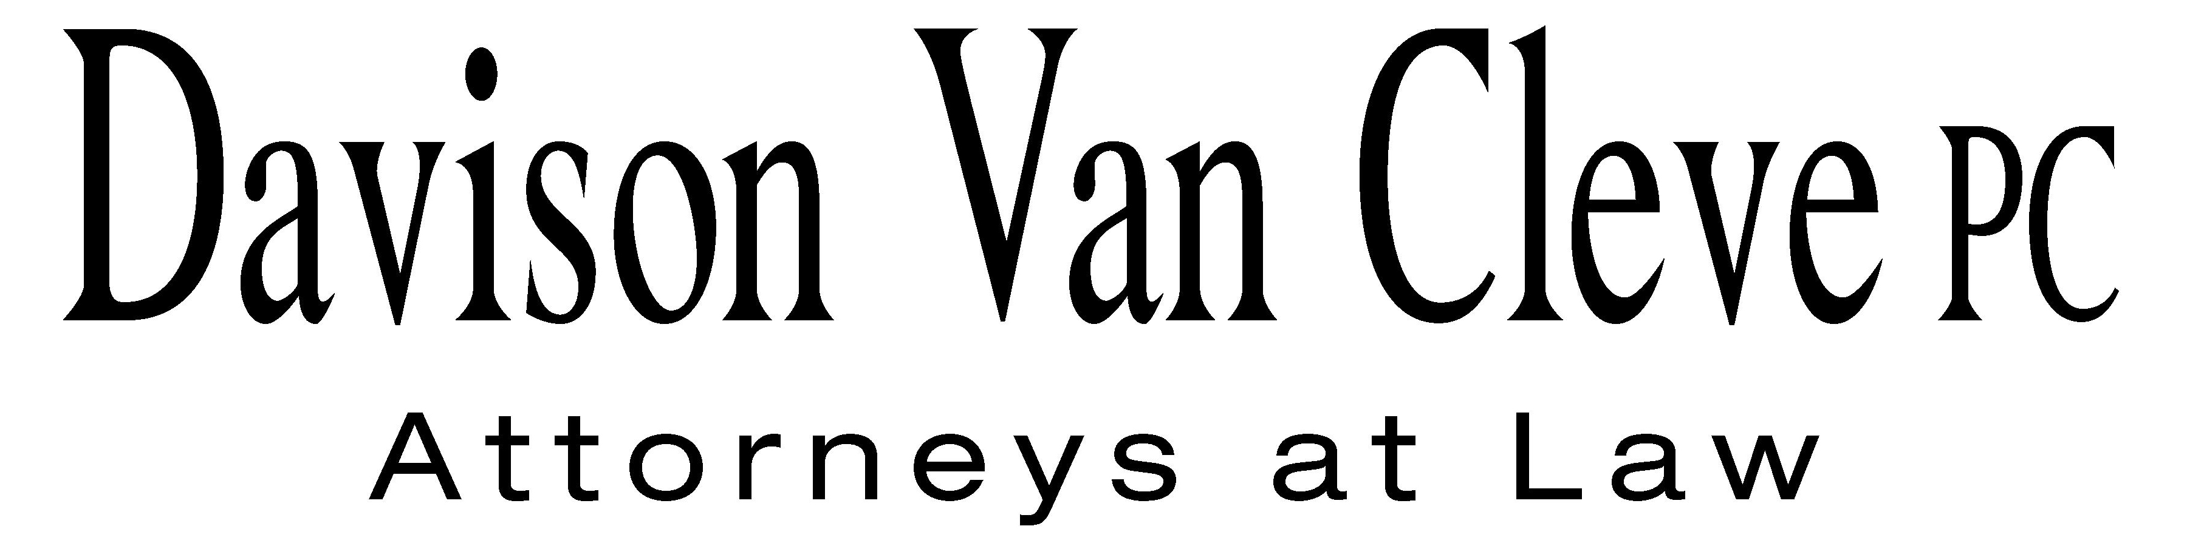
TEL (503) 241-7242 ● FAX (503) 241-8160 ● mail@dvclaw.com
Suite 400
333 SW Taylor
Portland, OR 97204

April 23, 2010

Via Email

David W. Danner
Executive Director & Secretary
Washington Utilities and Transportation Commission
PO Box 47250
1300 S Evergreen Park Drive SW
Olympia, WA 98504-7250
records@utc.wa.gov

Re: Industrial Customers of Northwest Utilities’ Statement of Issues

Docket No. U-100522

Dear Mr. Danner:

Attached please find the Statement of Issues of the Industrial Customers of Northwest Utilities in the above-referenced matter.

Thank you for your assistance. If you have any questions or concerns, please do not hesitate to contact our office.

Sincerely yours,

/s/ Martin H. Patail
Martin H. Patail

