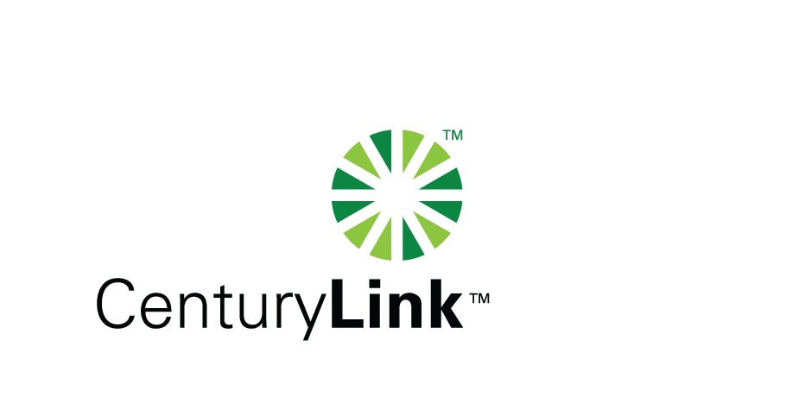

April 10, 2014

Steven V. King, Executive Director & Secretary
Washington Utilities & Transportation Commission
1300 S Evergreen Park Drive, SW
Olympia, Washington 98504-7250

Re: Washington Quality of Service Report for United Telephone, Docket No. UT-921192

Dear Mr. King:

Attached is the United Telephone Company of the Northwest d/b/a CenturyLink Service Quality Report for the month of March 2014. The trouble reports per 100 access lines objective was met for the month of March.

Please note that some of the attached information is confidential pursuant to WAC 480-07-160 as it is competitively sensitive. It is marked as required under the rule and redacted copies are also provided.

Should you have any questions, please contact Mark Reynolds at (206) 345-1568 or by e-mail at Mark.Reynolds3@Centurylink.com.

Sincerely,

Mark Reynolds

Enclosures: Installation/Repair Appointments
Service Activation in 5 Days
Trouble Per 100/Access Lines
Switching – Dial Tone Speed in 3 Seconds
Final Trunk Blockage (EAS and Toll)
Out of Service Trouble Cleared in 48 Hours
Not Out of Service Trouble Cleared in 72 Hours
Service Activation Delay 90-180 Days

