

CenturyLink Access Service Ordering and Billing System Consolidation Plan
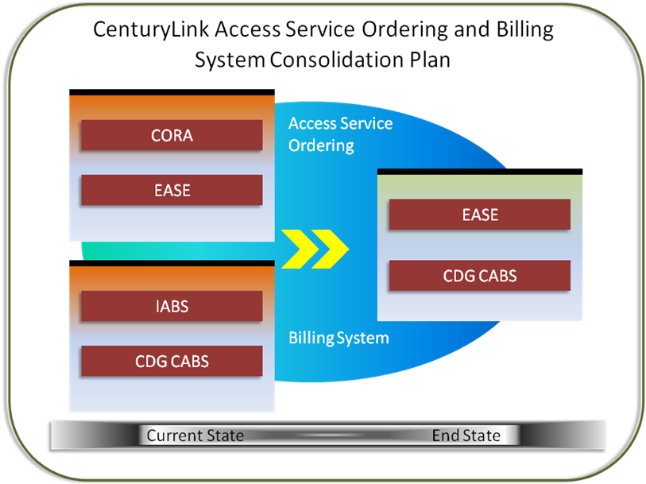

Version 5.0 12/1/16

Document Modification Log

All revisions to this document are in chronological order.

Version |  | Date |  | Description of Change
1 | 4/29/15
2 | 6/15/15 |  | Section 2.3.2 in reference to password removed
2 | 6/15/15 |  | Section 3.2 adjusted 2Q2015 to 3Q2015
2 | 6/15/15 |  | Section 1.2 added sentence “CenturyLink will fully utilize CMP post Consolidation.” To second bullet
2 | 6/15/15 |  | Section 2.3.1 updated Footnote 1: to read “BAN validation function will be implemented in EASE before Customer testing begins.”
2 | 6/15/15 |  | Section 2.4.2 added 3rd bullet “As part of the BAN Consolidation effort at consolidation, customers will see certain services billed in IABS today on one BAN split into two BANs in CABS. For example, Wireless Type 2 services in IABS bill on one BAN ‘NPA R54 NNNN NNN’ (both usage transactions and private line services). In CABS, there will be one BAN for switched usage and one BAN for specials facility services”
2 | 6/15/15 |  | Section 3.1 updated the date for the 3rd Party Facilitator Selected milestone to 9/30/15
3 | 1/15/16 |  | Changed all May 30, 2016 dates to August 1, 2016  Updated Section 3.1 Consolidation Plan Schedule and Milestones  Updated Section 3.2 3rd Party Facilitator and Section 3.3.3 Customer Testing
4 | 7/15/16 |  | Changed all August 1, 2016 dates to October 3, 2016  Updated Section 1.2 Assumptions from ASOG 52 to ASOG 53  Updated Section 2.3.1 Service Ordering Functionality from ASOG 52 to ASOG 53  Updated Section 2.3.1 Service Ordering Functionality to remove footnote regarding BAN validation as this deployed May 2016  Updated Section 3.1 Consolidation Plan Schedule and Milestones to add in Load and Performance Testing 2/14/16 and to add section for release to production  Updated Section 3.3.4 Load & Performance (L&P) Testing to add footnote.  Updated Appendix A with URL location of the referenced document
5 | 12/1/16 |  | Changed all October 3, 2016 dates to January 30, 2017  Updated Section 3.3.5 Weekend Consolidation Plan to reflect the addition of Appendix E: Customer Support Plan, with more details  Updated Section 3.3.6 Contingency Plan to reflect more details around the total time for a total back out and reinstall

© 2016 CenturyLink, Inc., All Rights Reserved. The CenturyLink mark, pathways logo, and certain CenturyLink product names mentioned herein are the property of CenturyLink, Inc. All other marks are the property of their respective owners.

Contents
CenturyLink Access Service Ordering and Billing System Consolidation Plan 1
1 Executive Summary 6
1.1 Scope 6
1.1.1 Items Not in Scope: 7
1.2 Assumptions 7
1.3 Historical Background 8
2 Ordering and Billing System Description 9
2.1 Current State System View 9
2.2 End State System View 10
2.3 Access Service Ordering End State System 11
2.3.1 Service Ordering Functionality – CORA to EASE (ASOG 52) 12
2.3.2 Access Service Ordering Differences between EASE and CORA 13
2.4 Billing End State System 14
2.4.1 Billing System Functionality – IABS to CDG CABS (BOS 55) 15
2.4.2 Billing System Differences between IABS and CABS 15
3 Consolidation Plan Implementation 16
3.1 Consolidation Plan Schedule and Milestones 16
3.2 3rd Party Facilitator 18
3.3 Consolidation Plan Implementation 18
3.3.1 Internal CenturyLink Consolidation Testing 18
3.3.2 Training and Process Plan 18
3.3.3 Customer Testing 198
3.3.4 Load & Performance (L&P) Testing 198
3.3.5 Weekend Consolidation Plan 208
3.3.6 Contingency Plan 209
Appendix A: CDG CABS Invoice & CSR Examples (Redacted) 210
Appendix B: Regulatory Organizations, Guidelines and Standards 221
Appendix C: Glossary 232
Appendix D: Document Authors 254
Appendix E: Customer Support Plan…………………………………………………………………25

Executive Summary
CenturyLink is consolidating its Access Service ordering and billing systems to streamline processes and systems across CenturyLink’s markets (hereafter, Consolidation). Due to Acquisitions (see Section 1.3), CenturyLink currently operates two different ordering and billing systems for Access Services. As a result, customers that are in multiple locations within CenturyLink’s network could be using both systems making this inefficient for the customer and for CenturyLink.
During consolidation, CenturyLink will move all Access Service Request (ASR) ordering to Electronic Administration & Service Order Exchange (EASE) and the associated billing to Communications Data Group (CDG) Carrier Access Billing System (CABS). (Refer to section: 2: Ordering and Billing System Description for more information.) This consolidation will move some properties off the CenturyLink Online Request Application (CORA) and the Integrated Access Billing System (IABS).
The benefits to the wholesale customers and CenturyLink of consolidating the ordering systems across all CenturyLink Markets are to provide:
- Single standardized order entry channel for ASR services
- Standardized process for ASR handling
- Single view of all ASR orders
- One set of training requirements
The benefits to the wholesale customers and CenturyLink of consolidating the billing systems across all CenturyLink Markets are to provide:
- Single process for ASR billing functions
- Consistent billing levels – i.e., moving to State vs. Local Access Transport Area (LATA) level billing
- Consistent method to view the billing for any products and services ordered on an ASR
- Consistent bill format for all access billing

Scope
The CenturyLink Access Service Ordering and Billing System Consolidation Plan (hereafter; the Consolidation Plan) document provides CenturyLink’s wholesale customers, (hereafter; Customers) with further information about the Consolidation and how they will be affected.
The purpose of this document is to cover the scope of the Consolidation Plan to fulfill specific requirements of settlement agreements with various parties, as well as associated state commission and FCC orders, related to the CenturyLink/Qwest merger (hereafter, Merger Requirements). This document summarizes the critical milestones that will occur when CenturyLink consolidates the Current State Ordering and Billing Systems into the End State solution. The Consolidation is planned for January 30, 2017.

Items Not in Scope:
Items that are not in-scope for this project include, but are not limited to:
- Future system enhancements to EASE resulting from Access Service Ordering Guidelines (ASOG) updates
- Future system enhancements to CDG CABS resulting from Ordering and Billing Forum (OBF) updates for the electronic output
- Local Service Request (LSR) processing

Assumptions
The following is a list of assumptions that are applicable during implementation and upon completion of the Consolidation:
- CenturyLink will comply with all applicable Merger Requirements
- CenturyLink will utilize the existing Qwest Corporation d/b/a CenturyLink Change Management Process (CMP) to communicate system and product/process changes in the appropriate timing and format. CenturyLink will fully utilize CMP post Consolidation. To view the complete CMP document, visit the CMP Website or click on the Wholesale Change Management Process Document link.
- The CMP timeline will be adjusted consistent with Merger Requirements
- Customers will enter ASRs in EASE and receive their bill output from CDG CABS
- Customers will submit orders in ASOG 53 standard format
- CenturyLink will send electronic media in Bill Output Specifications (BOS) 55 standard format
- CenturyLink will continue to update the end state Ordering and Billing systems according to ASOG and BOS per industry schedules after the Consolidation
- Online bill viewing will continue to be available in IABS for 13 months from the Consolidation date
- Historic CORA order inquiry will continue to be available on-line for 24 months from the Consolidation date
- CenturyLink will communicate billing account number changes to Customers before the Consolidation
- IABS Bill and CSR data will be available to view for 13 months after Consolidation
- CenturyLink will retain existing output selections for billing media (i.e., paper vs. electronic) at Consolidation
- Customers will not have to resend any In-Flight orders

In-Flight orders are:
When Customers submit orders and CenturyLink acknowledges acceptance, but the processing of the orders are not complete before the Consolidation weekend.

Historical Background
Strategic acquisitions are the primary contributor to CenturyLink’s rapid growth. Pacific Telecom, Embarq, and Qwest are a just few of the companies acquired in recent years. CenturyLink also purchased a large number of access lines from GTE in 2000 and Verizon in 2002. After each acquisition prior to Qwest, CenturyLink consolidated access billing into CDG CABS.
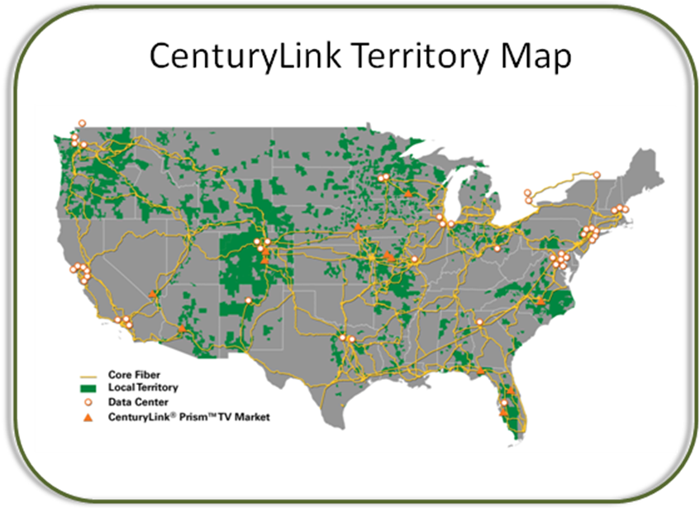After the acquisition of Embarq in 2009, CenturyLink successfully consolidated the Embarq Access Billing System (CASS) to CDG CABS. IABS and CASS are based on the same data model; therefore, this data Consolidation will be similar to the CASS to CDG CABS Consolidation.
Embarq used the EASE Service Ordering System before acquisition. CenturyLink consolidated Embarq’s EASE Service Ordering System ordering into its Access Service Ordering system flow for use in all of its markets at that time.

Ordering and Billing System Description
This section provides Customers with Current State and End State Ordering and Billing system views, common features, and information about the differences between Current State and End State systems. It also provides information about the functionality and applications that CenturyLink uses to facilitate Customer and system interfaces.

Current State System View
CenturyLink currently uses two separate Access Service Request Ordering and Billing Systems. CenturyLink uses both EASE and CORA for Access Service Request Ordering. CenturyLink uses both CDG CABS and IABS for billing. The diagram below depicts the current state system view for CORA Ordering and IABS Billing.
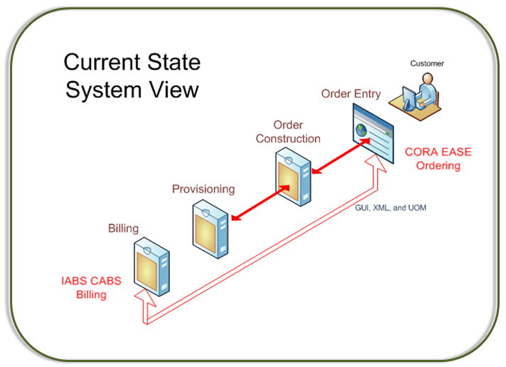

CORA is an internally developed ASR submission and results portal, allowing ASR processing via a Graphical User Interface (GUI) and batch files, and real-time eXtensible Markup Language (XML) transactions.
Included within CORA are:
- Edits
- Validations
- Pre-order information queries
- Status information

CORA uses the industry standard Uniform Ordering Model (UOM) data definitions.
IABS is the system that bills Customers for services ordered through CORA.

End State System View
The following diagram shows CenturyLink’s Single ASR Ordering and Billing System. It depicts the End State Ordering and Billing System for all CenturyLink Markets.
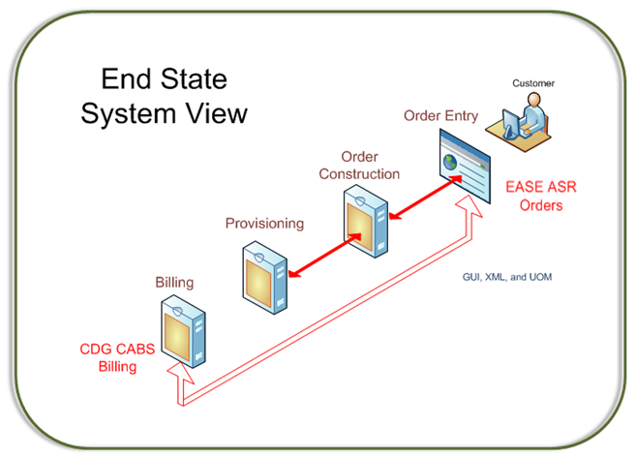
EASE is the end state ASR submission and results portal used by Customers, as well as CenturyLink, allowing ASR processing via a GUI and batch files, and real-time XML transactions.
Included within EASE are:
- Edits
- Validations
- Pre-order information queries
- Status information

The Industry Ordering and Billing Forum (OBF) directive will retire the industry Batch Standard by the end of 2016. As communicated in January 2015, CenturyLink will be consolidating its ASR systems by replacing the CORA ASR processing system with the CenturyLink EASE system January 30, 2017. In order for customers to save time and expense, CenturyLink recommends customers wait to migrate to EASE UOM at the time of the ASR system consolidation rather than moving to CORA UOM prior to that consolidation.
CDG CABS is the end state system that bills Customers for services ordered through ASRs.

Access Service Ordering End State System
CenturyLink Customers use the Synchronoss based EASE system for ASR Ordering. Synchronoss, founded in 2000, specializes in software and services for Wireline and Wireless Telecommunications Carriers. Headquartered in Bridgewater, NJ, Synchronoss is a publicly traded company (NASDAQ: SNCR) with annual revenue for the fiscal year 2014 of approximately $459M.
Synchronoss acquired the technology and assets that support the EASE platform as part of its overall acquisition of Wisor Telecom OSS in 2008. Since then, Synchronoss has continued to maintain, enhance, and market the platform supporting EASE.
EASE is an industry compliant order entry and workforce management system that allows end-to-end view and management of the ASR orders. The system consists of GUI and UOM/XML ordering capabilities. The system is robust and table driven with extensive business rule capabilities.
EASE follows industry-standard ordering business rules, including the twice-annual ASOG industry updates. EASE provides the following:
- Single, centralized platform for all ASR processing
  - Supports both eBonding and Portal (Virtual Front Office (VFO) GUI) capabilities
- Proven carrier-grade solution
  - Solutions are used by major carriers across the US and beyond, including major Incumbent Local Exchange Carriers (ILECs) and Competitive Local Exchange Carriers (CLECs)
  - Extensive features and functions for validation, delivery, and integration
- Full compliance with ASOG/ASR industry standards and standard ASR configurations
  - Manages all ASOG updates going forward
- Integration with back office systems
  - Platform Application Programming Interface (API) will support additional integrations as needed for all ASR Order volumes.
- Platform Expandability
  - Local Number Portability (LNP) / Local Service Request (LSR) / Receive / custom transaction types

Service Ordering Functionality – CORA to EASE (ASOG 53)
The following matrix is a comparison of functionality between the EASE and CORA systems:
Functionality | CORA | EASE
Support eBonding and portal for ASR requests | Yes | Yes
Industry standard ASR forms and fields | Yes | Yes
Pre-order query:  Scan CLLI codes  Validate a CFA  Validate NC/NCI/SecNCI  Validate Address  - By street address  - By WTN  - By circuit  Validate a BAN | Yes  Yes  Yes  Yes  Yes  Yes  Yes | Yes  Yes  Yes  Yes  Yes  Yes  Yes
Create and submit a request | Yes | Yes
Revise a rejected request | Yes | Yes
Supplement a request | Yes | Yes
Up front order editing | Yes | Yes
Search ASRs | Yes | Yes
Wildcard search | Yes | Yes
Order tracking | Yes | Yes
Order replication and template creation | Yes | Yes
Online Help | Yes | Yes
Field Level Help | Yes | Yes
View Confirmations | Yes | Yes
Receive Design Layout Reports (DLR)s | Yes | Yes
Order History | Yes | Yes
Order Status | Yes | Yes
Customer user admin function | Yes | Yes
Reporting | Yes | Yes

Note: Technical, legal and regulatory changes may affect information provided in the above table. Changes made following the introduction of this document in CMP are not reflected in the table above.
Follow the link to access ASOG: http://www.atis.org/obf/download.asp

Access Service Ordering Differences between EASE and CORA
For an up-to-date list of Ordering Differences, please reference:
http://www.centurylink.com/wholesale/systems/ossconsolid.html
- Each Owner Agent has a single login in CORA and is able to submit ASRs for all companies he/she represents. In EASE, an Owner Agent has a single login for a company and for all related companies within the same hierarchy. Separate login IDs will be required if related companies have separate hierarchies in ordering. In this instance, an Owner Agent submits orders for multiple companies by having multiple browser sessions opened, one for each company. This feature provides stronger controls to prevent unauthorized user access.
- Comprehensive Global Validation – When a Customer enters an order, CORA provides form level validations on demand. CORA experiences its validation optionally after each page completion, as well as systematically when the Customer submits the order. EASE provides validations on demand, during the order entry process, and before order submission.

Billing End State System
CenturyLink uses CDG CABS to bill services ordered through an ASR. Communications Data Group (CDG) is a privately owned company, established in 1970. CDG specializes in providing software solutions and services for companies in the telecom sector. CDG CABS is a robust, flexible, table driven system that is business configurable. CDG CABS meets the C/BOS industry standards for Bill and CSR (Customer Service Record) electronic records, as well as paper invoice outputs.
CDG is the only vendor that has ever been a member of the BOS Technical Review Group (TRG). The TRG committee maintains the BOS format for Interconnection billing. It is generally comprised of carriers, not vendors. CDG is also a member of the Ordering & Billing Forum (OBF) Billing Committee and the Metro Ethernet Forum (MEF).
CDG CABS has been utilized by numerous ILEC’s, Rural Local Exchange Carriers (RLEC’s), CLEC’s, Wireless, Cable and Broadband providers of all sizes over the years and is the choice of 11 of the 20 largest LECs in the country.
CenturyLink continues to work with CDG to enhance systems to provide Customers the accuracy, efficiency, and industry compliance they need to succeed.

Billing System Functionality – IABS to CDG CABS (BOS 55)
The following table shows key capabilities of the CDG CABS System.
IABS to CABS Billing System Integration
Key Capabilities | Description
Online Bill View | CenturyLink will provide the Customer with an external link for up to 18 months of bill invoices, CSRs, and remittance slips. The Customer will be able to sign up for this access. This history will be built going forward after Consolidation.
Media Options | CDG CABS provides multiple options for receiving bills. Options include paper, online bill viewing, and electronic BOS standard files.
Invoices and CSRs | CenturyLink will continue to provide industry compliant invoices and CSRs. Refer to separate attachment for Appendix A: CDG CABS Invoice & CSR Examples.

Note: Technical, legal and regulatory changes may affect information provided in the above table. The table above does not reflect changes made following the introduction of this document in CMP.
Refer to the following link to view more information about BOS (Bill Output Specifications): http://telecom-info.telcordia.com/site-cgi/ido/docs2.pl?ID=&page=cabslist

Billing System Differences between IABS and CABS
For an up-to-date list of billing system differences, please reference:
http://www.centurylink.com/wholesale/systems/ossconsolid.html
- Customers will be required to change the routing location for payment processing. CenturyLink will provide notification of this change in advance of the requirement deadline.
- IABS billing is at the LATA level and CDG CABS billing is at the State level. The implementation of this plan will consolidate multiple existing LATA level accounts into a Single State level account. CenturyLink will communicate Account Mapping before Consolidation. Where applicable, CenturyLink will send new Billing Account Numbers (BANs) that include a unification of BANs at a State level, rather than at a LATA level, before Consolidation.
- As part of the BAN Realignment effort at consolidation, customers will see certain services billed in IABS today on one BAN split into two BANs in CABS. For example, Wireless Type 2 services in IABS bill on one BAN ‘NPA R54 NNNN NNN’ (both usage transactions and private line services). In CABS, there will be one BAN for switched usage and one BAN for specials facility services.

- The current Channel Mileage Universal Service Order Code (USOC) which bills for fixed and variable mileage will be split into two USOCs – one for fixed and one for variable.
- CDG CABS offers an online tool which stores up to 18 months of bills, Customer Service Records (CSRs), and remittance page history. CenturyLink offers this in lieu of the IABS abbreviated print bill functionality. Existing abbreviated bill functionality allows Customers to receive a printed output of certain sections of their bill only.
- Currently, CDG CABS BOS updates are in March and IABS BOS updates are in November. Annual BOS updates post Consolidation will continue to follow the March implementation schedule.
- Technical Specifications will explain any electronic billing file differences, if applicable.
- Switched invoices will summarize usage details at a master Carrier Identification Code (CIC) level. CenturyLink assigns the master CIC and is most likely (although not always) represented by the ‘primary’ CIC or Operating Company Number (OCN) for a Customer. For the usage summarization on the IABS FG (Feature Group) D switched bills – IABS presents CICs (based on the CIC in the usage record) separately under a given OCN. On a CDG CABS FG D bill, the Customer will see usage summarized at the OCN/CIC level (rolling multiple CICs into one).

Consolidation Plan Implementation
The Consolidation Plan provides a framework for informing all participants about the Consolidation.

Consolidation Plan Schedule and Milestones
Consolidation completion January 30, 2017. CenturyLink will comply with all applicable Merger Requirements, including use of the CMP process.
The following table shows a list of milestones that impact the Consolidation Plan. CenturyLink will communicate updated milestone dates per the CMP process.
= A milestone, established by the Merger Requirements, that alters the established CMP milestones schedule.
Consolidation Plan Milestone | Date
CMP CRs for System Introduction and Retirement  CRs SCR120314-1, SCR120314-2, SCR120314-3 and SCR120314-4 These can be found at: http://www.centurylink.com/wholesale/cmp/cr/crnumber_system_index.html | 12/3/14
ASR Consolidation Plan due | 4/29/15
Initial Release Notification (for SCR120314-1 and SCR120314-2) | 4/29/15
Initial Retirement Notice (for SCR120314-3 and SCF120314-4) | 4/29/15
ASR Consolidation Plan Review Meeting | 5/13/15
Extended Customer Comment Window for Initial Release Notification, Initial Retirement Notice and Consolidation Plan | 5/29/15
CenturyLink issues response to CLEC comments and Final Retirement Notice, including the Final version of the ASR Consolidation Plan | 6/19/15
3rd Party Facilitator Selected | 9/30/15
Draft Interface Tech Specs | 11/2/15
Tech Specs Walk-through | 11/12/15
CLEC Comments for Interface Tech Specs | 11/18/15
Final Interface Tech Specs | 11/23/15
DATES REVISED BELOW ASSOCIATED WITH
August 1, 2016 RELEASE TO PRODUCTION DATE
(New) GUI Initial Release notice | 2/1/16
Load & Performance Testing | 2/14/16
Draft Revised Interface Tech Specs | 2/17/16
(New) GUI Draft Release notes | 2/17/16
Revised Tech Specs Walk-through | 2/22/16
(New) GUI Review Meeting | 2/22/16
Product Process Notification associated with Level 2 OSS changes | 2/26/16
CLEC Comments due on Revised Interface Tech Specs | 3/2/16
CLEC comments due on (New) GUI Release Notes | 3/2/16
CLEC comments due on Level 2 OSS Product Process changes | 3/7/16
Training available | 3/7/16
(New) GUI Final Release Notes | 3/7/16
Final Revised Interface Tech Specs | 3/7/16
Final notice for Level 2 OSS Product Process changes | 3/14/16
Customer Testing Begins (120 Days) | 3/21/16
Customer Testing Ends | 7/18/16
Customer Go/No Go Vote | 7/18/16
DATE REVISED BELOW ASSOCIATED WITH
October 3, 2016 RELEASE TO PRODUCTION DATE
Release to Production | 10/3/16
DATE REVISED BELOW ASSOCIATED WITH
January 30, 2017 RELEASE TO PRODUCTION DATE
Release to Production | 1/30/17

3rd Party Facilitator
In accordance with the Merger Requirements, CenturyLink has contracted with Wicresoft North America, Inc to coordinate between companies during planning and execution of Customer Testing. Refer to section: 3.3.3: Customer Testing. Wicresoft will assist in Customer Testing scenario development and be available during the 120-day Customer Testing period, which began in 1Q2016 resolution.

Consolidation Plan Implementation
This section provides further details on the Consolidation Plan implementation, including testing, training, the weekend consolidation plan, and contingency planning.

Internal CenturyLink Consolidation Testing
CenturyLink will execute test orders through EASE to ensure that proper billing codes assignation occurs and the orders flow successfully into CDG CABS for billing. CenturyLink business SMEs (Subject Matter Experts) will check for accuracy and completeness.
The following is the standard process that CenturyLink has used for previous consolidations and will use for this system consolidation:
- First, ‘mock’ consolidations from IABS into CDG CABS prior to the Customer testing period will be iteratively executed
- Test bills will be generated and compared to production IABS bills for accuracy
Automated comparisons will occur for all circuits/products that are on the account, all monthly recurring charges, taxes, and any in-flight activity such as pending payments, one time charges and disputes. CenturyLink resources will investigate fallout and issues during the comparison process and update the processes/programs to achieve billing accuracy.
CenturyLink SMEs from EASE /CORA and CABS/IABS systems and process areas will participate in testing and validation efforts. In addition, contract resources will supplement these internal resources to ensure intense focus on Consolidation activity and to allow 24-hour cycles.

Training and Process Plan
Per the Merger Agreement, CenturyLink will provide Customer training and education without charge.
For the Consolidation, CenturyLink will provide the following:
- CenturyLink will provide updated EASE Customer training
- CenturyLink will conduct a Customer walk through session prior to the start of Customer testing
- An additional Customer walk-through of the training will be conducted before Consolidation
- CenturyLink will provide updated external documentation prior to the beginning of the Customer testing phase

Customer Testing
In accordance with the Merger Agreement, CenturyLink will make available a testing environment at the appropriate time for the Customers to test orders into the EASE ordering system. A testing schedule will allow the generation of test bills and CSRs at scheduled intervals during the 120-day testing window. CenturyLink has produced a Customer Test Plan Process Document as well as Potential Test Cases. These documents can be found at:
http://www.centurylink.com/wholesale/systems/ossconsolid.html

Load & Performance (L&P) Testing
CenturyLink completed an analysis of the increased demand on EASE to process CORA transactions. To meet the needs of the expected volume from this analysis, EASE processing capability was increased. CenturyLink modifies processing capacity by using internal virtual server environments allowing CenturyLink to respond quickly to capacity issues.
In addition to the completed performance analysis, CenturyLink will perform a Load & Performance test on EASE based on the anticipated needs after the CORA volume is included. Specifically:
- The Load & Performance test will be conducted prior to Consolidation, but no later than end of 1Q2016
- The combined ASR transaction volume for the preceding 36 months will be made available to Customers
- The highest monthly volume of aggregate transactions for the preceding 12 months will serve as the testing baseline
- Using the highest monthly volume, a single day’s average transaction volume of ASRs will be calculated
- 125% of the single day’s transaction volume will be processed and performance metrics captured
- These metrics will be available to Customers

Weekend Consolidation Plan
The overall Consolidation from ordering through billing will be a flash cut. This means that Customers will submit orders via CORA pre-Consolidation weekend and new orders post-Consolidation will go into EASE. The weekend Consolidation cutover will be for all properties. The Consolidation weekend will be near the end of a month following the completion of all billing cycles for that month, and before any billing cycles executed in the following month.
Customers’ will receive notifications of the Consolidation’s extended weekend maintenance window. At Consolidation, all existing products billed in IABS will convert and all new bills generated from CDG CABS. For a Detailed Customer Support Plan, please see Appendix E: Customer Support Plan.

Contingency Plan
A backup of all relevant source and target databases will occur at the beginning of the extended maintenance window. Once these backups complete successfully, consolidation activities will begin. The CDG CABS database will contain IABS products, in-flight orders will be contained in the end state databases and internal validation will occur.
In the event of catastrophic issues with the production system during consolidation weekend, the original databases’ pre-consolidation state restoration would occur through a predefined back-out plan. This predefined plan is a systematic process, which will take about five hours to complete.
The implementation of this plan would only occur in the event of catastrophic issues with the production system during that weekend. In the unlikely event this back-out plan is required, the decision would be made in time to have the systems available on January 30, 2017.
Once the consolidation is complete and validated, source databases will be modified to ‘read only’ to allow view capability where applicable.
- CDG CABS Invoice & CSR Examples (Redacted)

Please reference Appendix A, Version 1 4/29/15 at: https://www.centurylink.com/wholesale/systems/ossconsolid.html
- Regulatory Organizations, Guidelines and Standards
The following is a list of regulatory organizations, guidelines and industry standards mentioned in this document.
- ASOG (Access Service Ordering Guidelines)
  - http://www.atis.org/obf/download.asp
- BOS (Bill Output Specifications) and the BOS Technical Review Group (TRG)
  - http://telecom-info.telcordia.com/site-cgi/ido/docs2.pl?ID=&page=cabslist
- CMP (CenturyLink Change Management Process)
  - http://www.centurylink.com/wholesale/cmp/review.html
- FCC (Federal Communications Commission)
  - www.fcc.gov/
- OBF (Ordering and Billing Forum)
  - http://www.atis.org/obf/download.asp
- PUC (Public Utility Commissions)
  - The following link is to the National Association of Regulatory Utility Commissioners. You will be able to obtain information about Public Utilities Commissions by State
http://www.naruc.org/Commissions/

- Glossary
The glossary lists terms and acronyms used in this document with descriptions and definitions.
Term/Acronym | Description/Definition
API | Application Programming Interface
ASOG | Access Service Ordering Guidelines
ASR | Assess Service Request
BAN | Billing Account Number
BOS | Bill Output Specifications
C/BOS | CABS Billing Output Specifications
CABS | Carrier Access Billing System
CDG | Communications Data Group
CDG CABS | The Carrier Access Billing System created and owned by Communication Data Group
CFA | Carrier Facility Assignment
CIC | Carrier Identification Code
CLEC | Competitive Local Exchange Carrier
CLLI | Common Language Location Identifier
CMP | Change Management Process
CORA | CenturyLink Online Request Application
CSR | Customer Service Records
Current State System View | Denotes CenturyLink’s existing systems and their functionality pre-Consolidation
EASE | Electronic Administration & Service Order
End State System View | Denotes CenturyLink’s systems and functionality post Consolidation
FCC | Federal Communications Commission (USA)
GUI | Graphical User Interface
IABS | Integrated Access Billing System
ILEC | Incumbent Local Exchange Carrier
LATA | Local Access Transport Area
LEC | Local Exchange Carrier
LIS | Local Interconnect Services
LNP | Local Number Portability
LSR | Local Service Request
NC | Network Channel
NCI | Network Channel Interface
OBF | Ordering & Billing Forum
OCN | Operating Company Number
OSS | Operating Service System
PUC | Public Utility Commissions
RLEC | Rural Local Exchange Carrier
SEC NCI | Secondary Network Channel Interface
TRG | Technical Review Group
UOM | Uniform Ordering Model
USOC | Universal Service Order Code
VFO | Virtual Front Office
WTN | Working Telephone Number
XML | eXtensible Markup Language

- Document Authors
The table below lists the qualifications of the document authors including information technology professionals with substantial experience and knowledge regarding CenturyLink systems, process, and requirements.

- Customer Support Plan
Date: 12/1/2016

Post Consolidation Customer Support Methods
CenturyLink will provide various communication methods to resolve external customer issues after consolidation.

Consolidation Hotline
CenturyLink will establish a toll free Consolidation Hotline (1-844-210-8821) to assist customers. This hotline will be staffed by trained Customer Support analysts and will be available Monday to Friday from 7am to 5pm (MT) from January 30, 2017 through February 10, 2017. (The end date may be extended through February 24, 2017 if required).

Consolidation eMail Box
CenturyLink will provide an email box (asrconsolidationtesting@centurylink.com) to receive emails from external customers as well as communicate the ticket status solution with external customers.

Other Customer Support Not Related to this Consolidation
Today, there are many ways to support CenturyLink wholesale customers. Customers may continue using those to contact CenturyLink on different issues. For more information on Wholesale customer contacts, please visit the website: http://www.centurylink.com/wholesale/clecs/customercontacts.html

Online Chat
CenturyLink will continue to provide Online Chat to assist with wholesale service requests. The hours of operation are Monday to Friday, from 7am to 7pm (MT).
Online Chat can be accessed via this URL: https://www.centurylink.com/wholesale/customerservice.html

Online Ticketing
Online ticketing functionality is also provided via CenturyLink.com. Customers can submit their ASR tickets to Customer Care.
Online Ticketing can be accessed via this URL: http://www.centurylinkapps.com/wholesale/customerservice/asr.cfm

Provisioning Support Line
For any questions related to LOAs and all service requests, order status, CNRs, Jeopardy or how to complete ASRs, the customer should contact the CenturyLink ordering and provisioning center @ 800-244-1271. The hours of operation are Monday to Friday, from 7am to 5pm (MT).

Billing Support Line
The CenturyLink’s Billing Centers assist customers with any billing questions. For any questions related to customer access billing, the customer may contact the CenturyLink Billing Center @ 800-335-5672. The hours of operation are Monday to Friday, from 7am–3pm (MT).

Wholesale Systems Help Desk
The Wholesale Systems Help Desk (WSHD) is the single point of contact for system related questions regarding connectivity issues, outputs and system outages. If the WSHD professional is unable to assist you, they will refer your ticket information to the proper CenturyLink Subject Matter Expert (SME). The SME will either contact you directly or pass the resolution information to the WSHD professional who will then provide you the information and confirm resolution The contact number for the EASE system is 888-796-9102, option 2. The hours of operation are Monday to Friday, from 6am to 7pm (MT) and Saturday 7am to 2pm (MT). NOTE: During the Consolidation Hotline period availability, please contact the Hotline first for any system issues.

Expedites and Escalations
For Expedites and Escalations during and after the consolidation, CenturyLink will follow the current procedure which is defined on the CenturyLink website at URL https://www.centurylink.com/wholesale/clecs/exescover.html.

Support Matrix
Below is the summary for all contacts provided by CenturyLink for the consolidation.
Contact | Hours of Operation | For Assistance with
Consolidation Hotline  844-210-8821 | M-F 7am–5pm (MT)  (1/30/17 – 2/10/17)* | Consolidation issues
Consolidation Mailbox  asrconsolidationtesting@centurylink.com | 1/30/17–2/24/17 | Consolidation Issues
Online Chat | M-F 7am–7pm (MT) | Ordering and provisioning support
Online Ticketing |  | Customer care for ASR
Provisioning Support  800-244-1271 | M-F 7am–5pm (MT) | Service Request
Billing Support  800-335-5672 | M-F 7am–3pm (MT) | Customer care for ASR billing
Wholesale Systems Help Desk  888-796-9102, option 2 | M-F 6am–7pm (MT)  Sat 7am-2pm (MT) | EASE ASR Helpdesk

*May be extended to 2/24/17

Consolidation Hotline and eMail Support
A special Consolidation Hotline and email box are setup for consolidation support. Key CenturyLink resources will be available to immediately investigate and address any concerns. Customers will receive a ticket ID for their open issue.
The Consolidation Support team will:
- Receive the calls and emails from customers for the issues related to consolidation. They will create tickets describing the problem identified by the external customer and assign a severity to the tickets.
- Provide the customer with an adequate resolution. A resolution is generally one of the following: an answer to a customer question, a suggestion of how to accomplish a particular task, or a workaround to an issue.
- Provide statusing for all open issues through to closure.
- Soft transfer calls for issues not related to consolidation.

Issues Supported
The Consolidation Support team handles issues including:
- EASE VFO Access
- EASE VFO Password Resets
- ASR Validation Errors
- System Errors
- EASE PreOrder Functions
- Consolidation Related Issues
The Consolidation Support team will soft transfer issues not specifically related to the consolidation including:
- Order Status
- Question on Orders
- Question on CNR, Jeopardy, FOC
- Question on Invoice/Payment

Consolidation Hotline
Customer Support analysts are available by telephone to receive support requests. The telephone number for external customer support is 1-844-210-8821. If your call is outside of the Consolidation Hotline hours, a voice mail message can be recorded for later response. CenturyLink personnel will return your call as soon as possible.

Email Support
Customer Support analysts will respond to customer issues via email from January 30, 2017 through February 24, 2017. The email address for external Customer Support is asrconsolidationtesting@centurylink.com

Consolidation Hotline Support Hours
Customer Hotline Support is available Monday through Friday, 7:00 AM to 5:00 PM MT. This Support will be available January 30 - February 10. These dates may be extended through February 24, 2017, depending on the needs of the business.

Consolidation Support Process
When a customer contacts the Access Services System Consolidation Support helpdesk (using any of the communication methods in section 2.0), a Consolidation Support analyst will address their request.
The support analyst will try to address issues during the phone call first.
The support analyst will open a ticket and provide ticket ID to the customer for tracking if the issue won’t be able to be addressed during the call.
The ticket will to be directed to a live, internal bridge open at CenturyLink with key CenturyLink resources that will be available to immediately investigate and address issues.
Issue status and solution will be promptly reported back to customers by the Consolidation Support team.

Case Severity Levels
Table 1 provides the definitions used in identifying and assigning a severity level to the customer's reported problem.

Table 1 - Severity Definitions
Customer Severity | Ticket Severity | Criteria
Critical | 1 | System is down or unusable resulting in total disruption of work or other critical business impact. No workaround is available
High | 2 | Major feature/function failure  Operations are severely restricted, there is a major disruption of work, there is not an acceptable workaround available
Medium | 3 | Minor feature/function failure  Program does not operate as designed, minor impact on usage, acceptable workaround deployed
Low | 4 | Minor problem  Documentation, general information, enhancement request, etc.

Response and Resolution Targets/SLAs
Reasonable efforts will be used to meet the response times and resolution targets in Table 2.

Table 2 - SLAs
Severity | Targeted Response | Targeted Resolution | Solution (one or more of the following)
Critical  Severity 1 | Within 15 Minutes | Within 4 Business Hours | - Satisfactory workaround is provided.  - Program patch is provided.  - Fix incorporated into future release.  - Fix or workaround implemented.
High  Severity 2 | Within 30 Minutes | Within 1 Business Day | - Satisfactory workaround is provided.  - Program patch is provided.  - Fix incorporated into a future release.  - Fix or workaround implemented.
Medium  Severity 3 | Within 1 Business Hour | Within 5 Business Day | - Answer to question is provided.  - Satisfactory workaround is provided.  - Fix incorporated into future release.  - Fix or workaround implemented.
Low  Severity 4 | Within 4 Business Hours | Within 10 Business Day | - Answer to question is provided.  - Fix or workaround implemented.

See In the Matter of the Joint Petition for Approval of Indirect Transfer of Control of Qwest Operating Companies to CenturyLink, Minnesota Public Utilities Commission, Docket No. p-421, et al./PA-10-456, Settlement Agreement between the Joint Petitioners and Joint CLECs, March 4, 2011.
Load and Performance test results can be found: https://www.centurylink.com/wholesale/systems/ossconsolid.html

