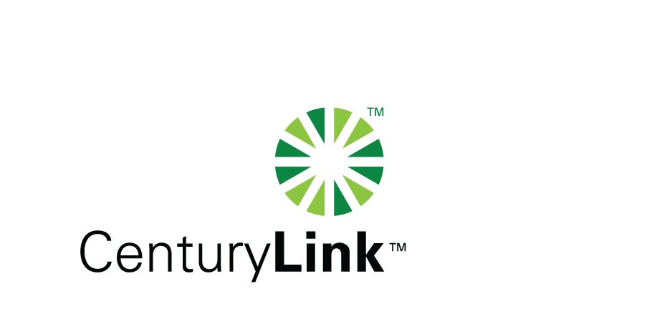

March 12, 2014

Steven V. King, Executive Director & Secretary
Washington Utilities & Transportation Commission
1300 S Evergreen Park Drive, SW
Olympia, Washington 98504-7250

Re: Washington Quality of Service Report

Dear Mr. King:

Attached is the United Telephone Company of the Northwest d/b/a CenturyLink Service Quality Report for the month of February 2014.

The trouble reports per 100 access lines objective was met for the month of February.

Should you have any questions, please contact Mark Reynolds at (206) 345-1568 or by e-mail at Mark.Reynolds3@Centurylink.com.

Sincerely,

Mark Reynolds

Enclosures: Installation/Repair Appointments
Service Activation in 5 Days
Trouble Per 100/Access Lines
Switching – Dial Tone Speed in 3 Seconds
Final Trunk Blockage (EAS and Toll)
Out of Service Trouble Cleared in 48 Hours
Not Out of Service Trouble Cleared in 72 Hours
Service Activation Delay 90-180 Days

