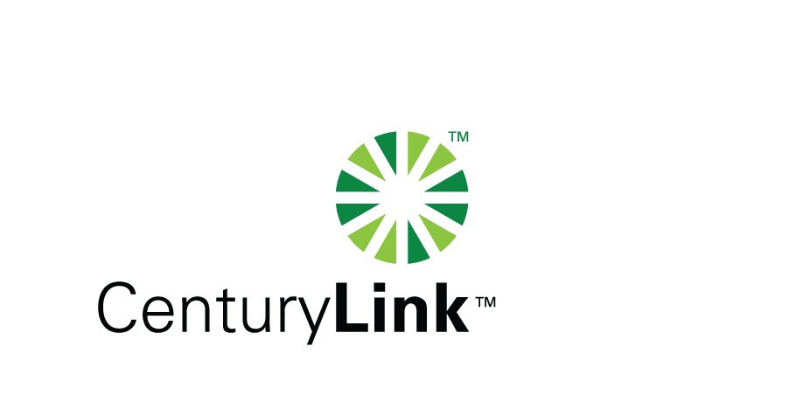

March 12, 2014

Steven V. King, Executive
Commission
1300 S Evergreen Park Drive, SW
Olympia, Washington 98504-7250

Re: Washington Director & Secretary
Washington Utilities & Transportation Quality of Service Report

Dear Mr. King:

Attached is the CenturyTel Service Quality Report d/b/a CenturyLink for the month of February, 2014.

The trouble reports per 100 access lines objective was met for the month of February.

If you should you have any questions, please contact Mark Reynolds at (206) 345-1568 or by e-mail at Mark.Reynolds3@Centurylink.com.

Sincerely,

Mark Reynolds

Enclosures: Installation/Repair Appointments
Service Activation in 5 Days
Trouble Per 100/Access Lines
Switching – Dial Tone Speed in 3 Seconds
Final Trunk Blockage (EAS and Toll)
Out of Service Trouble Cleared in 48 Hours
Not Out of Service Trouble Cleared in 72 Hours
Service Activation Delay 90-180 Days

