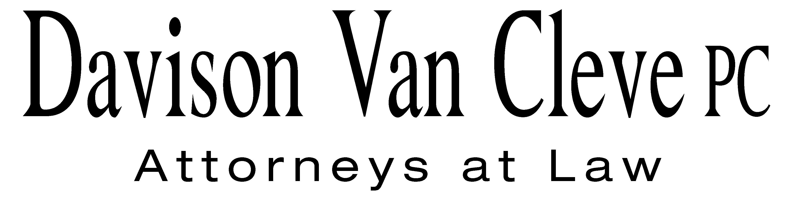
TEL (503) 241-7242 ● FAX (503) 241-8160 ● mail@dvclaw.com
Suite 400
333 SW Taylor
Portland, OR 97204

April 18, 2013

Via Email and Federal Express

Mr. Steven King
Washington Utilities and Transportation Commission
PO Box 47250
1300 S Evergreen Park Drive SW
Olympia, WA 98504-7250

Re: In the Matter of PUGET SOUND ENERGY, INC. Expedited Rate Filing
WN V-60, Tariff G, Electric Service, Advice No. 2013-01
Docket Nos. UE-130137/UG-130138

Dear Mr. King:

Enclosed please find an original and sixteen (16) copies of the Confidentiality Agreements of Melinda J. Davison, Joshua D. Weber, Donald Schoenbeck, and Michael Deen on behalf of the Industrial Customers of Northwest Utilities.

Thank you for your assistance.

Sincerely yours,

/s/ Sarah A. Kohler
Sarah A. Kohler
Enclosures

cc: Service List

CERTIFICATE OF SERVICE

I hereby certify that I have this day served the foregoing documents upon all parties of record in this proceeding by electronic mail.
DATED this 18th day of April, 2013.
Davison Van Cleve, P.C.

/s/ Sarah A. Kohler
Sarah A. Kohler

PUGET SOUND ENERGY  KEN JOHNSON  PO BOX 97034 PSE-08N  BELLEVUE WA 98009-9734  ken.s.johnson@pse.com | PUBLIC COUNSEL  SIMON FFITCH  800 FIFTH AVENUE STE 2000  SEATTLE, WA 98104-3188  simonf@atg.wa.gov
WASHINGTON UTILITIES & TRANSPORTATION COMMISSION  SALLY BROWN  PO BOX 40128  OLYMPIA, WA 98504  sbrown@utc.wa.gov | CHAD STOKES  Cable Huston Benedick Haagensen & Lloyd, LLP  1001 SW 5th Avenue STE 2000  Portland, OR 97204
Ronald L Roseman  Attorney At Law  2011 - 14th Avenue East  Seattle, WA 98112 | Damon E Xenopoulos  Brickfield, Burchette, Ritts & Stone, P.C.  1025 Thomas Jefferson Street NW; Eighth Floor-West Tower  Washington, DC 20007
Nucor Steel Seattle, Inc.  Nucor Steel  2424 SW Andover  Seattle, WA 98106-1100 | NORTHWEST INDUSTRIAL GAS USERS  ED FINKLEA  326 Fifth Street  Lake Oswego, OR 97034
KURT J BOEHM  Boehm, Kurtz & Lowry  36 E. Seventh St. STE 1510  Cincinnati, OH 45202 | Quality Food Centers, Inc.  10116 N.E. 8th Street  Bellevue, WA 98004
John Carr  Industrial Customers of Northwest  Utilities  818 SW 3rd Avenue # 266  Portland, OR 97204 | The Kroger Co.  1014 Vine Street  Cincinnati, OH 45202
Charles M Eberdt,  Manager  The Energy Project  3406 Redwood Ave  Bellingham, WA 98225 | Norman Furuta,  Associate Counsel  Department of the Navy  1455 Market Street STE 1744  San Francisco, CA 94103-1399
PERKINS COIE  SHEREE CARSON  10885 N.E. FOURTH STREET STE 700 BELLEVUE WA 98004-5579 | Fred Meyer Stores, Inc.  3800 Southeast 2nd Street  Portland, OR 99202

