
Mark Brinton
Manager, Regulatory Operations
Mark.Brinton@CenturyLink.com
1801 California St 10th Floor
Denver, CO 80202
Voice: (303) 992-5832

July 16, 2014

Withdraw: Advice No. WA 14-10A

Steven King
Executive Director and Secretary
1300 S. Evergreen Park Dr. S.W.
P.O. Box 47250
Olympia, Washington 98504-7250

Dear Mr. King:

United Telephone Company of the Northwest d/b/a CenturyLink is withdrawing the sheets listed on Attachment A at the request of the Washington Commission Staff. The original filing was made on July 1, 2014.

CenturyLink QC respectfully requests that this withdrawal become effective on July 16, 2014. If you have questions concerning this filing, please contact Mark Brinton – Regulatory Operations on (303) 992-5832.

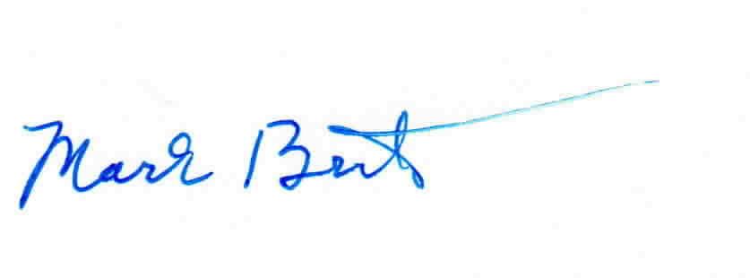
Sincerely,

Mark Brinton

Attachments

Attachment A
Withdraw: Advice No. WA 14-10A

ACCESS SERVICE
WN U-11

SECTION | SHEET | REVISION
3 | 3-1 | 1st
6 | 6-108 | 1st
6 | 6-144 | 2nd
6 | 6-145 | 1st
6 | 6-146 | 1st

