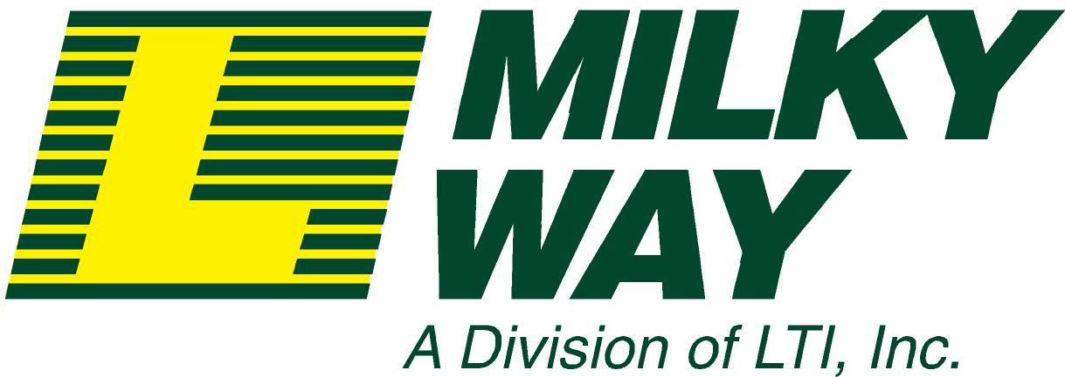
May 11, 2007

Carol Washburn
State of Washington
Utilities and Transportation Commission
P.O. Box 47250
Olympia, WA 98504-7250

Re: WUTC Reference # 070696

Ms. Washburn,

This letter is submitted in opposition to removal of the railroad crossing on West Hickox Road near Mt Vernon, WA.

Our company provides transportation services, hauling fresh bulk milk from PNW dairy farms to their markets. West Hickox Road and this particular crossing are used daily in the course of our milk hauling operations to serve dairy farmers in this area.

We believe that removing the Hickox Road railroad crossing will negatively impact; residents and the farm business owners in this area, our business, and the general public.

Our concerns are as follows:

Emergency Services:
- Removing the Hickox Road Crossing will increase Emergency Services response time and could leave residents and the general public vulnerable. If construction, weather, traffic accidents, etc. close Dike Road for any period of time, the access and response time of Emergency Services to this area would be further weakened.

Flooding:
- With potential for Skagit River flooding, Dike Road may become impassible from time to time. Removing the Hickox Road crossing would limit access to the residences and farming businesses on Dike Road. As a perishable commodity, if fresh milk is not picked up on regularized schedule, it must be discarded. The impacts are both economic and environmental.

Routing:
- Removing the Hickox Road Crossing would add time and miles to our daily routes. The cost is virtually impossible to pass to dairy product consumers.

- The alternative route will change our direction of travel. The maneuverability of our standard 83-foot long tractor and double tank trailer configuration will be made very difficult by the directional change.
May 11, 2007

Carol Washburn
State of Washington
Utilities and Transportation Commission
P.O. Box 47250
Olympia, WA 98504-7250
Page 2

Re: WUTC Reference # 070696

Hickox Road is a vital access point to the farm businesses and residences in this area. Please do not allow the removal of this very important railroad crossing.

If you have any question or comment, please contact me directly. I can be reached at:

LTI, Inc.
8631 Depot Road
Lynden, WA 98264
bradw@lynden.com
800/327-6255

Thank you for your consideration.

Sincerely,

LTI, Inc. d/b/a/ Milky Way

Brad Williamson
President

May 11, 2007

Carol Washburn
State of Washington
Utilities and Transportation Commission
P.O. Box 47250
Olympia, WA 98504-7250
Page 3

Re: WUTC Reference # 070696

Dairy Farm Locations on Hickox Road and Dike Road near Mount Vernon, WA.

