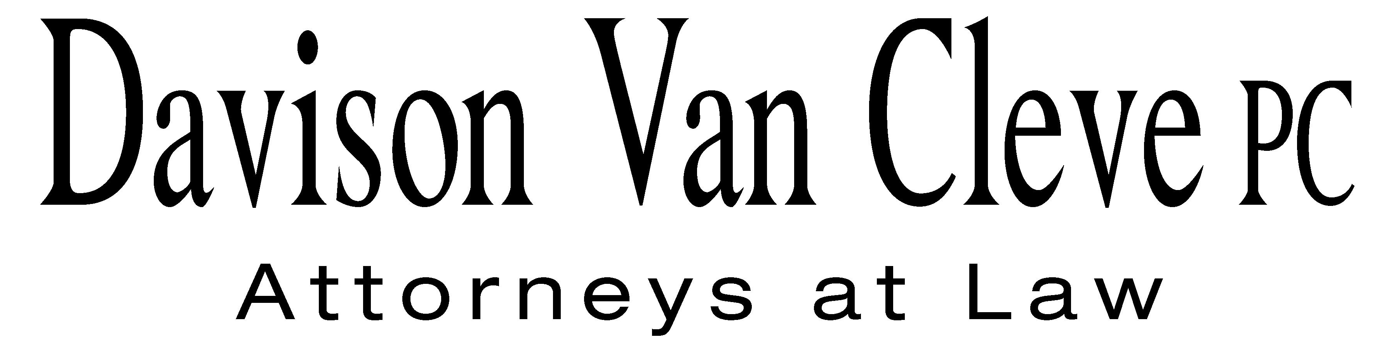
TEL (503) 241-7242 ● FAX (503) 241-8160 ● mail@dvclaw.com
Suite 400
333 SW Taylor
Portland, OR 97204

May 23, 2012

Via Email and Federal Express

Mr. David E. Danner
Executive Director & Secretary
Washington Utilities and Transportation Commission
PO Box 47250
1300 S Evergreen Park Drive SW
Olympia, WA 98504-7250

Re: In the Matter of WUTC v. Avista Corporation

Docket No. UE-120436

Dear Mr. Danner:

Enclosed please find the original and twelve (12) copies of signature pages to the Protective Order of Michael Gorman, Chris Walters, and Magdalena Ackenhausen on behalf of the Industrial Customers of Northwest Utilities in the above-referenced docket.

If you have any questions or concerns, please do not hesitate to contact our office. Thank you for your assistance.

Sincerely yours,

/s/ Sarah A. Kohler
Sarah A. Kohler

Enclosures

cc: Service List

CERTIFICATE OF SERVICE

I hereby certify that I have this day served the foregoing documents upon all parties of record in this proceeding by mailing a copy thereof in a sealed, first-class postage prepaid envelope to each individual’s last-known address, as listed below.
DATED this 23rd day of May, 2012.
Davison Van Cleve, P.C.

/s/ Sarah A. Kohler
Sarah A. Kohler

Charles M Eberdt  The Energy Project  3406 Redwood Ave  Bellingham, WA 98225  CHUCK_EBERDT@oppco.org | David Meyer  Avista Corporation, d/b/a Avista Utilities  PO BOX 3727  Spokane, WA 99220-3727  dmeyer@avistacorp.com
Simon ffitch  Office of the Attorney General  800 5th Ave STE 2000  Seattle, WA 98104-3188  simonf@atg.wa.gov | Lisa Gafken  Office of the Attorney General  800 Fifth Avenue STE 2000  Seattle, WA 98104-3188  lisa.gafken@atg.wa.gov
Ronald L Roseman  Attorney At Law  2011 - 14th Avenue East  Seattle, WA 98112  ronaldroseman@comcast.net | Don Trotter  Assistant Attorney General  WUTC  PO Box 40128  Olympia, WA 98504-0128  dtrotter@utc.wa.gov
Donald W Schoenbeck  RCS, Inc.  900 Washington Street STE 780  Vancouver, WA 98660  dws@r-c-s-inc.com | Kelly Norwood  Vice President  Avista Corporation, d/b/a Avista Utilities  1411 E. Mission  Spokane, WA 99220  kelly.norwood@avistacorp.com
Paula E Pyron  Executive Director  NORTHWEST INDUSTRIAL GAS USERS  4113 Wolf Berry Court  Lake Oswego, OR 97035-1827  ppyron@nwigu.org | Michael Fassio  Assistant Attorney General  WUTC  PO Box 40128  Olympia, WA 98504-0128
Todd D. True  NW Energy Coalition  705 Second Avenue STE 203  Seattle, WA 98104 | Kristen Boyles  NW Energy Coalition  705 Second Ave. STE 203  Seattle, WA 98104
Amanda Goodin
NW Energy Coalition
705 Second Avenue STE 203
Seattle, WA 98104

Chad M Stokes  Attorney  Cable Huston Benedick Haagensen & Lloyd, LLP  1001 SW 5th Avenue STE 2000  Portland, OR 97204  cstokes@cablehuston.com | Tommy A Brooks  Attorney  Cable Huston Benedick Haagensen & Lloyd, LLP  1001 SW 5th Avenue STE 2000  Portland, OR 97204-1136  tbrooks@cablehuston.com

