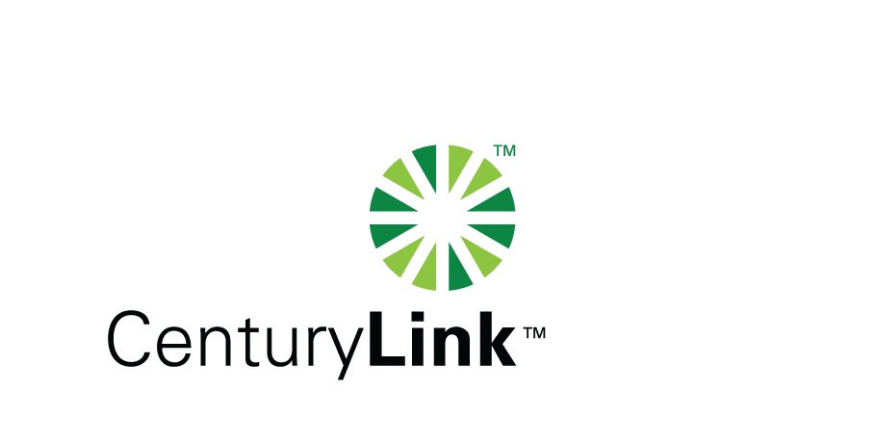

November 15, 2013

Steven V. King, Executive Director & Secretary
Washington Utilities & Transportation Commission
1300 S Evergreen Park Drive, SW
Olympia, Washington 98504-7250

Re: CenturyTel of Washington, CenturyTel of InterIsland and
CenturyTel of Cowiche (“CenturyLink”) Quality of Service Reports for October 2013

Dear Mr. King:

Attached is CenturyLink’s Service Quality Report for the month of October, 2013 in confidential and redacted versions.

The trouble reports per 100 access lines objective was met for the month of October with the exception of Creston at 4.2 where 4 tickets were received due to a bad line card and Nespelem at 4.3 where 13 tickets were received due to a third party damaging buried cable.

If you should you have any questions, please contact Mark Reynolds at (206) 345-1568 or by e-mail at mark.reynolds3@centurylink.com.

Sincerely,

Mark Reynolds

Enclosures: Installation/Repair Appointments
Service Activation in 5 Days
Trouble Per 100/Access Lines
Switching – Dial Tone Speed in 3 Seconds
Final Trunk Blockage (EAS and Toll)
Out of Service Trouble Cleared in 48 Hours
Not Out of Service Trouble Cleared in 72 Hours
Service Activation Delay 90-180 Days

