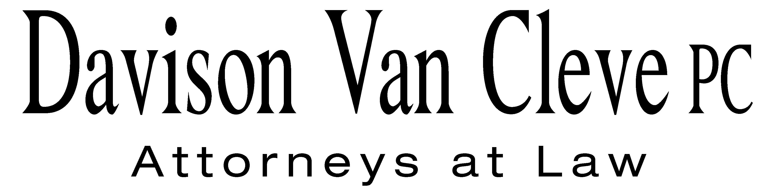
TEL (503) 241-7242 ● FAX (503) 241-8160 ● mail@dvclaw.com
Suite 400
333 SW Taylor
Portland, OR 97204

March 9, 2009

2BVia Email and Federal Express

0BCarole J. Washburn
Secretary
Washington Utilities and Transportation Commission
PO Box 47250
1300 S Evergreen Park Drive SW
Olympia, WA 98504-7250

Re: In the matter of WUTC v. PacifiCorp

Docket No. UE-090205

Dear Ms. Washburn:

Enclosed please find signed confidentiality agreements for Melinda J. Davison, Irion A. Sanger, Randall J. Falkenberg, Fiona Chang, Donald W. Schoenbeck, Robynn L. Woodbury, Michael Gorman, Magdalena Ackenhausen, and James A. Leyko on behalf of the Industrial Customers of Northwest Utilities in the above-referenced matter.

Thank you for your assistance. If you have any questions, please do not hesitate to call our office.

Sincerely yours,

U/s/ Brendan E. Levenick
Brendan E. Levenick
Enclosures

cc: Service List

CERTIFICATE OF SERVICE

I hereby certify that I have this day served the foregoing documents upon all parties of record in this proceeding by mailing a copy thereof in a sealed, first-class postage prepaid envelope to each individual’s last-known address, as listed below.
DATED in Portland, Oregon this 9th day of March, 2009.
Davison Van Cleve, P.C.

/s/ Brendan E. Levenick
Brendan E. Levenick

CATHIE ALLEN  PACIFIC POWER  REGULATORY AFFAIRS  825 NE MULTNOMAH STREET, STE 2000  PORTLAND OR 97232  E-mail:cathie.allen@pacificorp.com | KATHERINE MCDOWELL  MCDOWELL & RACKNER P.C.  Representing Pacific Power  520 SW 6TH AVENUE, STE 830  PORTLAND OR 97204  E-mail: katherine@mcd-law.com
MICHELLE MISHOE  LEGAL COUNSEL  PACIFICORP  Representing Pacific Power  825 NE MULTNOMAH STE 1800  PORTLAND OR 97232  E-mail: michele.mishoe@pacificorp.com | DON TROTTER  ASSISTANT ATTORNEY GENERAL  WUTC  ATTORNEY GENERAL SECTION  STATE MAIL STOP 40128  E-mail: dtrotter@utc.wa.gov
SIMON FFITCH
AAG
OFFICE OF THE ATTORNEY GENERAL
PUBLIC COUNSEL
800 FIFTH AVENUE STE 2000
SEATTLE WA 98104-3188
E-mail: simonf@atg.wa.gov

