BEFORE THE WASHINGTON UTILITIES AND TRANSPORTATION COMMISSION

PUGET SOUND ENERGY’S REPORT CONCERNING ITS TEN-YEAR CONSERVATION POTENTIAL AND ITS BIENNIAL CONSERVATION TARGET  PURSUANT TO RCW 19.285.040 AND WAC 480-109-010 | DOCKET NO. UE-111881

COMMENTS OF PUBLIC COUNSEL
December 7, 2011
I. INTRODUCTION
- Pursuant to the Commission’s November 4, 2011 Notice of Opportunity to Comment, (Notice) the Public Counsel Section of the Washington State Attorney General’s Office (Public Counsel) respectfully submits these comments in advance of the Commission’s December 15, 2011 Open Meeting. These comments address Puget Sound Energy’s (PSE or the Company) report concerning its ten-year conservation acquisition potential and its biennial conservation target filed with the Commission in compliance with RCW 19.285.040 and WAC 480-109-010. The ten-year potential and biennial conservation target are included in PSE’s 2012-2013 Biennial Conservation Plan (BCP). In addition to acting as the compliance report for WAC 480-109-010, the BCP also addresses additional requirements included in the settlement terms for electric conservation in Docket No. UE-100177 (2010 Electric Conservation Settlement Agreement).
- PSE proposed a ten-year conservation potential of 3,531,508 MWh and a biennial conservation target of 666,000 MWh based on its 2011 IRP. PSE’s BCP and its exhibits and attachments provide facts and evidence regarding how the ten-year potential and biennial target were developed, as well as discussion of how the Company will meet the biennial target. Based on our involvement in the public process and review of PSE’s BCP, Public Counsel has not found any reason for concern regarding how the Company developed its ten-year potential and biennial target. We believe that this filing is in compliance with the requirements of the EIA and the 2010 Conservation Settlement Agreement, and that the Commission should approve the target, with conditions. Public Counsel’s comments will provide a brief overview and discussion of (1) the proposed ten-year potential and biennial target, (2) the public involvement process, (3) the Biennial Conservation Plan, and (4) recommended conditions for approval of the target.
- TEN-YEAR POTENTIAL AND BIENNIAL TARGET

- Basis for PSE’s Ten-Year Potential and Biennial Target.

- PSE’s Ten-Year Potential was identified through two processes. The majority of the conservation savings associated with the ten-year potential were identified in the Conservation Potential Assessment (CPA) for PSE’s 2011 IRP, using methodologies consistent with the Northwest Power and Conservation Council. According to PSE, the potential identified in the IRP consists of the “optimized level of energy use and distribution system conservation potential selected by PSE’s resource portfolio model for the 2011 Integrated Resource Plan.” While the CPA identified the conservation potential for energy use and the Company’s distribution system, it did not assess the conservation potential at PSE’s production facilities. In order to account for available reductions in electric power consumption at PSE’s production facilities, the Company conducted energy audits at each facility to identify site-specific efficiency improvements to all energy-consuming equipment. As shown below, PSE has estimated that the vast majority (96%) of its ten-year potential is from Energy Use Conservation. Distribution and Production Conservation account for a very small portion of the potential, at 3% and 1% respectively.

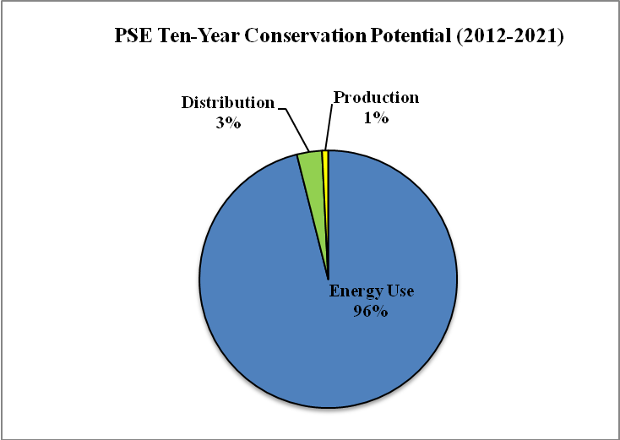
Source: BCP Exhibit: Ten-year Potential and Two Year Target, p.5.

- PSE’s biennial target of 666,000 MWh was derived from the ten-year potential assessment. As the CPA-identified potential is inclusive of savings that are available within the Company’s service territory from all possible sources, the Company made a number of prorata adjustments to account for the fact that it is not realistically feasible to achieve all of the potential through PSE-funded programs. As a result of these adjustments, the biennial target is reduced by approximately 2.5% from the total conservation potential identified for 2012-2013. This target represents an 18% share of the total ten-year conservation potential. At 666,000 MWh the target proposed for 2012-2013 is higher than the Company’s target for the 2010-2011 biennium, although the previous target did not account for production and distribution efficiency. However, even when the estimated savings from production and distribution are removed for the sake of an apples-to-apples comparison, PSE’s proposed biennial target is roughly 4.5% higher than it was in the prior period.
- The biennial target will be met primarily through conservation savings achieved through end-use efficiency programs. As shown below, the Company estimates that approximately 45% of the target will be met through its Residential Energy Management Programs and 47% from the Business Energy Management programs (commercial and industrial customers). Additionally, the Company projects that roughly 6% of the target will be met with savings from NEEA. The remainder, about 2%, will be achieved through distribution and production efficiency.
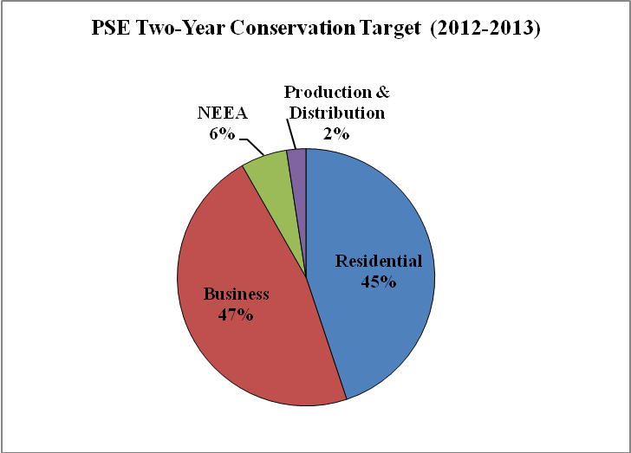
Source: BCP, p. 8.

B. Public Process.

- PSE engaged stakeholders in an appropriate public process for the development and review of its target, potential, and BCP both with the Conservation Resources Advisory Group (CRAG) and the Integrated Resource Plan Advisory Group (IRPAG). As noted in the BCP, the Company held seven IRPAG meetings in 2010-2011, and seven CRAG meetings between late 2010 and the time that the BCP was filed. Over that period of time, the Company provided periodic updates regarding the status of the development of the potential and the target. The content of the October 28, 2011 filing was in accordance with information previously provided to the CRAG and the IRPAG.
- The public process also allowed for discussion of a number of topics related to how the Company will meet its target. For example, PSE informed the CRAG of the challenges and opportunities the Company anticipates in the upcoming period and how those have impacted the way its programs are tailored. Additionally, the Company provided information regarding the internal processes PSE relies upon for reviewing and updating its programs and unit energy savings (UES) estimates throughout the biennium, which will increase the reliability of the Company’s reported savings.
- Biennial Conservation Plan.
- PSE’s BCP includes extensive documentation of the process by which the Company estimated its potential and target. It also includes important information regarding the methods and practices by which the Company will meet the biennial target, such as sector and program level-estimated savings, program budgets and anticipated savings, and processes for evaluating, measuring, and verifying the portfolio. The content provided in the BCP provides relevant facts and evidence in support of the Company’s proposed ten-year potential and biennial target, and also meets the reporting requirements laid out in the 2010 Conservation Settlement Agreement.
- At this time, discussion of the BCP is be limited to how it meets requirements related to the EIA. The specific details of PSE’s electric and natural gas programs and budgets contained in the BCP will be reviewed in Docket No. UE-111860 and UG-110861 and for which Public Counsel will provide separate comments.
III. PUBLIC COUNSEL CONCLUSIONS AND RECOMMENDATIONS

- Based on review of this filing and involvement in the stakeholder process, Public Counsel believes that PSE has met the requirements of RCW 19.285.040, WAC 480-109-010 and in the 2010 Electric Conservation Settlement Agreement. Public Counsel recommends the Commission approve PSE’s proposed ten-year potential and biennial target subject to the conditions included in the 2010 Electric Conservation settlement. Additionally, as discussed below, we request the Commission to provide guidance over the upcoming biennium on two issues that are currently addressed in an inconsistent manner across utilities.
- Conditions.

- PSE’s conservation programs have been operating under settlement agreement conditions in Docket Nos. UE-011571 and UG-011571. In Docket No. UE-100177, PSE’s first EIA compliance filing, the 2002 conditions and settlement agreement were updated as they related to electric conservation, primarily with the purpose of creating a framework that would assist with EIA compliance. According to the terms of the 2010 Electric Conservation Settlement Agreement:
Except where expressly stated, the conditions in Section K and all other provision of this Agreement are intended to remain in effect notwithstanding the biennial review conducted under the Energy Independence Act. Any party may petition to, or the Commission may on its own motion and notice to parties, modify the conservation program if required by the results of the review.

- The Company has indicated, both in its BCP and as a part of the public process, it will abide by the ongoing obligations of the 2010 Electric Conservation Settlement Agreement. Public Counsel believes these conditions remain relevant and that this approach is reasonable, particularly in light of the considerable effort that went into developing the conditions and the short period of time that has passed since the conditions were approved in September 2010. PSE has developed processes to ensure the conditions are being implemented and tracked, and there have been no significant problems with how the programs are operating under the current conditions.
- One problematic outcome of this approach is the elimination of Condition K(6)(g). This condition requires a one-time only, third-party evaluation to verify portfolio-level electric energy savings for the 2010-2011 biennium. As a part of this condition, the Company will submit the third party evaluation as a part of its biennial report on conservation program achievement. Public Counsel believes this third-party portfolio verification is likely to provide a useful purpose to the Commission, Staff, and stakeholders for the assessment of whether the Company has met its Biennial Conservation target in periods beyond the 2010-2011 biennium.
- In the same way that significant revisions to the conditions list are premature at this time because of the short period of time that they have been in effect, we also believe it is too early to eliminate what could be an important component of the compliance review before the parties are able to fully evaluate its role in EIA compliance. Public Counsel plans to raise the issue with the Company and the CRAG, and to discuss continuation of this important condition beyond its scheduled expiration.
- Consistency Issues.
- In the course of reviewing conservation-related compliance filings across multiple utilities, Public Counsel has recognized some inconsistencies. For example, we note that there is some uncertainty regarding the timing and approach to prudence determination of conservation expenditures for different utilities. This is an area that we believe requires further attention from all stakeholders and the Commission in the next biennium in order to resolve this inconsistent treatment.
- Additionally, we note that the three electric IOUs have taken different approaches to incorporating projected savings from NEEA's market transformation efforts in their proposed biennial targets for 2012-2013. The three different approaches are summarized below:
- Avista's BCP states that the biennial target is directly from its CPA, which includes a range of energy efficiency measures, regardless of delivery, and therefore includes savings acquired through NEEA. Avista's does not identify a specific amount of projected savings from NEEA within its biennial target, but the 2012 Business Plan projects 7,359 MWh from NEEA in 2012, about 15% of projected Washington electric DSM savings. Avista also states in their BCP that with respect to claiming NEEA savings, "[t]he methodology will be based upon the inclusion of the net market effects and the natural adoption of these regionally supported services and technologies ...."
- PSE's proposed biennial target for 2012-2013 includes 38,800 MWh for projected NEEA savings, which represents about 6% of PSE's proposed target. This amount reflects 75% of NEEA's projected net market effects savings allocated to PSE from currently funded and previously funded NEEA initiatives. PSE is seeking to "deem" this conservative value of savings, and would report this amount in June, 2014, even if actual NEEA savings are higher or lower. PSE discussed this approach with the CRAG and the CRAG supported this approach, with the understanding that there is a need for consistency in the way the utilities claim NEEA savings.
- Pacificorp's proposed biennial target for 2012-2013 includes 2.0 aMW for projected NEEA savings (17,520 MWh), which represents about 22% of Pacificorp's proposed target. This amount reflects NEEA's Total Regional Savings for the Company's Washington service territory, less savings from Pacificorp's local programs on relevant measures. This approach includes savings from what NEEA terms "naturally occurring baseline," or savings that would occur naturally. Pacificorp has included a memo from NEEA regarding the savings projections for the biennium as Appendix 9 to the Company's proposed 2012-2013 biennial target filed September 15, 2011.
- At this time Public Counsel does not endorse one particular approach over another in terms of the inclusion of NEEA savings in the biennial target. While it may not be feasible for the 2012-2013 biennium, we believe that ultimately it is most appropriate for the IOUs to use a consistent approach to incorporating NEEA savings in their biennial target, and in reporting and claiming savings associated with NEEA. We would welcome guidance from the Commission on this issue.
V. CONCLUSION
- Public Counsel appreciates the opportunity to comment on PSE’s proposed 2012-2013 Biennial Conservation Plan. At this time we respectfully request that the Commission approve PSE’s ten-year conservation potential and biennial conservation target, subject to the conditions of the 2010 Electric Conservation Settlement Agreement. Additionally, we request Commission guidance over the next biennium regarding consistent treatment of NEEA savings and prudence determination of conservation expenditures.

Agreed Conditions for approval of Puget Sound Energy, Inc’s 2010-2011 Biennial Electric Conservation Targets Under RCW 19.285 Docket No. UE-100177 and Agreed Modifications to Electric Settlement Terms for Conservation in Docket No. UE-011570 (2010 Electric Conservation Settlement Agreement).
By comparison, for the 2011-2012 Biennium, PSE’s approved 10 year potential was 3,748,773 MWh and its biennial target was 622,000 MWh.
The Company included with its BCP an exhibit titled “Ten-year Potential and Two-year Target” (Potential and Target Exhibit). This document provides a useful summary of how the potential and the target meet the requirements of WAC 480-109, as well as any additional requirements laid out in the 2010 Conservation Settlement Agreement.
See Comprehensive Assessment of Demand Side Resource Potentials (2012-2013), which is included as Attachment 5 to PSE’s Biennial Conservation Plan.
PSE 2012-2013 Biennial Conservation Plan, Exhibit: Ten-year Potential and Two-year Target (Potential and Target Exhibit), p. 1.
As explained on p. 1 of the Potential and Target Exhibit, as related to its production facilities, PSE has interpreted the definition of conservation in WAC 480-109-007(3) to relate to “any reduction in electric power consumption” due to energy efficiency improvements at the facilities.
Figure 2 of Potential & Target Exhibit provides detail of the Conservation potential identified at each facility.
Energy Use efficiency is includes measures such as improved building shell efficiency, high efficiency electric end-use equipment and controls, and electric-to-gas customer fuel conversion. Potential and Target Exhibit, p. 5.
These additional sources include codes and standards, market transformation, and adoption of conservation measures outside of any programs or code requirements.
Potential & Target Exhibit, p. 7. For further discussion of PSE’s specific prorata adjustments, see Potential & Target Exhibit, pp. 6-8.
For example, the RTF recently reduced the unit energy savings (UES) assumption for retail CFLs by 33%, a measure which accounts for a sizeable portion of the energy savings in the residential portfolio.
See, for example, BCP Exhibit 8, EM&V Framework, Attachment 3, “Guidelines for Evaluation Study Follow-up” and Attachment 5, “Measure Revision Guidelines.”
Public Counsel’s recommendation is premised upon the understanding that the Commission’s approval is limited narrowly to the numerical MWh biennial target and ten- year potential proposed by PSE in this docket. It has become clear in the initial implementation of the EIA that the commission should not prejudge the prudence of any of the underlying energy efficiency activities at this time. The approval of these targets in no way precludes the Commission from reviewing the prudence and cost effectiveness of the DSM programs that the Company will rely upon to meet this target.
Agreed Conditions for approval of Puget Sound Energy, Inc’s 2010-2011 Biennial Electric Conservation Targets Under RCW 19.285 Docket No. UE-100177 and Agreed Modifications to Electric Settlement Terms for Conservation in Docket No. UE-011570 (2010 Electric Conservation Settlement Agreement).
2010 Electric Conservation Settlement, Section B(4)a.
BCP, p. 20.
See BCP Exhibit 9: Condition Compliance Status.
2010 Electric Conservation Settlement Agreement, p. 9.
Docket No. UE-111882, Avista 2012-2013Biennial Conservation Plan (BCP), November 1, 2011, p. 9.
Avista BCP, Appendix A, 2012 DSM Business Plan, Tables 4 and 5, pp. 54-55. The projection of 7,359 MWh of NEEA savings is derived by subtracting Washington local portfolio savings (42,303 MWh, shown in Table 4) from Washington total projected savings (49,662 MWh, shown in Table 5).
Avista BCP, p. 17.
PSE BCP, p. 27.
PSE began using this approach regarding NEEA savings in 2007, based upon CRAG input, in conjunction with PSE's Electric Conservation Incentive Mechanism, in effect from 2007 - 2009. NEEA's "net market effects" (NME) savings are calculated as follows: NME = Total Regional Savings - Naturally Occurring Baseline - Local Programs.
Docket UE-111880, PacifiCorp’s Report on its Ten year Achievable Conservation Potential and Biennial Conservation Target for 2012-2013, September, 15, 2011, Table 9, p. 23. PacifiCorp’s proposed target of 8.89 aMW does not yet include projected distribution efficiency savings.

