June 8, 2009

David Danner
Executive Secretary
Washington Utilities & Transportation Commission
P.O. Box 47250
1300 So. Evergreen Park Dr. SW
Olympia, WA 98504-7250

Re: Docket Number TS-090424
San Juan Express, Inc.

Dear Mr. Danner:

I support the request San Juan Express, Inc. has submitted for a temporary suspension of the service to the San Juan Islands until May 2010. Their request is also supported by the San Juan Islands Visitors Bureau, Gray Line of Seattle, San Juan Outfitters and the San Juan Chamber of Commerce.

During these tough economic times, we have all experienced the effect of temporary changes that businesses and governments must take until the economy recovers. Please feel free to call me if you have any questions.

Sincerely,
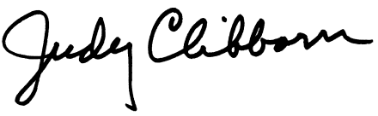
Judy Clibborn
State Representative

