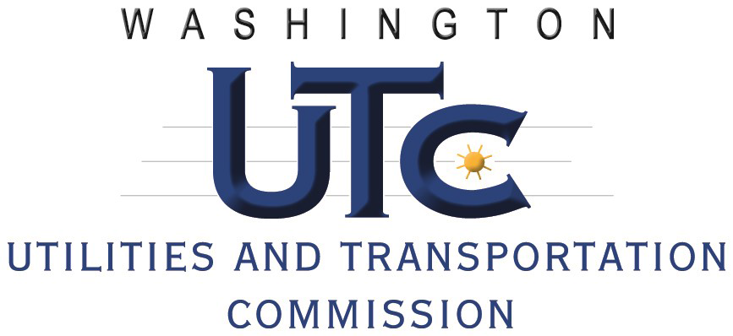 | 1300 S. Evergreen Park Drive SW  PO Box 47250  Olympia, WA 98504-7250  (360) 664-1262 or (360) 664-1202  Fax: (360) 586-1150  Web: www.utc.wa.gov

GRADE CROSSING PROTECTIVE FUND
2017 – 2019 GRANT APPLICATION
IMPROVEMENTS AT PUBLIC PASSIVE RAILROAD CROSSINGS

The Washington Utilities and Transportation Commission (commission), through its Grade Crossing Protective Fund (GCPF), provides grants for projects that eliminate or mitigate public safety hazards at railroad crossings and along railroad rights-of-way in Washington State. As part of this emphasis the commission is also committed to improving safety at public, passively-protected railroad crossings in Washington.

GCPF funds may be used for purchasing stop signs, yield signs, retro-reflective tape, posts (if required), retro-reflective cross buck signs, and emergency notification signs to a maximum of $250 for each crossing. Under this program, GCPF funds may not be used for labor costs if labor is provided by the applicant with current staff. All installations must comply with the Manual on Uniform Traffic Control Devices, 2009 edition.

To apply for a grant to improve safety at a passive railroad crossing, complete the following information and submit it and attachments to the commission.

Please be sure to complete the entire form. Incomplete or missing information can delay the grant review process.

Applicant Information

Applicant Name: Jerry Barnett, PE
Signature:
Organization: Clark County Public Works
Address: PO Box 9810, Vancouver, WA 98666-9810
Phone: 360.773.7664
Email: jerry.barnett@clark.wa.gov

Project Information

Attach additional sheets as necessary that provide the following:

- A list of all other companies, organizations, state agencies or local governments that may be involved in implementing this proposal and the contact name, address and phone number or email address for each (if known).
Organization | Contact/Email
Clark County, Washington | Jerry Barnett
 | jerry.barnett@clark.wa.gov
City of Battle Ground | Scott Sawyer
 | scott.sawyer@cityofbg.org
Portland Vancouver Junction Railroad | Eric Temple
 | etemple@pvjr.com
Battle Ground, Yacolt, Chelatchie Prairie Railroad | Randy Williams
 | BYCXpresident@gmail.com

- A list of each railroad crossing, by USDOT number, street name, and county, where the applicant plans to improve safety. Indicate which type of warning sign or other measure will be installed.
All crossings located in Clark County.
DOT # | Cross Street | Quantity | Type | Unit Cost | Extended Cost
917072P | NE 181st Street | 2 | R1-2 | 25.75 | 51.50
852348T | Eaton Blvd/NE 119th Street | 1 | W10-1 | 62.55 | 62.55
 |  | 1 | Post | 130.00 | 130.00
852350U | Main Street | 1 | W10-4 | 62.55 | 62.55
 |  | 1 | Post | 130.00 | 130.00
852352H | Fairgrounds Ave | 2 | W10-3 | 62.55 | 125.10
 |  | 2 | Post | 130.00 | 260.00
 |  | 2 | W10-5 | 62.55 | 125.10
 |  | 2 | Post | 130.00 | 260.00
 |  | 2 | W10-5P | 34.75 | 69.50
852357S | 259th Street | 2 | R1-2 | 25.75 | 51.50
852385V | Hoag St. | 2 | Crossbuck Posts* | 60.00 | 120.00
 |  | 2 | R1-2 | 25.75 | 51.50
 |  | 2 | W10-3 | 62.55 | 125.10
 |  | 2 | Post | 130.00 | 260.00
852383G | Jones St. | 2 | W10-3 | 62.55 | 125.10
852384N | Cushman | 2 | R1-2 | 25.75 | 51.50
 |  | 2 | R15-2P | 26.10 | 52.20
 |  | 2 | W10-3 | 62.55 | 125.10
 |  | 2 | Post | 130.00 | 260.00
582366R | Yacolt Rd | 1 | R8-8 | 34.75 | 34.75
 |  | 2 | Post | 130.00 | 260.00
 |  | 1 | W10-4 | 62.55 | 62.55
 |  | 2 | Post | 130.00 | 260.00
 |  |  |  | Total: | 3,115.60
* – Crossbuck posts with reflective strips.

- A cost estimate, including:
  - An itemized list of the total costs of the project.
  - Names of parties contributing to the project, including the applicant, and the amount each is contributing.
- See Item 2 above.
- Clark County will contribute the difference between the grant amount and the project costs.

- An estimated timeline of the project.
Crossing improvements will be performed within 1 calendar year after grant award.

- A description of the applicant’s experience in grant management or completing grant projects of this nature, including years of experience, types of projects completed and project cost/scope.
The applicant has procured and managed WUTC and Freight Rail Assistance Program grants in the past. The current Railroad Coordinator for Clark County Public Works has been writing state/federal grant applications and managing grants since 1999. These include road improvements, stormwater facilities, and munitions remediations in the approximate amount of $50M.

- Any other information the applicant believes would be useful to the commission in evaluating the project.
This request is for signs to replace existing signage. Existing signs no longer comply with the Manual on Uniform Traffic Control Devices requirements due to age, vandalism, or other factors.

Railroad Commitment

If the applicant does not own the railroad crossing, the applicant must submit the attached Railroad Commitment form signed and completed by the railroad owning the crossing.

Submitting the Application

After completing the application, please send the original to:
Washington Utilities and Transportation Commission
Attention: Grade Crossing Protective Fund
1300 S. Evergreen Park Drive SW
PO Box 47250
Olympia, WA 98504-7250

A signed application may be filed electronically at records@utc.wa.gov. When filing electronically, please specify “Grade Crossing Protective Fund” in the subject line.

Assistance

For questions or assistance, please contact:
- Betty Young at (360) 664-1202 or byoung@utc.wa.gov
- Lori Halstead at (360) 664-1262 or lhalstea@utc.wa.gov

Replacement signs only. Proposals to install a stop sign at a crossing not currently stop-controlled requires an on-site diagnostic meeting with commission staff, the railroad and road authority, filing a petitionand a commission order authorizing the installation.

