Avista Corp.
1411 East Mission P.O. Box 3727
Spokane, Washington 99220-0500
Telephone 509-489-0500
Toll Free 800-727-9170

August 1, 2016

Mr. Steven King
Executive Director & Secretary
Washington Utilities and Transportation Commission
1300 S. Evergreen Park Drive SW
P. O. Box 47250
Olympia, Washington 98504-7250

RE: Avista Corporation Affiliated Interest Filing (Courtyard Office Center) pursuant to RCW 80.16.020.

Dear Mr. King:
Pursuant to RCW 80.16.020 and WAC 480-90-245, please find enclosed for filing an original and three copies of the “Utility Easement” between Avista Corp. and SPS, INN, L.P., an affiliate of Avista, for a perpetual non-exclusive easement on, over, under, along and across real property by and between Avista and SPS, INN, L.P. The Utility Easement is attached hereto as Attachment A.
INTRODUCTION
The City of Spokane (the “City”) has announced plans to resurface a portion of Lincoln Street between West 2nd Avenue and West 1st Avenue in downtown Spokane. In that street, Avista Corporation, d/b/a Avista Utilities (“Avista”) maintains a variety of underground electric facilities, which the City has asked to be relocated. These facilities are part of Avista’s underground 208 volt downtown Spokane electrical network. Pursuant to its electric Franchise Agreement with the City, Avista has an obligation to accommodate the City’s request.
To the immediate east of Lincoln Street are several properties owned by subsidiaries of Avista. These include, from north to south along Lincoln Street: (a) the Courtyard Office Center, owned by the Courtyard Office Center, LLC, as successor in interest to SPS Inn, LP (“CYOC”); (b) a parking lot, owned by Steam Plant Square, LLC (“SPS”); and (c) the Steam Plant building, owned by SPS. To accommodate the City’s requested relocation, Avista plans to acquire an easement from CYOC to occupy a portion of a maintenance room in the Courtyard Office Center.

DETAILS OF THE TRANSACTION
The Easement Area
As illustrated in Figure 1, below, the area that Avista plans to utilize is located in the northwest corner of the Courtyard Office Center parking/basement level, where the building abuts both First Avenue and Lincoln Street.
Figure 1: Proposed Easement Area (In Red)
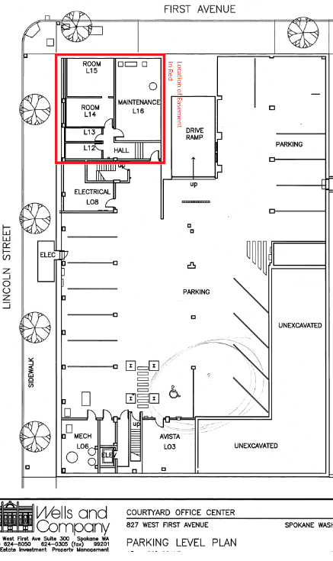
The proposed Easement area is approximately 35’ (east-west) by 40’ (north-south). The area is currently unoccupied, with the exception of a water heater, together with natural gas and water utilities. Avista would place a vault in the location to house its electrical transformers and related equipment.

The duct-line for Avista’s facilities will enter the building on the west side. The vault will be home to two network transformers. Each transformer will have a network protector and primary bus required to make the primary and secondary ties to feed the grid.
Relocating the existing network equipment from the middle of Lincoln to a vault provides several benefits to Avista. First, access to the existing infrastructure has been problematic in the past due to its location in the middle of a busy downtown street. Any previous work at the existing location has led to road closures and other traffic control mitigation. Second, the new two-bay transformer vault will provide for a safer work environment for our network employees.

Consideration
CYOC has agreed to provide the easement at no cost to Avista. For its part, Avista plans to make a few site changes such as relocating the natural gas meter out of this space to eliminate a combined gas/electric space for safety purposes. The water utilities will also need some limited work to accommodate the structural changes necessary to accommodate Avista’s relocated transformers. All other infrastructure improvements will be related to preparation of the transformer vault.
Please direct any questions regarding this filing to Jennifer Smith at (509) 495-2098.

Sincerely,

Kelly O. Norwood
Vice President, State and Federal Regulation
Enclosure

