July 1, 2016
Steven V. King
Executive Director and Secretary
Washington Utilities and Transportation Commission
1300 S. Evergreen Park Drive, SW
Olympia, WA 98504-7250
Re: T-Mobile West LLC Annual Certification
Dear Mr. King:
Enclosed for filing are the following:
- A Word document of T-Mobile West LLC’s Annual Petition for Certification as an ETC;
- A PDF of T-Mobile West LLC’s Annual Petition for Certification as an ETC with the public REDACTED versions of the attachments; and
- A PDF of T-Mobile West LLC’s Annual Petition for Certification as an ETC with the non-public CONFIDENTIAL versions of the attachments.
We do not have Word versions of any of the Attachments.
The confidential attachments to the Annual Petition contain information that is exempt from public inspection, examination and copying pursuant to WAC 480-07-160(2) and RCW 42.56.270(11), namely proprietary data and trade secrets concerning complaints, outages, and T-Mobile's investment in its network. This competitively sensitive information would harm T-Mobile's business with respect to its competitors if disclosed.
Please feel free to contact me with any questions.
Very truly yours,
Davis Wright Tremaine LLP
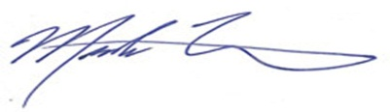
Mark P. Trinchero
Attorneys for T-Mobile West LLC

MPT/jan
Enclosures

