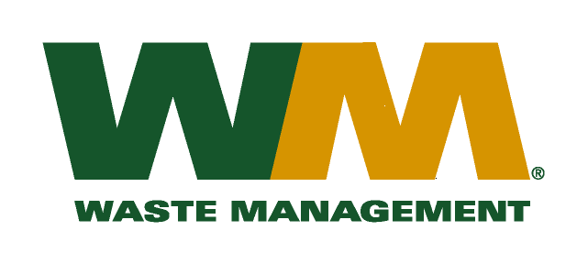
July 30, 2026
Washington Utilities and Transportation Commission
Chandler Plaza Building
1300 S. Evergreen Park Drive SW
P.O. Box 47250
Olympia, WA. 98504-7250

Subject: Waste Management of Ellensburg, a division of Waste Management of Washington, Inc. (G-237); Tariff # 12
Dear Sirs:
Enclosed herein, please find revised pages 2, 21, 23, 24, 29, 30, 32, and 33 to the above-referenced tariff. These proposed revised tariff pages contain decreased rates for residential and commercial garbage collection services. The requested rate decrease is necessary to comply with the resolution passed by the Kittitas County Board of Commissioners. The county commissioners approved the change in disposal fees from $101.34 to $99.85 per ton as reflected in Kittitas County Resolution 2016-082. The effective date of the disposal fee change will be August 1, 2016. The decreased rates, if approved by the commission, would approximately decrease Company revenue by $12,500, and residential and commercial garbage rates by 0.6%. The effective date of the proposed tariff revisions is August 1, 2016.
Also enclosed for your review are our accounting workpapers and Resolution No. 2016-082 for Kittitas County. Upon approval by the Commission, affected customers will be notified of this rate change on their next regularly scheduled billing. If you have any questions or need additional information, please contact me at (425) 814-7840.
Very truly yours,
Michael A. Weinstein
Senior Pricing Manager, Pacific Northwest Market Area

cc: Aaron Kelly
Adam Winston
Joe Krukowski
Clerk of the Board, Kittitas County Chair

