CenturyLink

1801 California Street, 10th Floor

Denver, Colorado 80202

303-992-5832

May 26, 2016

Advice No. 3714T

Steven King
Executive Director and Secretary
1300 S. Evergreen Park Dr. S.W.
P.O. Box 47250
Olympia, Washington 98504-7250

Dear Mr. King:

Qwest Corporation d/b/a CenturyLink QC is forwarding for filing the sheets listed on Attachment A.

As described in the attached narrative (“Description of Methodology”), this filing is the fifth step in implementing the “Transitional Intrastate Access Service” reductions mandated by the Federal Communications Commission's November 18, 2011 Report and Order and Further Notice of Proposed Rulemaking in WC Docket Nos. 10-90, etc. (FCC 11-161). Also enclosed is CenturyLink’s certification that the company is not seeking duplicative recovery in the state jurisdiction for any Eligible Recovery subject to the recovery mechanism established by the Transformation Order. The calculations supporting these rate changes are being filed as confidential.

As part of this filing CenturyLink is also changing tariff language to allow customers to report PIU/PVU factors by state rather than LATA. In addition, obsolete billing language is being revised.

CenturyLink QC respectfully requests that these proposed rate changes become effective on July 1, 2016.

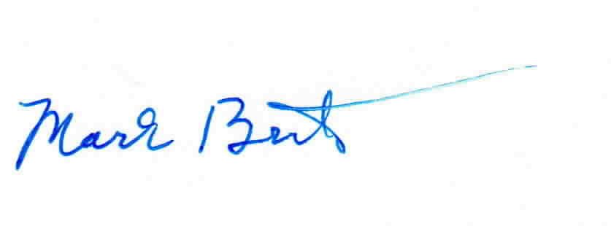
Sincerely,

Mark Brinton
Manager Regulatory Operations
Office: (303) 992-5832
e-mail: Mark.Brinton@CenturyLink.com

Attachments

Attachment A
Advice No. 3714T

ACCESS SERVICE
WN U-48

SECTION | SHEET | REVISION
2 | 14 | 1st
2 | 15 | 1st
2 | 16 | 1st
2 | 17 | 1st
2 | 18 | 1st
2 | 19 | 1st
2 | 20 | 1st
2 | 23 | 1st
2 | 24 | 1st
2 | 26 | 1st
2 | 34 | 2nd
6 | 46 | 1st
6 | 53 | 1st
6 | 122 | 1st
6 | 146 | 5th
6 | 151 | 1st
8 | 2 | 1st
8 | 4 | 1st
8 | 5 | 1st
8 | 7 | 1st
8 | 8 | 1st
13 | 34 | 1st
13 | 35 | 1st
15 | 13 | 4th

