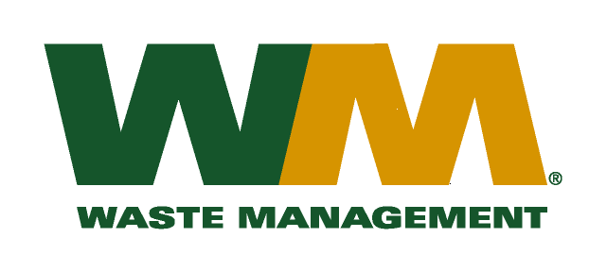
July 29, 2026
Washington Utilities and Transportation Commission
Chandler Plaza Building
1300 S. Evergreen Park Drive SW
P.O. Box 47250
Olympia, WA. 98504-7250

Subject: Waste Management of Spokane, a division of Waste Management of Washington, Inc.(G-237); Tariff #18
Dear Sirs:
Enclosed herein, please find revised pages, 2 and 33 to the above-referenced tariff. These proposed revised tariff pages reflect an increase in the Item 230 – Disposal Fees charged at the Graham Road Recycling & Disposal Facility. The City of Spokane approved the increase in disposal fees from $102.39 to $105.36 to be effective on January 1, 2016.
Enclosed for your review is a letter from the City of Spokane informing us of the increase in the rate. Upon approval by the Commission of this filing, affected customers will be notified of this rate increase on their next regularly scheduled billing.
If you have any questions or need additional information, please contact me at (425) 814-7840.
Very truly yours,
Michael A. Weinstein
Senior Pricing Manager, Pacific Northwest Market Area

cc: Jesse Granado
Clerk of the Board, Spokane County Chair

