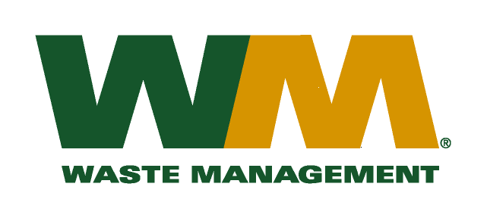
July 29, 2026
Washington Utilities and Transportation Commission
Chandler Plaza Building
1300 S. Evergreen Park Drive SW
P.O. Box 47250
Olympia, WA. 98504-7250

Subject: Waste Management of Greater Wenatchee, a division of Waste Management of Washington, Inc.(G-237); Tariff #13
Dear Sirs:
Enclosed herein, please find revised pages, 2, 21, 22, 23, 30, 31, 32, 33, 34 and 35 to the above-referenced tariff. These proposed revised tariff pages contain increased rates for residential and commercial garbage collection services. The requested rate increase is necessary in order to recover increased disposal costs at the Greater Wenatchee Regional Landfill & Recycling Center (GWRLF). The GWRLF notified us and other haulers of an increase in landfill disposal fee rates on December 9, 2015. Rates at the landfill for MSW waste will increase from $62.70 to $65.83 per ton on March 1, 2016. The increased rates, if approved by the commission, would approximately increase Company revenue by $97,000 and residential and commercial garbage rates collectively by 1.6%. The effective date of these proposed tariff revisions is March 1, 2016.
Enclosed for your review are our accounting work papers that reflect the results of operations from our last general rate filing approved in TG-120523 and as updated in TG-131125 with the last disposal fee increase. There have been no significant changes in the operations of Waste Management of Greater Wenatchee since this prior case. In addition, a copy of the letter from the GWRLF notifying us and other haulers of the increase in disposal fees is enclosed for your review. Upon approval by the Commission of this filing, affected customers will be notified of this rate increase on their next regularly scheduled billing.
If you have any questions or need additional information, please contact me at (425) 814-7840.
Very truly yours,
Michael A. Weinstein
Senior Pricing Manager, Pacific Northwest Market Area

cc: Aaron Kelly
Tami Yager
Clerk of the Boards, Chelan and Douglas County Chairs

