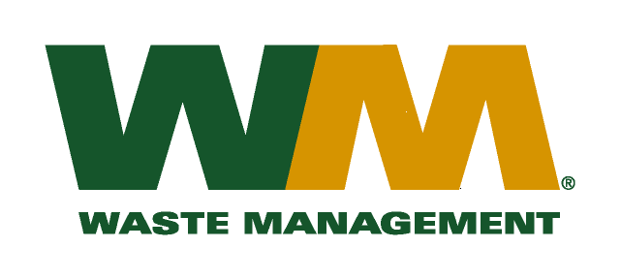
July 31, 2026
Washington Utilities and Transportation Commission
Chandler Plaza Building
1300 S. Evergreen Park Drive SW
P.O. Box 47250
Olympia, WA 98504-7250
Subject: Waste Management–South Sound and Waste Management of Seattle, divisions of Waste Management of Washington, Inc. (G-237); Tariff # 23

Enclosed are revised pages 2, 22, 25 and 27 to the above-referenced tariff. The purpose of these tariff revisions is to reflect the change in the commodity credits for residential and multi-family customers receiving recycling collection services. These tariff revisions reflect a decrease of the current commodity credit from $1.40 to $0.87 per month for residential customers in King County. Multi-family commodity credits are decreasing proportionately to the decreases to residential customers. As a result, this filing seeks approval to implement an increase in customers’ solid waste collection rates.
The decrease in the commodity credit is due to the overall change in commodity values and tonnages since our last commodity credit adjustment on January 1, 2015. The proposed effective date of the revised recycling commodity credit is January 1, 2016.
As a reminder of context, this filing is being submitted at the end of the two-year Revenue Sharing Plan with King County for 2014 - 2015. It is the second annual adjustment to the commodity credit that has been made during the two-year plan period, and as required by WAC 480-70-351 reflects the change to the commodity rebate due to actual prices and quantities over the past 12 months. In addition and in accordance with RCW 81.77.185 and the approved Plan, the Company has reflected in this filing the incentive earned and the amount over or under spent on program activities over the past two years.
Furthermore, in accordance with RCW 81.77.185, the recycling commodity credit is also being adjusted to accommodate the new Revenue Sharing Plan with King County for 2016 - 2017, under which the Company is authorized to retain up to 47.5% of recycling commodity revenues to be spent on program activities. The 2016 - 2017 Revenue Sharing Plan with King County that has been certified by County officials, is included with this filing with the budget for anticipated revenues and expenditures and narrative explanations of how the recycling revenue retained will be used to increase recycling. The County will be separately filing their Plan certification, as well as an analysis of the Company’s performance supporting the incentives earned under the 2014-2015 Plan.
Enclosed for your review are our accounting work papers. Customers will be notified of the change in their commodity credit adjustment on their next regularly scheduled billing after the approval of the Commission. In addition, the counties have been notified of these proposed tariff changes.
If you have any questions or need additional information, please contact me at (425) 814-7840.
Very truly yours,

Mike Weinstein
Senior Pricing Manager, Pacific Northwest Market Area
cc: Marc Davis & Lewis Carver, Waste Management
Pat D. McLaughlin, King County Solid Waste Division

