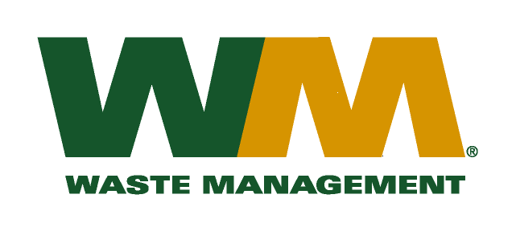
July 30, 2026
Washington Utilities and Transportation Commission
Chandler Plaza Building
1300 S. Evergreen Park Drive SW
P.O. Box 47250
Olympia, WA 98504-7250

Subject: Brem-Air Disposal, a division of Waste Management of Washington, Inc. (G-237); Tariff # 20
Enclosed are the revised tariff pages 2, 22 and 25 to the above-referenced tariff. The purpose of these tariff revisions is to reflect the change in the commodity credits for residential and multi-family customers receiving recycling collection services. These tariff revisions reflect a small decrease in the current recycling credit from <$2.24> per month to a credit of <$2.02> per month for residential customers and a decrease in the current recycling credit of <$0.41> per unit to a credit of <$0.39> per unit for multi-family customers.
These changes are jointly due to the change in commodity values, tonnages and materials composition since our last commodity credit adjustment on November 1, 2014. We are requesting that the proposed effective date of these tariff revisions be November 1, 2015.
Enclosed for your review are our accounting work papers. Customers will be notified of the change in their recycling <credit> debit adjustment on their next regularly scheduled billing after approval by the Commission. In addition, the county has been notified of these proposed tariff changes.
If you have any questions or need additional information, please contact or me at (425) 814-7840.
Very truly yours,

Michael A. Weinstein
Senior Pricing Manager, Pacific Northwest Market Area

cc: Joe Krukowski
Marc Davis
Clerk of the Board, Kitsap County Chair

