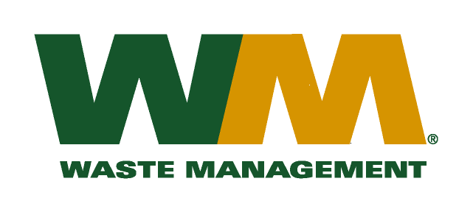
September 10, 2015
Washington Utilities and Transportation Commission
Chandler Plaza Building
1300 S. Evergreen Park Drive SW
P.O. Box 47250
Olympia, WA. 98504-7250

Dear Sirs:
Subject: Waste Management of Greater Wenatchee, a division of Waste Management of Washington, Inc.(G-237); Tariff # 13
Please find enclosed revised tariff pages 2 and 6 for the above-referenced company. The purpose of these tariff page revisions is to reflect the increase in garbage utility tax adopted by the City of Cashmere. Pursuant to Ordinance No. 1204, as codified in Title 5 of the Cashmere Municipal Code a utility tax of 10% is to be levied on the total gross revenues earned from businesses engaged in garbage collection within the City limits. Although the City of Cashmere provides its own garbage collection service to residents of the City there are annexed areas of the City currently under the jurisdiction of the WUTC and serviced by Waste Management. We currently service 11 customers in this annexed territory. The effective tax rate to be billed to our customers will be 11.11%. The proposed effective date of these tariff revisions is November 1, 2015.
Enclosed for your review is a copy of Title 5 to the City of Cashmere Municipal Code. Customers will be notified of this new fee on their next regularly scheduled billing after the approval by the Commission.
If you have any questions or need additional information, please contact me at (425) 814-7840.
Very truly yours,
Michael A. Weinstein
Senior Pricing Manager, Pacific Northwest Market Area

cc: Aaron Kelly
City of Cashmere

