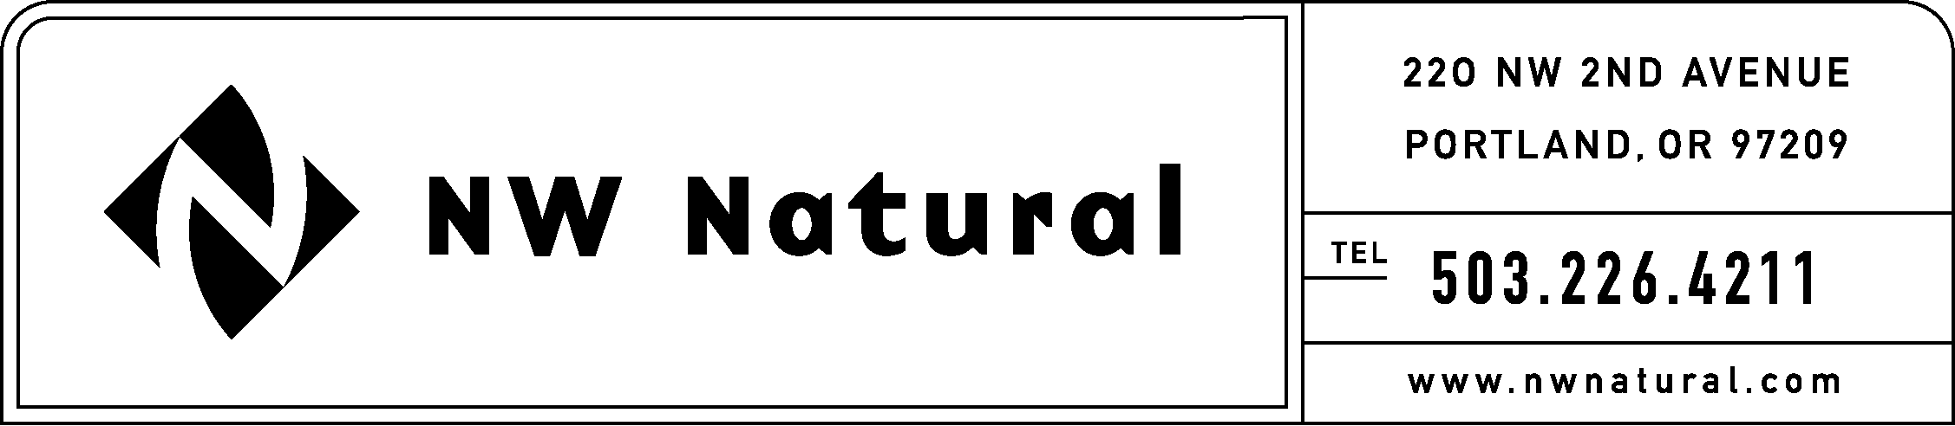
GAIL HAMMER
Tariff and Regulatory Compliance
Phone: 503.226.4211 ext. 5865
Fax: 503.721.2516
gail.hammer@nwnatural.com

August 28, 2015

Steven King, Executive Director and Secretary
Washington Utilities and Transportation Commission
1300 S. Evergreen Park Drive, S.W.
P.O. Box 47250
Olympia, Washington 98504-7250

RE: NW Natural’s 2016 IRP Work Plan

Northwest Natural Gas, dba NW Natural (“NW Natural” or the “Company”), herein files its 2016 Integrated Resource Plan (“IRP”) Work Plan in compliance with Washington Administrative Code (“WAC”) 480-90-238, which states,

(4) The work plan must outline the content of the integrated resource plan to be developed by the utility and the method for assessing potential resources.

and

(5) The work plan must outline the timing and extent of the public participation.

If you have any questions regarding this plan, please contact me at
1-503-226-4211, extension 5865.

Sincerely,

/s/ Gail Hammer

Gail Hammer
Rates and Regulatory Affairs

enclosures

