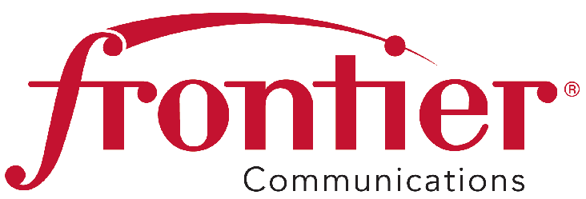
August 4, 2015

Frontier Communications Northwest Inc.

1800 – 41st Street
Suite N-100
Everett, WA 98203
Fax: 425-261-5262

Advice No. 3349

Mr. Steven King, Executive Director and Secretary
Washington Utilities and Transportation Commission
P. O. Box 47250
1300 S. Evergreen Park Drive SW
Olympia, WA 98504-7250

Dear Mr. King:

Frontier Communications Northwest Inc. submits Advice No. 3349, an administrative tariff filing in the General and Local Exchange Tariff, WN U-17, Section 2.

The purpose of this administrative filing is to modify the Lifeline eligibility requirements criteria to be consistent with the FCC requirements, per the Washington Utilities and Transportation Commission staff request.

Frontier requests an effective date of September 11, 2015 for this administrative tariff filing.

Pursuant to WAC 480-80-103(4) and WAC 480-80-104(8), I certify that I am authorized to make this administrative filing on behalf of the company. If you have questions regarding this administrative filing, please contact Cathy Dahlquist at (425) 261-6380.

Sincerely,
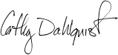
Cathy Dahlquist
Manager, Government & External Affairs

CD: lms
Enclosures

W.U.T.C.
August 4, 2015
Advice No. 3349

Attachment A

General and Local Exchange Tariff, WN U-17

Section 2

2nd Revised Sheet 33

FRONTIER COMMUNICATIONS NORTHWEST INC.
EVERETT, WASHINGTON

N O T I C E

Frontier Communications Northwest Inc. submits Advice No. 3349, an administrative tariff filing in the General and Local Exchange Tariff, WN U-17, Section 2.

The purpose of this administrative filing is to modify the Lifeline eligibility requirements criteria to be consistent with the FCC requirements, per the Washington Utilities and Transportation Commission staff request.

The effective date for this administrative tariff filing is September 11, 2015.

A copy of this tariff is available for public inspection at the following Frontier Plus store locations:

1402 SE Everett Mall Way 18700 33rd Ave. West, Suite D 4916 W. Clearwater
Everett Lynnwood Kennewick
Everett Frontier Plus Alderwood Frontier Plus Kennewick Frontier Plus

Posted at __________________________
__________________________
by __________________________

Post in above store location.

WN U-17

FRONTIER COMMUNICATIONS NORTHWEST INC.

Section 2

2nd Revised Sheet 33

Canceling

1st Revised Sheet 33

GENERAL AND LOCAL EXCHANGE TARIFF

RULES AND REGULATIONS

C. General Regulations (Continued)

11. Lifeline Service (Continued)

b. Eligibility Requirements

Lifeline Service is only available to low income residential customers who meet the following criteria:

(1) The applicant must be a participant in at least one of the following programs:
(T)

(T)
(D)

(D)
(T)

(T)
(i) Medicaid;
(ii) Supplemental Nutrition Assistance Program (formerly Food Stamps);
(iii) Supplemental Security Income;

(iv) Federal Public Housing Assistance (Section 8);
(v) Low-Income Home Energy Assistance Program;
(vi) National School Lunch Program’s free lunch program; or
(vii) Temporary Assistnace for Needy families.

The consumer must meet eligibility criteria established by a state for its residents provided that such state-specific criteria re based solely on income or factors directly related to income.

Applicants will be certified eligible by the Department of Social and Health Services (DSHS).

The eligibility period is a one-year period as certified by DSHS and runs from July 1 through June 30 of the succeeding year.

(2) The Company shall provide lifeline telephone service to any applicant who certifies via supporting documentation, under the penalty of perjury, the household income to be at or below 135 percent of the applicable Federal Poverty Guidelines.

Advice No. 3349

Issued: August 4, 2015 Effective: September 11, 2015
Issued by Frontier Communications Northwest Inc.
By Steve Crosby, Senior Vice President, Regulatory Affairs

