What is a PGA?
In the natural gas industry, PGA means Purchased Gas Adjustment. Simply stated, a PGA is a method designed to pass the actual costs of gas supplies to customers.
Each year, Cascade Natural Gas Corporation makes the best possible projection of the cost of gas supplies for the coming year. Any differences between the gas costs included in the company’s overall rates and the actual cost of supplies are calculated and passed back to customers in the next PGA filing.
If actual gas costs are lower than originally projected, customers will see lower rates. If gas costs are higher, rates will go up. Whether the change in rates is an increase or a decrease, a PGA filing does not affect the company’s profits.
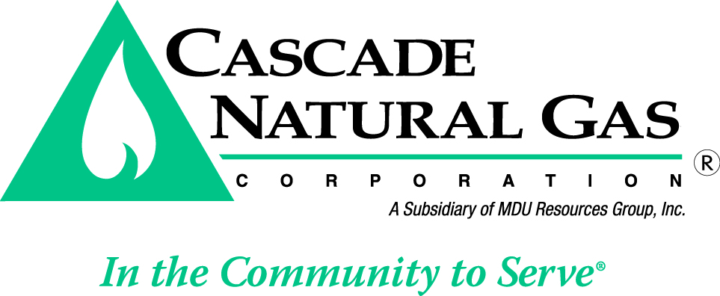
Based on projected gas costs, Cascade Natural Gas is anticipating a decrease to rates in its PGA filing. Cascade Natural Gas encourages you to use energy wisely and continue your conservation efforts.

www.cngc.com

08/15

