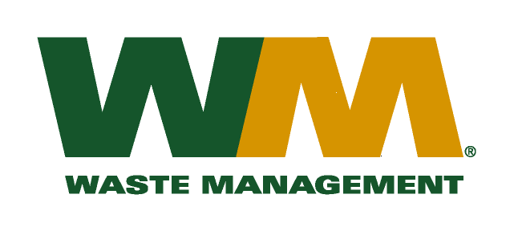
July 6, 2015
Washington Utilities and Transportation Commission
Chandler Plaza Building
1300 S. Evergreen Park Drive SW
P.O. Box 47250
Olympia, WA. 98504-7250
Dear Sirs:
Subject: Waste Management of Greater Wenatchee, a division of Waste Management of Washington, Inc.(G-237); Tariff # 13
Please find enclosed revised tariff pages Title page, 2, 31 and 32 for the above-referenced company. The purpose of these tariff page revisions is to remove the 1.25 yard service level which is no longer available to our customers. Currently there are no customers that subscribe to this service. We are requesting that these tariff revisions go into effect on seven days’ notice.
If you have any questions or need additional information, please contact me at (425) 814-7840.
Very truly yours,

Michael A. Weinstein
Senior Pricing Manager, Pacific Northwest Market Area

cc: Aaron Kelley

