CenturyLink

1801 California Street, 10th Floor

Denver, Colorado 80202

303-992-5832

May 29, 2015

Advice No. 3711T

Steven King
Executive Director and Secretary
1300 S. Evergreen Park Dr. S.W.
P.O. Box 47250
Olympia, Washington 98504-7250

Dear Mr. King:

Qwest Corporation d/b/a CenturyLink QC is forwarding for filing the sheets listed on Attachment A.

As described in the attached narrative (“Description of Methodology”), this filing is the fourth step in implementing the “Transitional Intrastate Access Service” reductions mandated by the Federal Communications Commission's November 18, 2011 Report and Order and Further Notice of Proposed Rulemaking in WC Docket Nos. 10-90, etc. (FCC 11-161). Also enclosed is CenturyLink’s certification that the company is not seeking duplicative recovery in the state jurisdiction for any Eligible Recovery subject to the recovery mechanism established by the Transformation Order. The calculations supporting these rate changes are being filed as confidential.

CenturyLink QC respectfully requests that these proposed rate changes become effective on July 1, 2015.

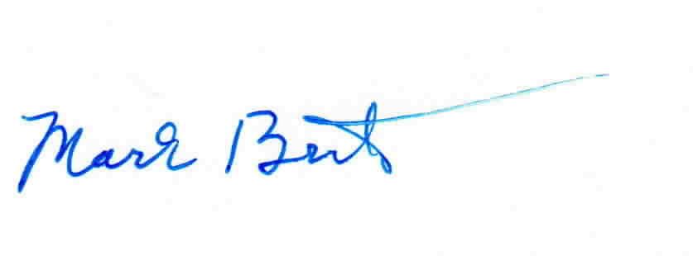
Sincerely,

Mark Brinton
Manager Regulatory Operations
Office: (303) 992-5832
e-mail: Mark.Brinton@CenturyLink.com

Attachments

Attachment A
Advice No. 3711T

ACCESS SERVICE
WN U-48

SECTION | SHEET | REVISION
6 | 146 | 4th
15 | 13 | 3rd

