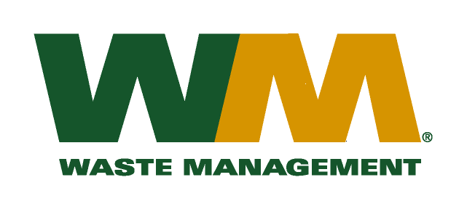
July 29, 2026
Washington Utilities and Transportation Commission
Chandler Plaza Building
1300 S. Evergreen Park Drive SW
P.O. Box 47250
Olympia, WA. 98504-7250

Subject: Waste Management of Ellensburg, a division of Waste Management of Washington, Inc.(G-237); Tariff # 12
Dear Sirs:
Enclosed herein, please find revised pages 2, 30 and 32 to the above-referenced tariff. These revised pages are being submitted to correct a clerical error which was discovered subsequent to the closing of TG-150646. Accordingly, we are requesting that these changes go into effect on July 1, 2015.

Very truly yours,

Michael A. Weinstein
Senior Pricing Manager, Pacific Northwest Market Area

