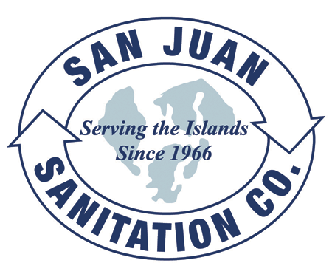

Steven King, Executive Secretary
Washington Utilities and Transportation Commission
1300 South Evergreen Park Drive SW
P.O. Box 47250
Olympia, WA 98504-7250 April 23, 2014

Dear Secretary King,

We are submitting this transmittal letter and change to Tariff Number 7, Item 230 for San Juan Sanitation, Inc. (G-144). There are two changes to Item 230:

- The San Juan Transfer Station is no longer operated by San Juan County. It is open with a new operator, Lautenbach Industries, and will again be permitted as a transfer station, rather than just a drop-box site as it was in the recent past. The new rate per ton reflects the initial rate which the new operator has offered.

- We have added the disposal site of the Skagit County Transfer Station to our Item 230. San Juan County has rescinded the portion of its flow control ordinance that requires that waste collected in San Juan County be disposed of at county owned facilities. Skagit County has agreed to take waste generated in San Juan County at a rate that includes a $7.00 out-of-county surcharge.

We are submitting this as a seven day filing as per WAC 480-70-262.

Attached please find the revised ordinance from San Juan County, a letter from Lautenbach Industries, and a rate resolution from Skagit County outlining their rates.

The contact person for this submittal is: Calvin Den Hartog
P.O. Box 267, Lynden, WA 98264
Phone: (360) 354-3400 Fax: (360) 354-3288
Email: Calvin_NVD@msn.com
Sincerely,

Calvin Den Hartog
General Manager

CC: San Juan County Council San Juan County Public Works

