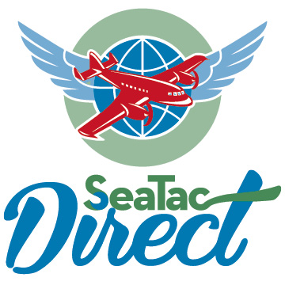
Northwest Smoking & Curing, Inc.
dba SeaTac Direct

C-65454

3 December 2014

Steve King
Executive Secretary
Washington Utilities and Transportation Commission
1300 S Evergreen Park Drive SW
Olympia, WA 98504
via electronic trans

Transmittal Letter
Re: Schedule Change

Dear Mr. King:

This is a filing in accordance with WAC 480-30-311 for 30 day notice requirement. We propose adding a daily roundtrip to our current schedule of closed door service between Best Western Lakeway Inn Bellingham, WA and SeaTac Airport. This new run would depart Bellingham at 8:30 p.m, arrive SeaTac at 10:30 p.m.; and depart SeaTac to return to Bellingham at 11:00 p.m., arrive Bellingham at 1:00 a.m.

Passenger Transportation Notice to Customers of this proposed service is attached and has been posted as of today, December 3, 2014, on the three company buses and in the office per WAC 480-30-321.

Also attached is the revised tariff schedule page in accordance with WAC 480-30-361.

Please let us know if we need to do anything further to implement this change.

Thank you,
Joel Kronenberg,
President & CEO

360-733-3666
kronenbergjoel@hotmail.com

Attached: 1. Notice to Customers
2. Tariff Schedule

