Avista Corp.
1411 East Mission P.O. Box 3727
Spokane, Washington 99220-0500
Telephone 509-489-0500
Toll Free 800-727-9170

August 29, 2014

State of Washington
Washington Utilities & Transportation Commission
1300 S. Evergreen Park Drive
Olympia, Washington 98504-8002
Attention: Mr. Steven King‚ Executive Director and Secretary

RE: WN U-29 – Natural Gas Service
Avista’s Proposed Annual Natural Gas Decoupling Rate Adjustment

Enclosed for filing with the Commission are changes to the following proposed tariff sheets:

Eleventh Revision Sheet 159 canceling Tenth Revision Sheet 159

This tariff sheet reflects the proposed Natural Gas Decoupling Rate Adjustment, filed in compliance with the Commission’s Order No. 10 in Docket No. UE-090134/UG-090135/UG-060518 (consolidated). This filing reflects the deferral balance for the period July 1, 2013 through June 30, 2014.

The decoupling mechanism allows the Company to: 1) defer up to 45% of the margin lost due to lower customer natural gas usage since the Company’s last general rate case, and 2) file a tariff to recover up to the total deferred amount through a surcharge under the proposed tariff.

The proposed tariff sheet continues to reflect a rate of $0.00000 per therm. The Company has only made a modification to the margin rate used in calculating monthly lost margin.

Calculation of Decoupling Balance
The decoupling balance calculated for the July 2013 through June 2014 decoupling period is $5,372. There are two components that make up the balance.

The first component is related to the lost margin for the period July 2013 – June 2014. While the Company deferred in the surcharge position $127,190 for the July 2013 – June 2014 time period, the Company did not reach the targeted therm savings, which is referred to as the “DSM Test” as discussed later in this filing. As a result of not passing the DSM Test, the Company will not recover lost margin for the July 2013 – June 2014 time period.

The second component of decoupling balance is the inclusion of the prior period rollover balance of $5,372. In the Company’s 2013 Annual Natural Gas Decoupling Rate Adjustment Filing, the Company proposed to carry the surcharge balance of $5,189 forward until next year. The difference between the surcharge balance in last year’s filing, and the current balance, is due to interest. The workpapers supporting the lost margin and deferred revenue are provided in Exhibit 1.

Company’s Request
Because the deferral balance continues to be extremely small, the Company is requesting to carry the surcharge balance of $5,372 forward until next year. As such, the Company has not proposed to change the rate in Schedule 159 from $0.00000 per therm.

DSM Test
The DSM test is based on the Company’s actual level of programmatic natural gas DSM savings (verified by independent audit) for the prior calendar year compared to its targeted level of savings set forth in its 2012 natural gas Integrated Resource Plan (IRP). The target level of natural gas DSM savings (Washington jurisdiction) is 893,000 therms for calendar year 2013 (as noted in Sheet 159B of the present tariff). For this filing, the actual level of verified savings for calendar year 2013 is compared to the target level. If the Company’s actual level of DSM savings is less than the target, then the amount of the surcharge is reduced, as shown on Sheet 159A of the present tariff.

In order to verify the Company’s reported level of DSM savings, the Company retained The Cadmus Group, an independent third party energy efficiency consulting firm, to verify the Company’s 2013 natural gas DSM results. The verified level of DSM savings (Washington jurisdiction) for 2013 was 613,788 therms, which is 68.7% of the target level of 893,000 therms (Washington jurisdiction). Because the savings percentage was below the minimum savings target of 70%, none of the lost margin for the July 2013 – June 2014 period is recoverable. A copy of the Cadmus report has been included as Exhibit 2.

Summary
The Company is proposing to retain the current Natural Gas Decoupling Rate of $0.00000 per therm under Schedule 159, and is only proposing one change to the tariff sheet related to the margin rate used for decoupling calculations. The Company requests to continue deferring the surcharge balance of $5,372 until such time that the balance could be added to, or reduce, a future decoupling deferral.

If you have any questions regarding this filing, please call me at 509-495-8620.

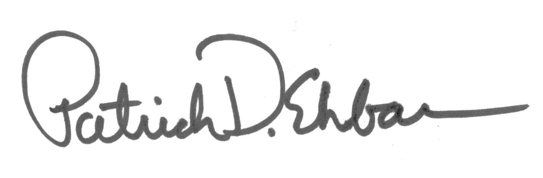
Sincerely,

Patrick Ehrbar
Manager, Rates & Tariffs

In the Company’s current natural gas general rate case, Docket UG-140189, as a part of the Settlement Stipulation pending approval before the Commission, the Parties to the Settlement agreed that this existing partial natural gas decoupling mechanism will be terminated effective January 1, 2015, and that the Company would transfer any remaining deferral balance into the new mechanism.

