
Mark Brinton
Manager, Regulatory Operations
Mark.Brinton@CenturyLink.com
1801 California St 10th Floor
Denver, CO 80202
Voice: (303) 992-5832

July 30, 2014

Advice No. 3708T (Replacement Page)

Steven King
Executive Director and Secretary
1300 S. Evergreen Park Dr. S.W.
P.O. Box 47250
Olympia, Washington 98504-7250

Dear Mr. King:

Qwest Corporation d/b/a CenturyLink QC is replacing the sheet listed on Attachment A due to a PDF margin code shift at the request of the Washington Commission Staff. The original filing was made on July 18, 2014.

Please do not re-docket. If you have questions concerning this filing, please contact Mark Brinton – Regulatory Operations on (303) 992-5832.

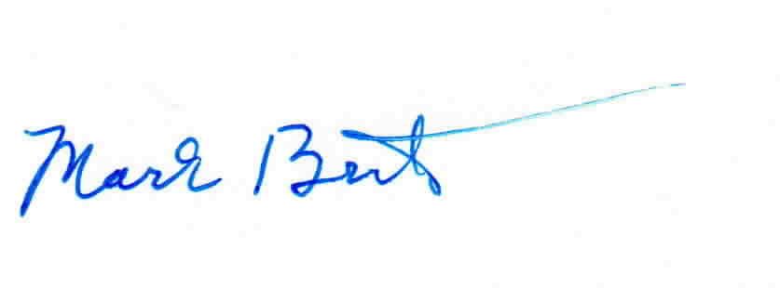
Sincerely,

Mark Brinton

Attachments

Attachment A
Advice No. 3708T
Replacement Page

ACCESS SERVICE
WN U-48

SECTION | SHEET | REVISION
11 | 2 | 1st

