Mark S. Reynolds

VP Regulatory & Legislative Affairs

Western Region

CenturyLink

1600 7th Avenue, Room 1506

Seattle, Washington 98191

(206) 345-1568

Facsimile (206) 343-4040

May 30, 2014

Re: Advice No. WA 14-08A for United Telephone Company of the Northwest

Steven King
Executive Director and Secretary
1300 S. Evergreen Park Dr. S.W.
P.O. Box 47250
Olympia, Washington 98504-7250

Dear Mr. King:

United Telephone of the Northwest Access Service d/b/a CenturyLink is forwarding for filing the sheets listed on Attachment A.

As described in the attached narrative (“Description of Methodology”), this filing is the third step in implementing the “Transitional Intrastate Access Service” reductions mandated by the Federal Communications Commission's November 18, 2011 Report and Order and Further Notice of Proposed Rulemaking in WC Docket Nos. 10-90, etc. (FCC 11-161). Also enclosed is the CenturyLink certification certifying that CenturyLink is not seeking duplicative recovery in the state jurisdiction for any Eligible Recovery subject to the recovery mechanism established by the Transformation Order. The calculations supporting these rate changes are being filed as confidential.

In addition, the company is proposing language changes to its tariff relating to Jurisdictional Report Requirements. Changes are proposed to the percentage interstate usage (PIU) to bill actual minutes of use instead of using calculated PIU factors which mirrors the methodology in the company’s interstate access tariff.

CenturyLink respectfully requests that these proposed rate changes become effective on July 1, 2014. If you have questions concerning this filing, please contact Gary Kepley – Regulatory Operations on (913) 345-7572.

Sincerely,

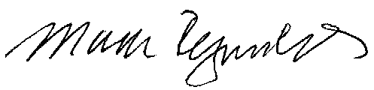

Mark Reynolds

Attachments
Attachment A
Advice No. WA 14-08A

ACCESS SERVICE
Tariff WN U-11

SECTION | SHEET | REVISION
2 | 2-13 | 1st
6 | 144 | 1st

