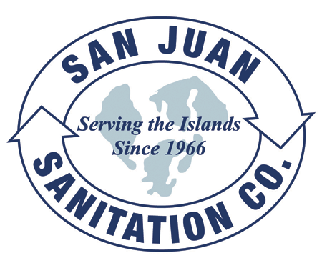

Steven King, Executive Secretary
Washington Utilities and Transportation Commission
1300 South Evergreen Park Drive SW
P.O. Box 47250
Olympia, WA 98504-7250 September 20, 2013

Dear Secretary King,

We are submitting this transmittal letter and a change to Tariff Item 230 for San Juan Sanitation, Inc. (G-144), to update it with lower rates as charged by the new operator of the Orcas Island Transfer Station. Enclosed please find revised tariff pages and the letter from San Juan County which we received yesterday. We are filing this change as directed by WAC 480-70-262. This is an adjustment to Solid Waste Tariff Number 7, with an Effective Date of September 30, 2013.

The contact person for this submittal is: Calvin Den Hartog
P.O. Box 267, Lynden, WA 98264
Phone: (360) 354-3400 Fax: (360) 354-3288
Email: Calvin_NVD@msn.com

