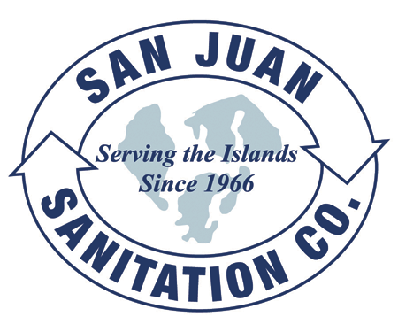

Steven King, Executive Secretary
Washington Utilities and Transportation Commission
1300 South Evergreen Park Drive SW
P.O. Box 47250
Olympia, WA 98504-7250 September 10, 2013

Dear Secretary King,

We are submitting this transmittal letter and a change to Tariff Item 30 for San Juan Sanitation, Inc. (G-144), to update with changes as recommended and required by the Commission. Enclosed please find revised tariff pages. This is an adjustment to Solid Waste Tariff Number 7, with an Effective Date of November 1, 2013.

The contact person for this submittal is: Calvin Den Hartog
P.O. Box 267, Lynden, WA 98264
Phone: (360) 354-3400 Fax: (360) 354-3288
Email: Calvin_NVD@msn.com

